76. Activity title: „Hedgehog and mushrooms“
Activity type: lessons
Purpose:
Continue to enrich the experience of children in action with objects of various sizes and colors.
To teach children to find and display a picture with a given image.
Fix the ability to draw with your fingers, sculpt from salt dough.
Exercise in onomatopoeia.
To form an emotional response to music, a sense of rhythm.
Develop fine and general motor skills, tactile sensations.
Participants: group of children
Level: 2-4 year old
Materials:
Massage spiky balls and brushes.
Toy "hedgehog."
Mushrooms (large and small), leaves, cones, apples.
Audio recordings: Mozart's “Lullaby”, the song “Little Hedgehog”.
Salted dough, beans.
Plastic plates, finger paints.
Toothpicks, molded from plasticine hedgehogs.
Pictures with the image of a hare, cat, hedgehog.
Time: 30 minutes
Activity description and instructions, rules, comments:
Greeting
In a golden crib, the sun was asleep across the river.
The sun rose in the morning, woke the children.
Kids came to play
They began to clap and wave.
And Vanya is here, and mother ... here.
And Nick is here ...

Surprise moment

Oh! Who is this here? Hedgehog! Hello, hedgehog! Children, say hello to a hedgehog.

Game massage "Roll prickly hedgehog"

Roll prickly hedgehog
There is no head or legs.
On the palm runs
And puffs, puffs, puffs.
(circular motion ball between the palms).
I'm on the run
And puffs, puffs, puffs.
Runs here, here,
I tickled yes, yes, yes.
(movements on the fingers).

The game "take care of the hedgehog"

Hedgehog ran through the woods, stopped, listened. Suddenly an autumn leaf fell from a tree and landed right on the hedgehog. Put a piece on top of the hedgehog. I shook the hedgehog and dropped the sheet.

Listening to music "Mozart's Lullaby"

Here is our hedgehog wanted to sleep. Sleep a hedgehog and listen to a lullaby.

Dynamic pause "I went to the forest hedgehog walk"

Hedgehog went, went, went,
Walking.
And found a fungus.
Every child takes a fungus.
He sat down, ate and went on.
To squat.

Hedgehog went, went, went,
Walking.
Little apple found.
Every child takes an apple.
He sat down, ate and went on.
To squat.

Hedgehog went, went, went,
Walking.
The bump he found.
Every child takes a lump.
He sat down, ate and went on.
To squat.

Finger drawing "Decorate a plate for a hedgehog"

Children decorate a plate with specks. Here is what a beautiful little plate is now a hedgehog.

Game "Collect big and small mushrooms"

See how many mushrooms have grown in the forest after the rain. There are large mushrooms, there are small ones. Let's collect a lot of mushrooms, but lay them in different baskets: large mushrooms - in a large basket, and small mushrooms - in a small basket.

Dima walked, walked, walked.
And found a fungus.
Once - a big fungus,
Two - a small fungus,
Put them in box.

Exercise "Needles for a hedgehog"

The teacher shows the children a brush and offers to touch it.
What brush to touch? Prickly. Hedgehog needles are the same prickly.
In the plasticine hedgehog children stick toothpicks.

Didactic game "Find the hedgehog in the picture"

Among the pictures of a hare and a cat, children choose a picture of a hedgehog.

Onomatopoeia

hedgehog snorts: fu-fu-fu.

Hide and seek with a hedgehog

Where did the hedgehog hide? The teacher hides in a visible place, and the children are looking for.
Then the children hide, and the hedgehog is looking for them.

Dynamic pause "Like ours in animals"

How are our animals
Paws are fun to knock:
Top-top-top, top-top-top,
Stomping
And tired legs,
Clap your palms:
Clap clap clap, clap clap clap,
Clapping hands.
And then in the sit down
Animals are dancing side by side.
Spring.
And how to start running -
No one to catch up with them.
Run.

Sculpture from salt dough "Pie with beans"

Children make a cake from a piece of dough of a spherical shape (by pressing it with a palm on top, placing a plate on the decorated with a finger drawing). Then the beans are pressed into the cake from above.

Music game "Little hedgehog"

Children listen to, arbitrarily move to the music or repeat movements for an adult.

77. Activity title: „Meet Antarctica“
Activity type: lessons
Purpose:
To acquaint children with the nature of Antarctica.
Teach children to read, achieving cohesion and speed.
Exercise in the ability to write a sentence scheme.
Improve the skills of counting, solving examples, comparing aggregates, measuring length with the help of a ruler.
Develop children's curiosity, thinking, attention, fine and general motor skills.
Cultivate curiosity.
Participants: group of children
Level: 3-7 year old
Materials:
Pictures of iceberg, penguins, wandering albatross, sea leopard.
World map.
Direct and reverse invoice.
The number of "fishing."
Numbers. Connect the dots.
Solution examples. Coloring.
Outdoor games and races.
Creativity "Penguins on the ice"
Dynamic pause "Penguin flock"
Reading.
Sentence.
Prepare your hand for the letter "Circle the drawing."
Thinking "Color the fish."
Find the shadow.
Penguin dance.
Time: 30 minutes
Activity description and instructions, rules, comments:
Antarctica is called the South Pole. Antarctica is an icy continent surrounded by the ocean. This is the harshest place on the planet.
No one lives in Antarctica all the time, but scientists from all over the world come to numerous research stations and conduct research.
Antarctica is almost completely covered with snow and ice. And icebergs float around its shores - floating ice mountains, which have only a small portion above the water and a large part under the water. Take a look at the picture. (Show pictures).

Direct and countdown - “Spend a penguin on ice floes”
Enter the missing numbers on the ice from 1 to 10 and back.

Quantity - Fishing
Diving into the sea between the ice floes,
Penguin swims behind the fish.
In the sea, agile, like a cat
He eats fish.

So it is, the main food of penguins is fish. And squid and krill. Here they are, take a look. (Show pictures). Penguins eat small prey right in the water, and on a large scale they finish on the surface.

Feed the penguin flocks with fish. Spend each penguin company to a suitable polynya. The number of penguins should be equal to the number of fish in the polynya.

Numbers - connect the dots
Connect the dots and find out who is in the picture.
This is a southern elephant seal.

Solving examples - mathematical coloring
Solve examples and answers will tell you how to color the image.

Measurement
Measure the height of icebergs with a ruler. How many centimeters high iceberg more low.

Outdoor games and races "Penguins"

Penguins are birds. But they do not know how to fly, and on land they walk slowly. But then these clumsy birds swim excellently, dive and spend most of their lives in the water.

"Carry the Egg"
Emperor penguins do not build their nests, laying an egg, they keep it on their paws, warming themselves.
The soft ball must be clamped between the ankles and carry a certain distance.

"Penguins are heated"
In Antarctica, the strongest storms on earth are raging. At the same time there is so much snow in the air that nothing is visible around.
At the command of a “blizzard”, the children become in a tight circle, clinging to each other.

"Penguins on the ice"
Penguins have an enemy - sea leopard seal.
At the command “Penguins, on the ice floe! Sea leopard is near! ”Children are placed on a sheet of paper depicting an ice floe. Then the floe-paper decreases - it melts.

"Penguins go to the sea"
And Adelie penguins have nests. To get to the nesting place from the sea, they waddle or slide on the ice.
With a penguin's step, the children line up one after another and move after the guides.

Creativity "Penguins on the ice"
Penguins are not taller than you. The back and head of the penguins are black, and the chest and belly are white.
Find the detail of white and stick it on the black silhouette of the penguin. Glue the eyes and beak to the front of the head. The eyes help the penguins to see the fish under water, and the beak to grab this fish.
Although penguins do not fly, they have small wings. The penguin needs wings not for flying, but for swimming.
Glue the two wings of the penguin.

Have a penguin and a tail in the lower back.
Find the tail cut from the paper and stick it in the right place. Let the edge of the tail protrude beyond the torso. Stick it and zagnite it like this (show), and the tail will turn out like a real one.

What is missing our penguin? Paw Paws at penguins with membranes. What do you think, scratching a penguin such paws. Similar to flippers? (Children's answers). Which birds you know have the same paws? (Children's answers). In geese and ducks.
Paws with webbing help the penguin to row while swimming, and swim fast. On land, penguins are clumsy and unwieldy, and in the water they are fast and agile - because otherwise you won't catch a fish.
Let's glue the paws to the penguin. Glue the upper part of the paws with glue, let the lower part, like the tail, protrude beyond the torso. Paws, we, too, will be bent forward, like this. (Show work performance).

Reading the Penguin Poem

Preparing the hand for the letter “Circle the drawing”

Penguins have a rounded shape, small legs and a head. Penguins must be plump, plump, so that the fat protects them from the cold. A hungry, skinny penguin can freeze.

Circle the dotted lines and color the picture.
Doing a job on a worksheet (the children circle the image of the penguin and paint it).For example:
This is a squirrel. She lives on a tree in a hollow, sometimes she builds a nest. Another squirrel collects spruce and pine cones, hangs mushrooms on branches - makes stocks for the winter.
If the blue color falls out - choose a bird; red color - insect; yellow - a bird, an insect, an animal that does not live in the forest and motivates its choice.
Thinking "Color the fish"
Continue to color the fish in a specific order.

Find the shadow
Penguin see want -
Look for him in Antarctica.
Among the snow lives penguin.
He is not alone in Antarctica.

Indeed, penguins do not live alone, but in large numbers of flocks. Take a look at the picture. (Show picture)
Find the shadow of each penguin, combine the line shadow and color image.

Dynamic pause "Penguin flock"
Walks waddling, wings spread,
On the ice the whole penguin is a huge flock.
(Imitation of penguin movement)
Diving in the sea between the ice floes, the penguin swims behind the fish.
In the sea, dexterous, like a cat, he eats fish.
(Imitation of diving and swimming in fish hunting)

Penguin dads carry an egg with chick from above on their paws,
From the cold, hiding under the folds of fat.
There is enough heat for his “passenger”!
(Children take the balls and go, holding them between the legs)

The wandering albatross has a wingspan of 4 meters - more than any other bird in the world. 12 swallows can fit under the wings of a wandering albatross. The egg of this bird is the same size as a small penguin.

Penguin dance
Children dance to the music and video with movements.

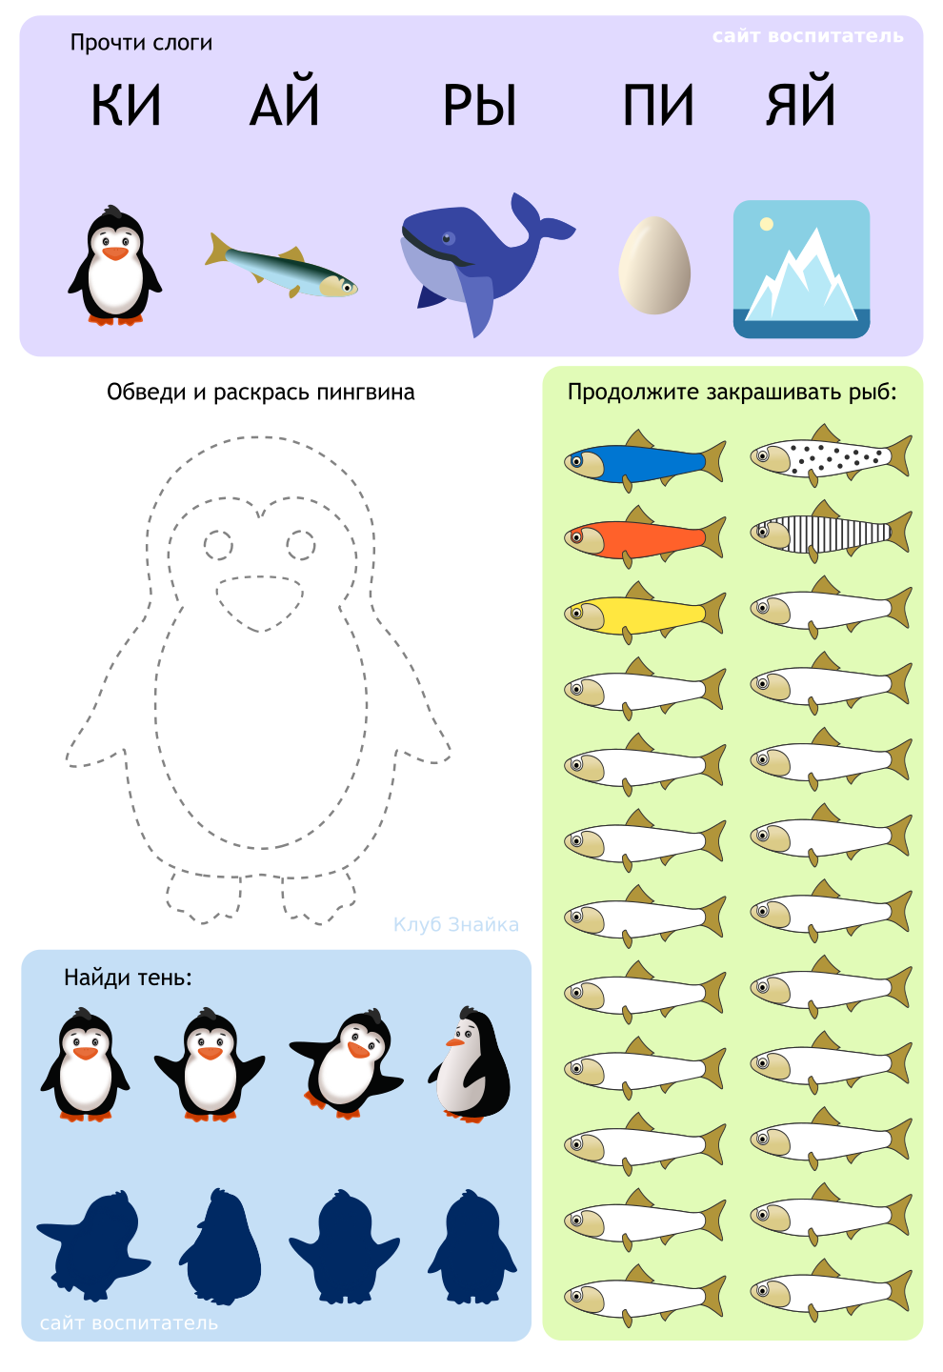
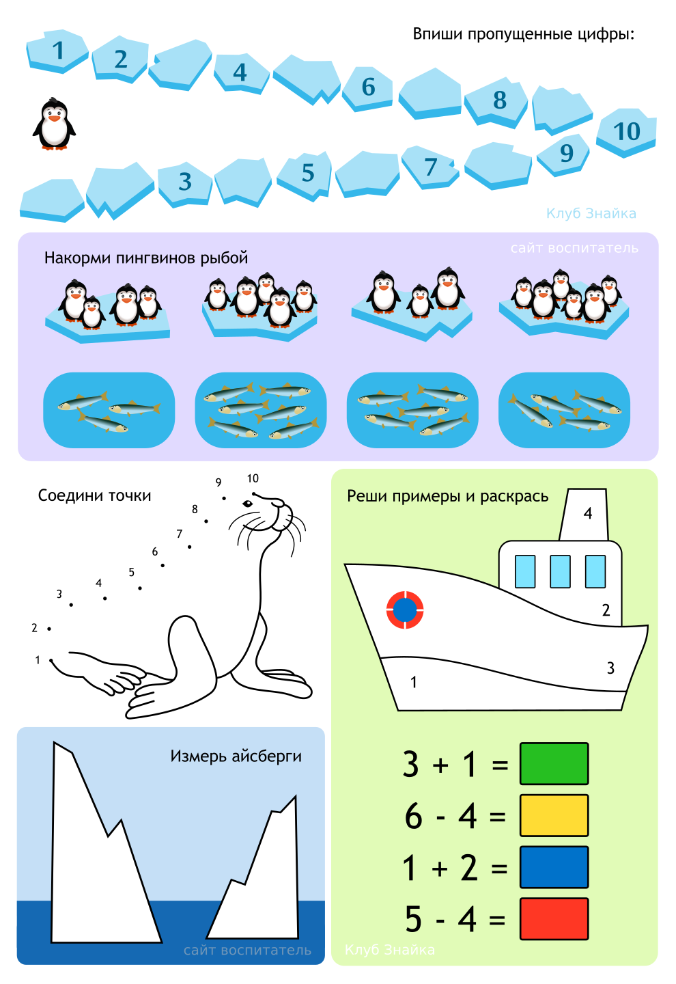

78. Activity title: „Pets“
Activity type: lesson
Purpose:
Continue to acquaint children with pets and their young.
Enrich the vocabulary of children on the topic.
To form sustainable ideas about the shape, color, quantity, size, geometric shapes.
To practice in echo imitation, modeling, gluing, drawing with fingers and pencils.
Continue to learn to build a building material on the model, cut paper with scissors.
Develop thinking, visual and auditory concentration, fine motor skills, coordination of movements, sense of rhythm.
Teach children to do collective building and play with it.
Participants: group of children
Level: 2-7 year old
Materials:
Toys "pets", a little chest, a wonderful bag, musical hammers.
Colored silhouette pictures of pets and their dark shadows.
Picture-background "On the farm", geometric shapes.
Green paper strips, scissors.
Building material: bars and arches.
Picture blank for drawing (sky, meadow, oval-lake), blue and green pencils, glue, silhouette pictures of pets.
Groats, spoons, soap dishes.
Colorful clothespins, colored silhouette pictures of the heads of kids with bells of different colors on the neck.
Picture-background with cells of different sizes, colored silhouette pictures of rabbits of the corresponding size.
White plasticine, blank picture "lamb".
Sheet-background, glue, details of application: sun, bone, door from the booth; finger paints, wet wipes.
Picture-background with the image of booths of different colors, triangular roofs for booths, cut out of cardboard, corresponding colors.
Educational game "Find Mom."
Audio recording: "Carousel", "Far, far away, on a meadow to graze ..".
Time: 30 minutes
Activity description and instructions, rules, comments:
Game greeting "Our smart heads"
Our smart heads
They will think a lot, deftly.
Ears will listen,
Mouth to speak clearly.
The handles will clap,
Feet will stomp.
Backrest straightened
Smile at each other.

Surprise moment "Wonderful little chest"
"Here is a wonderful little chest,
You guys are a friend.
I'd like to know
Like, you like to play! ”

Didactic exercise "Find the shadow"
What are the pets in front of you? Pick a shadow for everyone.

Construction On Farm
Lay out the geometric shapes in the appropriate places in the picture. Where did you put the circle? Oval? Square? Triangle? Rectangle?

Didactic game “Who lives on a farm?
The children put their hands in a wonderful bag and take turns taking out the toys of domestic animals, call them.
COW
The cow has horns
And hooves on the legs.
She chews a little grass
Baby gives milk.
A cow has a baby called “calf”. The calf says, "Mooo." Tell me what the calf says.

Scissor cutting “Grass for cow”
Children scissor a strip of green paper.

Graphic activity "In the meadow"
Draw a green pencil with a grass, a blue pencil draw a water in the lake, paste pet figures on a meadow.

Musical and rhythmic exercise "In a meadow graze to .."
Children beat the rhythm of musical hammers.

PIG
At the muddy pigs
Bristle on back,
On snout little penny,
Behind a thin tail hook.
In a pig, the child is called - pig. Piglet says: “Oink”. Say it like a little piggy.

Designing "Fence for pigs"
Take the bars and build a fence around the piglets. Like this. (Show)

Exercise "Fill the piglet feeder"
Children fill up with a spoon a multi-colored soap-trough with cereals.

HORSE
Have long-ripped horses
The character is cheerful and playful.
Hay will eat it now
Yes, and rolls us.
The horse child is called - the foal. The foal says: "i-go-go." Tell me how the foal says.

Didactic game "What can a horse?"
Can you clearly say the word "yes"? Tell me. Now say the word "no." You did well, so you can play an interesting game with me.
I will ask you about what a horse can do, and you think and answer: if a horse knows how to do it, say “yes”. And if the horse can't do it, say no.
The horse can jump fast.
A horse can fly in the sky.
A horse can chew grass.
The horse can knock with hoofs.
A horse can play toys.
The horse can laugh loudly: yoke-go.

Mobile game "Carousel"
Children move in a circle in a tempo corresponding to the music and words of the song.

GOAT
Goat bouncing,
Naughty
Like a sneak
There are cabbages from the garden.

In a goat, a child is called - a goat. He says: "Me-ee." Tell me the way the kid speaks.

Play with clothespins "colorful horns"
What color is the bell in the goat, the same color, make him horns of clothespins. (Then you can invite children to swap pictures).

RABBITS
Do not hurt the flies
Long-eared rabbit.
In a cage for him always
There is a carrot and water.
In a rabbit, a cub is called - a bunny.

Didactic game "Rassadi rabbits"
Before you are rabbits. Show the biggest rabbit, the smallest, two identical rabbits. Rabbits live in cages-houses. Seat rabbits in the appropriate size of the cage.

SHEEP
Lamb fur
Soft, in curls.
Shear the sheep and
Tie warm socks.

In a sheep, a child is called a lamb. The lamb says, "be-ee." Tell me what the lamb says.

Sculpted "Curly at the Lamb"
Children tear pieces of white clay and stick to the image of a lamb.

DOG
Bones dog gnaws,
Evil people bite too -
In order not to get a thief
Watchman and the house and yard.

The dog is called a puppy. The puppy says: "woof-woof." Tell the way the puppy says.

Didactic game "Booths for dogs"
Pick the right roof color and door dog kennels.

Pictorial activities "Puppy"
Children stick on the sheet-background sun, bone. Then a foam of brown color is drawn by a foam rubber stamp and the flowers are drawn with fingers.

Didactic game "Find Mom"
Now take the cards with the cubs and find their moms.
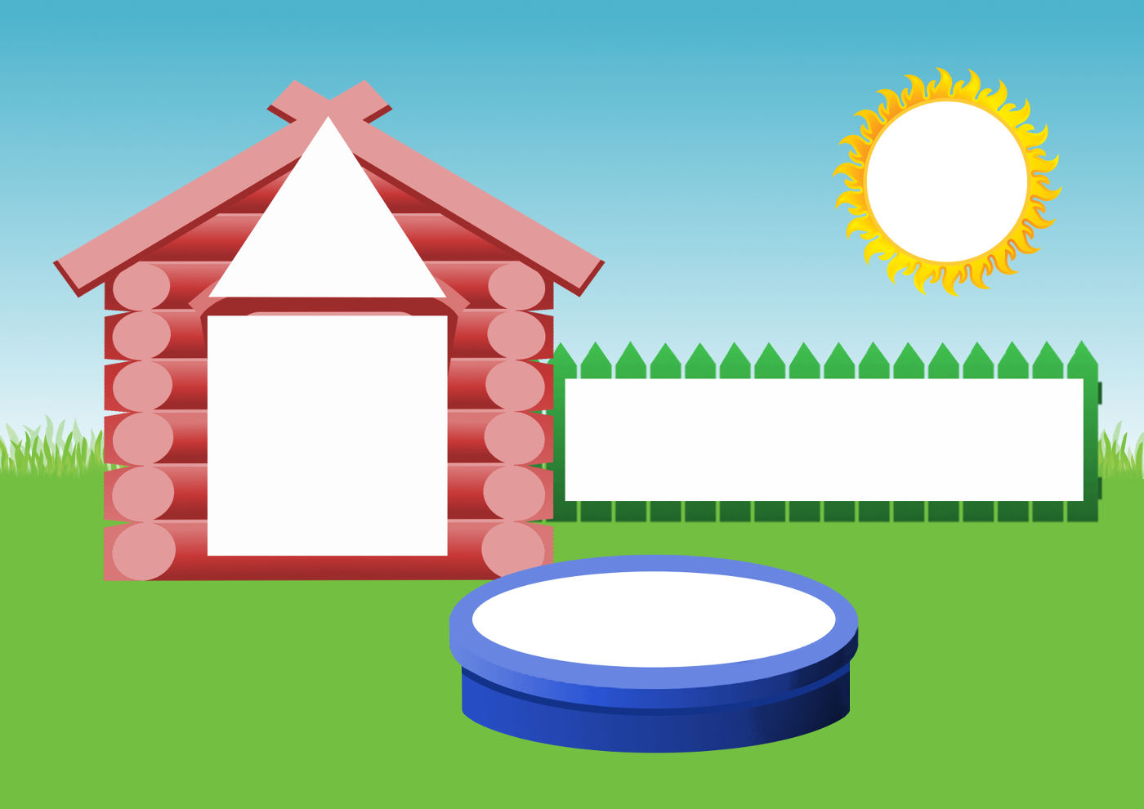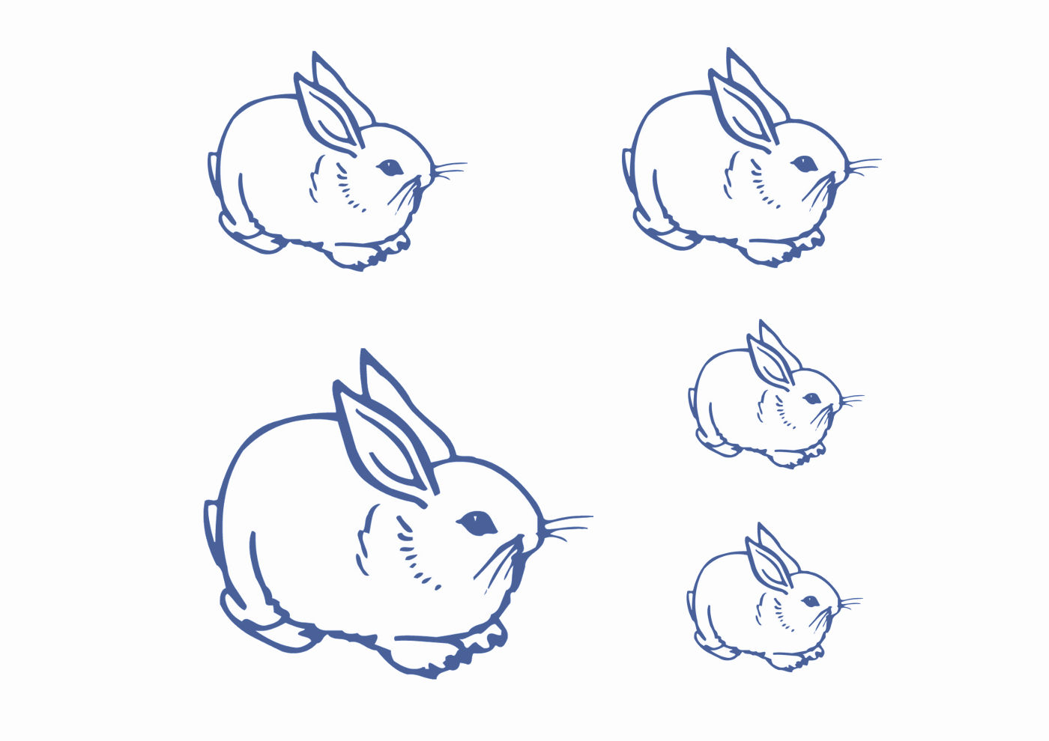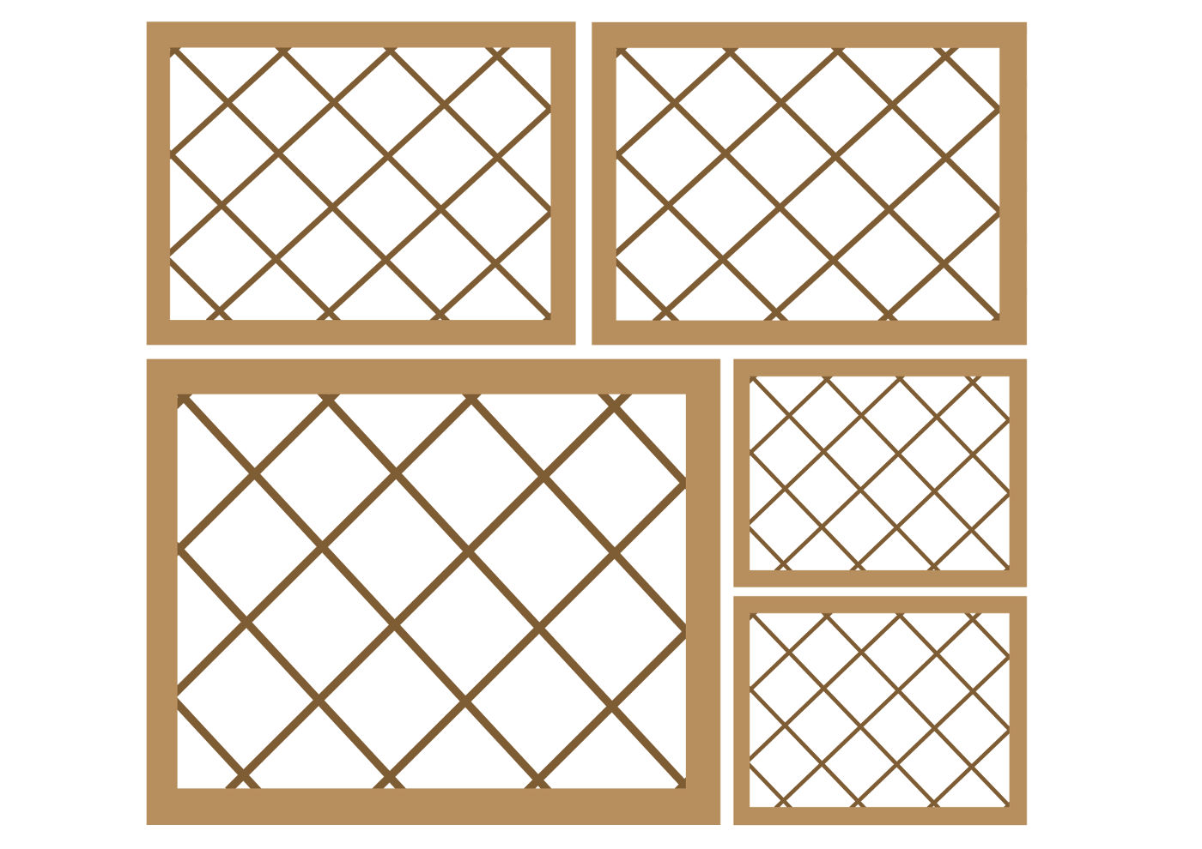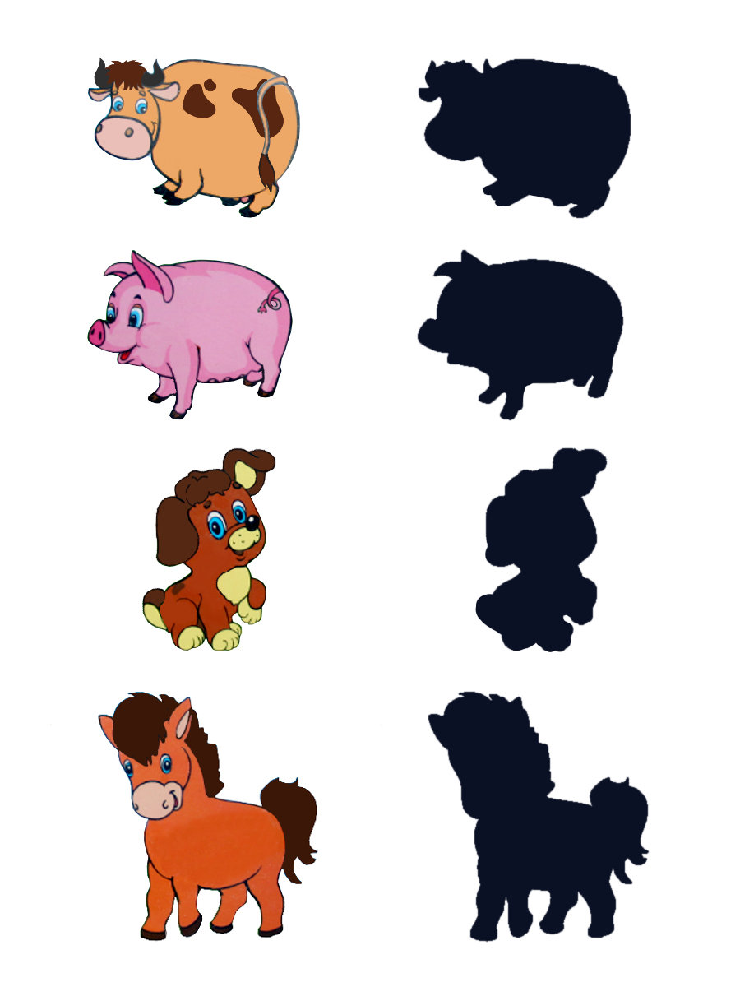

79. Activity title: „Winter in the forest“
Activity type: lesson
Purpose:
To expand the knowledge of children about the inhabitants of the forest, the peculiarities of their life in winter.
Consolidate knowledge of the number and number 1.
To form the ability to distinguish the shape of objects.
Teach children to guess the animal by description. Find a picture with the image of a given animal.
To acquaint children with the story of L. Tolstoy “The Wolf and the Squirrel”.
Continue to learn to sculpt, paint and stick.
Develop attention, auditory and visual concentration.
Practice in the ability to coordinate words and movements.
Develop thinking, fine and general motor skills.
Participants: group of children
Level: 2-4 year old
Materials:
Attached to the back of the chair pictures of the forest dwellers; tickets with similar pictures.
Mittens dolls: bear, fox, wolf, hare, hedgehog, squirrel, deer.
Silhouette images of hedgehogs without spines, clothespins.
Container with cereals, nuts, foil.
Silhouette image of a squirrel, finger paints.
Picture of a fox without a tail pasted on cardboard, orange clay.
Pictures of animals without tails, carved tails of these animals.
Napkins green.
Picture-background of the winter forest with a den, silhouette images of a bear, hare, squirrel, fox, wolf.
Pictures of colored animals and their black shadows, pencils.
Rattles.
Audio recordings: "Bunny", "Wolf" Zheleznova.
Time: 30 minutes
Activity description and instructions, rules, comments:
Greeting "Everyone clapped their hands"

Everyone clapped their hands,
Friendly, more fun!
Our feet were knocked,
Louder and faster!
On the knees hit.
Hush, hush, hush.
Handles, handles raise,
Higher, higher, higher!
Our pens are wrapped.
Down again.
Circled, circled
And they stopped.

Game situation "Journey to the winter forest"

The teacher builds chairs one after another, on the back of each chair a picture of the animal. Children are given tickets, which depict the same animals.
Guys, look at your ticket and find each your place. All settled in their places? Then hit the road - in the winter forest!

The teacher puts on his hand a doll mitten "Squirrel"

I am a squirrel, cheerful animal, jumping and jumping.
But in the winter I change, I change into a gray fur coat.
All the autumn hollow warmed
Pooh, straw pulled there.
For winter preparing stock: mushrooms, berries, nuts ...
So as not to starve in the winter. Where am I going to get in the cold?
It is difficult for a squirrel to spend the winter ...

Exercise "Find the nuts"
Children are looking for nuts in their hands with containers with cereals.

Manual labor "Nuts for squirrels"
Children wrapped nuts in foil and put them in a hollow (a hole cut in a brown plastic bottle)

The teacher puts on the hand a doll mitten "Hedgehog"
In winter, I sleep soundly,
Buried in a warm hole.
Since summer, I have saved my fat, ate a lot and drank a lot.
I have one job in the winter in winter - sleep hard and wait for spring!

Didactic exercise "Find one who is alone"

Children find in the picture among animals that which is one and denoted by the number 1.

Play with clothespins "Prickly hedgehog"

Children attach the clothespins to the hedgehog's silhouette image.

The teacher puts on his hand a doll mitten "Hare"

I am a hare, I will tell you how I live in the forest.
By the winter, guys, turned white, put on a new fur coat.
Under the bush, I'll sit down, hide under the pine tree.
He will not see, the beast will not recognize me in the forest!
It is very difficult in winter when it is very cold.
And the food is not enough.
And I feed on bark, frozen berries.
That under the snow the hare will find - everything will go to him for the future.

Musical dynamic pause "Bunny jumped"
Children shift according to the lyrics.

The teacher puts on his hand a doll-mitten "Fox"
I am not afraid of winter, I wear warm fur coats.
What a beautiful tail - I like it most!
I live in a hole. I sleep there, relax, and then I begin to hunt.
I am looking for a field mouse or a living creature.
I want to catch a hare, but it's not easy not to catch up with him!
Few people probably know about this, but it is difficult for me in the winter too.
Sometimes I run all day and no food at all.

Sculpture "Fox tail"
Children mold a thick sausage in a circular rolling pattern, then roll out their finger with a thin-thin edge of this sausage. Then apply the tail to the fox image and press down with your fingers.

The teacher puts on his hand a doll-mitten "Wolf"

I myself will tell you how to winter in the forest.
The wolf in winter is very angry.
Alone does not go; wolves roam in packs.
Gray, thin, hungry and angry.
They howl heavily at night, even scary beasts!
Better they do not fall, you have to beware of them.
But the wolf is difficult in the winter ...
There is not enough food, and he is starving.

Didactic game "Whose tail?"
It is necessary to find and attach the tail to the image of the animal.

Dynamic pause "Winter Forest"
We came to the winter forest.
How many miracles are here!
To the right is a birch in a fur coat,
Left spruce looks at us.
The snowflakes are spinning in the sky,
On the ground lie beautifully.
Here's a bunny rode,
He ran away from the fox.
This gray wolf prowls
He is looking for prey!
We all hide now,
Then he will not find us!
Only a bear is sleeping in a den,
So he will sleep all winter.
Bullfinches fly by.
How beautiful they are!
In the forest, beauty and peace,
And we have to go home.

Reading the story “The Wolf and the Squirrel” by L. N. Tolstoy
The squirrel jumped from branch to branch and fell right on a sleepy wolf. The wolf jumped up and wanted to eat it.
Squirrel began to ask: "Let me go." The wolf said, “Well, I will let you in, only you tell me why you squirrels are so cheerful. I am always bored, but you look at you, you all play and jump up there. ” Belka said: “Let me go to the tree first, I’ll tell you from there, otherwise I’m afraid of you.” The wolf let go, and the squirrel went to the tree and from there said: “You are bored because you are angry. Your anger heart burns. And we are cheerful because we are good and do not do evil to anyone. ”

Drawing "Squirrel"
Children paint over the outline of the squirrel.

The teacher puts on the doll doll mitts "Bear"

Under the snag in the windbreak
Sleeping bear, as if in the house.
He put a paw in his mouth
And how little sucks.

Exercise "Winter in the forest"
Children impose a picture of a bear, a hare, a squirrel on a background image. The teacher asks where the children put the animals.

Finger game "Wild Animals"
This is a little hare, this is a little squirrel. Alternate flexion of the fingers
This is a little fox, it's a wolf cub. starting from the little finger.
And it sleeps and sighs wake wiggle with his thumb.
Brown, hairy, funny little bear.

Didactic game "Show the picture"
I will tell you about the animals, and you guess who it is and show the picture.

Small, long-eared, timid, jumping. (Hare)
Gray, angry, toothy. (Wolf)
Redhead, furry, sly, agile. (Fox)
Big, brown, clumsy, clumsy. (Bear)

The teacher puts on his hand a doll mitten "Deer"
No sweets, no dumplings
Do not eat deer in the forest.
And lunch is not bad for them,
If there is grass and moss.

Manual labor "Hay for a deer"
Children tear napkins of green color into thin strips-hay.

Didactic exercise "Find the shadow of an animal"
Children connect the line color image and its black shadow

Musical and rhythmic exercise "Wolf"
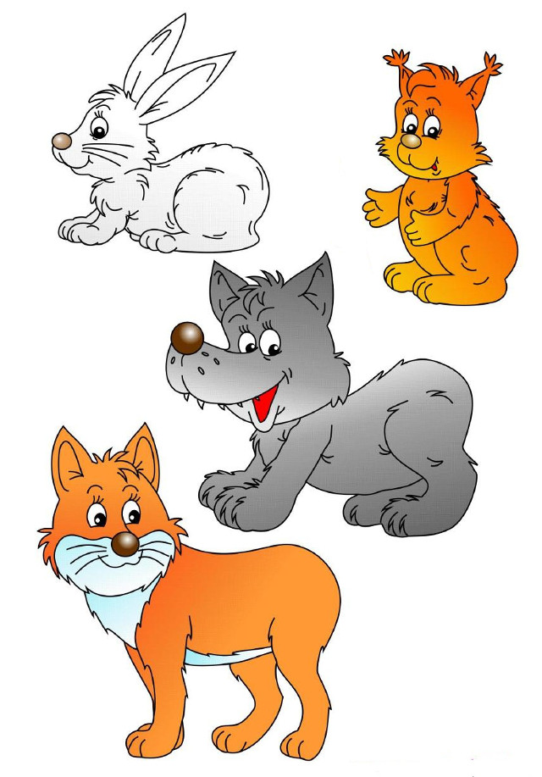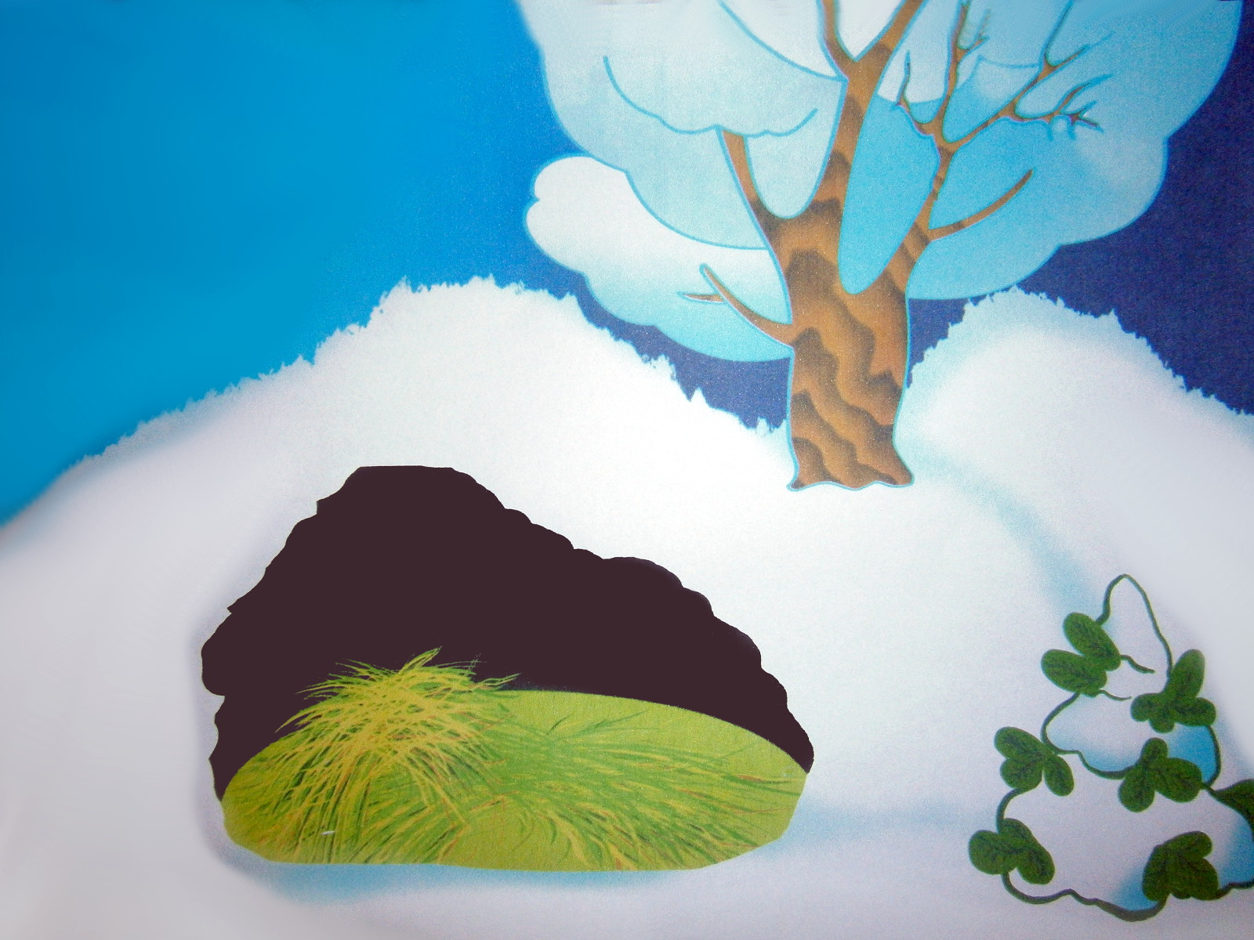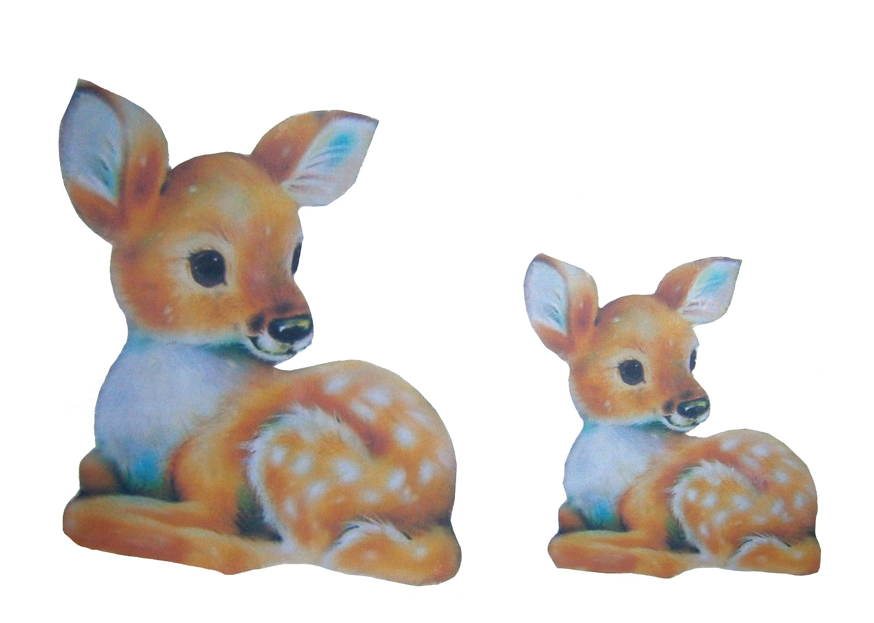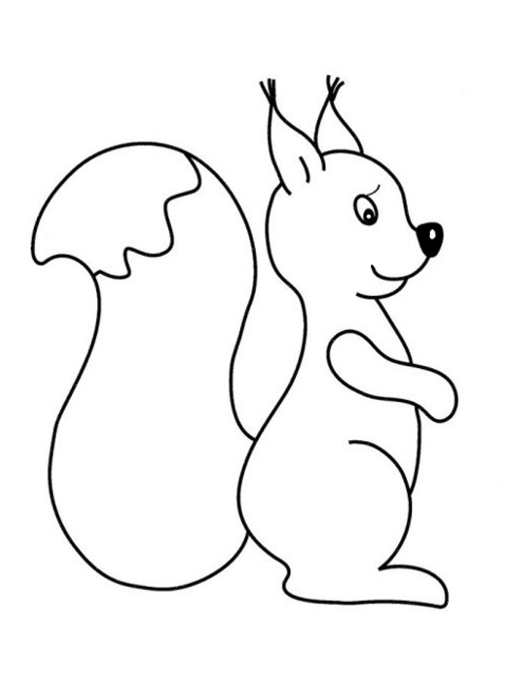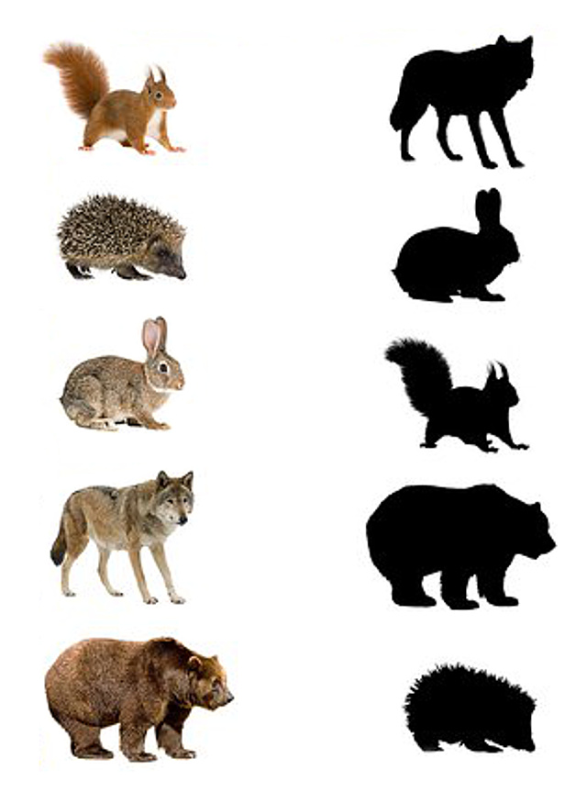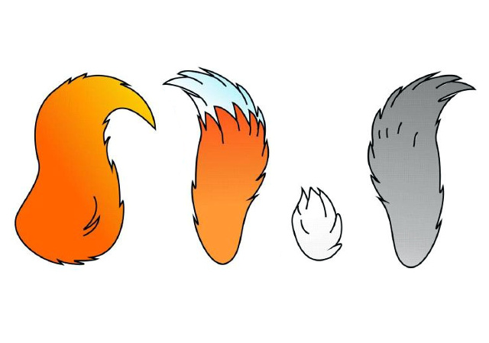

80. Activity title: „Butterfly“
Activity type: lesson
Purpose:
Expand children's knowledge about butterflies.
Enrich the vocabulary of children on this topic.
To form sustainable ideas about the size, quantity, color, location of objects in space.
To acquaint children with the concept of "symmetry".
Improve the skills of modeling, sticking, drawing with pencils, fingers and stamps.
Learn to perform an exercise on the development of correct articulation breathing.
Develop thinking, fine motor skills, coordination of movements.
Participants: group of children
Level: 2-4 year old
Materials:
Toy "Butterfly".
The picture with the image of four butterflies. one of which is different from the others.
Image-diagram with the image of a butterfly from geometric shapes, geometric shapes, cut from colored cardboard, counting rods for antennae.
Silhouette picture "Butterfly" on the wings of which circles of different colors and sizes, corresponding to the size and color of the buttons.
Multicolored clothespins, silhouettes of the body and the head of a butterfly, carved from cardboard.
Paper colored butterflies attached to strings.
Colored butterflies glued on toothpicks, blue and red flowers painted on foam plastic.
Plasticine, peas, shells, cut out of colored paper silhouettes of butterflies.
Picture-blank with painted white flowers (middle of different colors), colored pencils, glue, silhouette pictures of butterflies of color corresponding to the middle of colors.
Finger paints, picture-blank with the image of a butterfly with white dots on the wings.
Silhouette pictures of caterpillars and butterflies of red, blue, green, yellow colors.
Picture-background with painted butterflies of different colors and sizes, corresponding in color and size to the silhouettes of butterflies, carved from colored cardboard.
Cut out of cardboard flowers of different colors.
Parachute of four sections of different colors.
Gouache, butterfly stamps, meadow picture.
Audio recording: "Butterfly".
Time: 15-30 minutes
Activity description and instructions, rules, comments:
Game greeting "Our smart heads"
Our smart heads
They will think a lot, deftly.
Ears will listen,
Mouth to speak clearly.
The handles will clap,
Feet will stomp.
Backrest straightened
Smile at each other.

Surprise moment "Who is behind the window?"
Our guest today is about to fly here. Let's open the window. And here she is!
Did you recognize our guest? Who is she? Butterfly.

Didactic exercise “Find a butterfly unlike any other”
- Look at the picture and show the butterfly, not like others, different from other butterflies.

Build a Butterfly
In the picture diagram, the children spread the image of a butterfly from geometric shapes. The teacher asks you to show the given shape and name its color.

Butterfly Button Game
- Spread the buttons into circles of suitable color and size.

Didactic game "Caterpillars become butterflies"
- Each butterfly was once a caterpillar. Spread out the tracks in front of you. What color is each caterpillar? And now let's turn the caterpillars into butterflies. the yellow caterpillar will become a yellow butterfly. And what kind of butterflies will other caterpillars? (Children put on color silhouette pictures of butterflies on silhouette pictures of caterpillars).

Manual labor "Butterfly"
- Make a thick sausage-torso from a large piece of plasticine by direct rolling. Make a ball-head from a small piece in a circular rolling and attach to the body. From two seashells to make wings, from peas - eyes.

Graphic activity "Butterflies on flowers"
- Here are the flowers in the meadow. Draw a pencil in green long straight lines - the stems of flowers. And short lines will be blades of grass.
Please note that the middle of the flowers in different colors. Butterflies will now arrive and each will spread out on their own flower - the middle of which is the same color as the butterfly itself. Glue butterflies on your flowers.

The outdoor game "Find your flower"
- Choose a flower of the color that you like best. Put a flower on the carpet. Now the children turn into butterflies and sit each on their own flower - butterflies are sleeping. But the butterflies woke up and looked around (turns the head left-right).
The butterflies spread their wings and took off. Butterflies flew. (While the children are running, the tutor swaps the flowers on the carpet). The rain begins. Butterflies, fly rather to your flower! (After the children find their flowers, the game repeats).

Game with clothespins "Butterfly"
- Make butterfly wings of clothespins in different colors. only the wings of the butterfly should be the same: they attached a red clothespin to the left, which means that they should attach a red clothespin to the right.
You can also make a butterfly mustache of clothespins.

Didactic game "Decompose Butterflies"
- Butterflies scattered from the picture, help to return them to their places. (The children lay out the butterflies in the picture according to the color and size).

Breathing exercise "Send a butterfly in flight"
Children take a thread with a paper butterfly attached to it and blow it on it (without blowing their cheeks).

Finger drawing "Butterfly Beauty"
- Leave your fingerprints in white circles. Use paint of the color of the wing color.

Dynamic pause "Parachute"
A parachute of four sections of different colors is spread on the floor. children are invited to fly like butterflies and sit down on a given color, jump from one color to another. Spread out your flowers on the appropriate color on a parachute.

Didactic game "Rassad butterflies on flowers"
- Count how many flowers are in front of you? Three flowers.
Put the flowers in front of you so that there is a red flower in the middle and blue flowers on the sides. Stick a stick with a butterfly in a red flower - plant it.

Bas-relief "Butterfly"
- Make a thin sausage and attach a butterfly to the body. and now make a butterfly a beautiful pattern on the wings - tear off the pieces of clay and stick on the wings. Only if on one wing you made a yellow spot, it means that on the other wing in the same place there should be the same yellow spot.

Drawing stamps "Many butterflies"
- Use a stamp to draw a lot of butterflies.

Dance exercise "Butterflies"


