66. Activity title: „Nature around us“
Activity type: Didactic Game "Forester".
Purpose:
Participants: group of children
Level: 5-7 year old
Materials:
Time: 15-30 minutes
Activity description and instructions, rules, comments:
Children are in a circle, the teacher holds a ball of thread, and begins: "I am a birch tree, my leaves like to feast on ... a caterpillar." Holds the end of the thread, and the ball passes to one of the children. “The Caterpillar” continues: “The blue tit feeds on me”. The clew continues its way until everyone is connected, some several times. The teacher asks: “What have we got? Gossamer Pull the strings (they are all tied together tightly like a gossamer). ”
- Now imagine - the lumberjack came and cut birch. What will happen? And if the whole forest is cut down? When a tree falls, it pulls along with itself all the strings with which it is connected with others, and everyone who feels that the tree has pulled the string behind itself is affected in one way or another by the death of the tree. Now everyone who has felt the breakthrough in connection with the fall of the tree will also make a breakthrough.
Note: This game must be continued until all children feel that they have been affected by the death of the tree. We have seen that there is mutual benefit in the relationship between plants and animals.
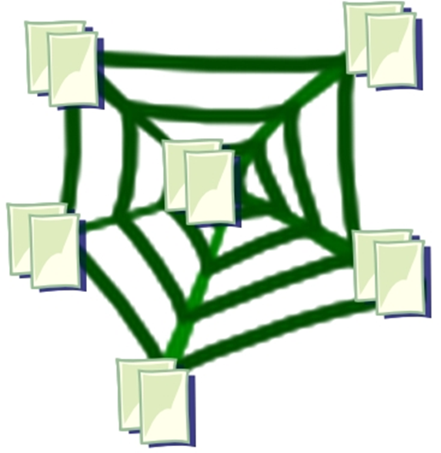

67. Activity title: „Arctic“
Activity type: board game
Purpose:
Development of memory, counting, math skills.
Participants: group of children
Level: 4-7 year old
Materials: Cube of a twelve hexagon and buttons or pebbles of two colors with 15 pieces of each color.
Time: 15-30 minutes
Activity description and instructions, rules, comments:
Children throw a dice in turn and put buttons on the playing field until they close all the circles. If the circles with the drawn amount have ended, the player skips the turn. If it falls on the image of a bear, then you can throw again.
Instructions: The cube of the twelve is printed on thick paper, cut. Cut all the edges with a stationery knife, glue them together.

68. Activity title: „Natural Communities“
Activity type: Didactic game "Who lives nearby?"
Purpose:
To summarize the ideas of children about the forest, meadow, pond as natural communities. Refine ideas about the typical inhabitants of various communities. To consolidate the ability to establish the simplest causal-effect relationships that reveal the need for coexistence of plants and animals
Participants: group of children
Level: 3-7 year old
Materials: Masks (caps) of plants, mushrooms, animals of the forest, meadows, water (for example, wolf, hare, squirrel, woodpecker, spruce, birch, hazel, white mushroom, butterfly, lark, bee, dandelion, chamomile, frog, heron , perch, nugget, reed) - by the number of children; hoops of red, blue, green.
Time: 15-30 minutes
Activity description and instructions, rules, comments:
Instruction: Before the game, the teacher reminds that plants and animals are adapted to life in certain conditions and in close connection with each other; that some live in water, others near water, in a forest, or in a meadow. Forest, meadow, pond - this is their home. There they find their food, raise offspring.
Game description: In different parts of the playground, hoops of red, blue and green are laid out. Children wear masks (caps).
The teacher says: - “Determine who you are and where you live, grow. Some time you will walk around the site. At the command "Take your home!" The inhabitants of the forest should take a place in the green hoop, the inhabitants of the meadow - in red, the inhabitants of the reservoir - in blue. "
After the children take their place in the hoops, the teacher checks whether the task is correctly completed: “animals” and “plants” name themselves and their habitat. Then the children change their masks, the game is repeated several times.
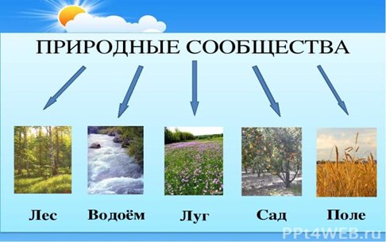

69. Activity title: „The World Around Us“
Activity type: Didactic game "Picture of Nature"
Purpose:
The game expands children's knowledge about wildlife, habitats of living organisms (water, land, air).
Participants: group of children
Level: 6-7 year old
Materials: Volumetric tetrahedral pyramid with the image of water, earth, air; removable icons with pictures of animals, plants, birds, fish, insects
Time: 15-30 minutes
Activity description and instructions, rules, comments:
We offer children to look at the edges of the pyramid and tell what kind of habitat it is. Choose among the picture icons of living creatures that live in each specific environment, place them on the corresponding faces of the pyramid and explain your choice.
Example: “This is the sea. In the sea, live fish, marine mammals, crustaceans, various algae. I will choose a picture with the image of dolphins, I will settle them in the sea, because they are marine mammals. ”
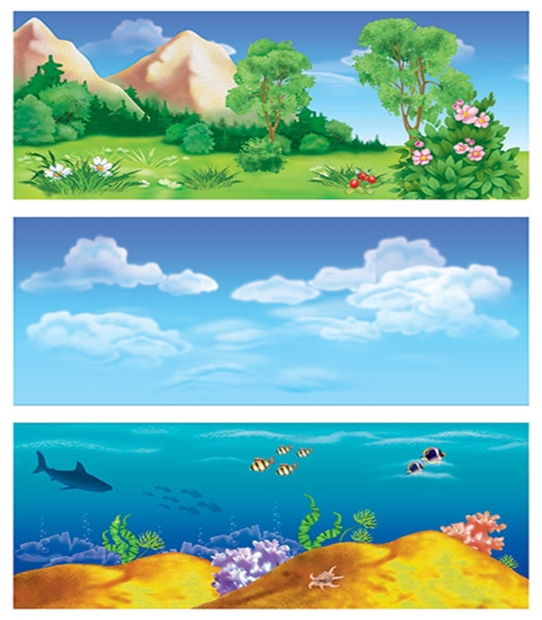
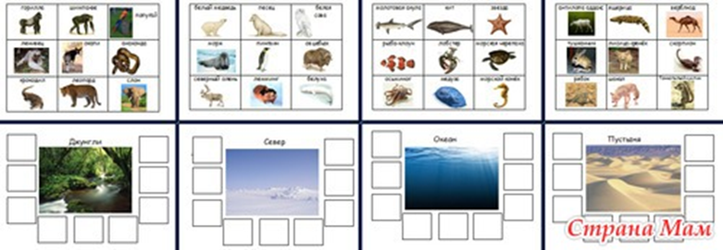

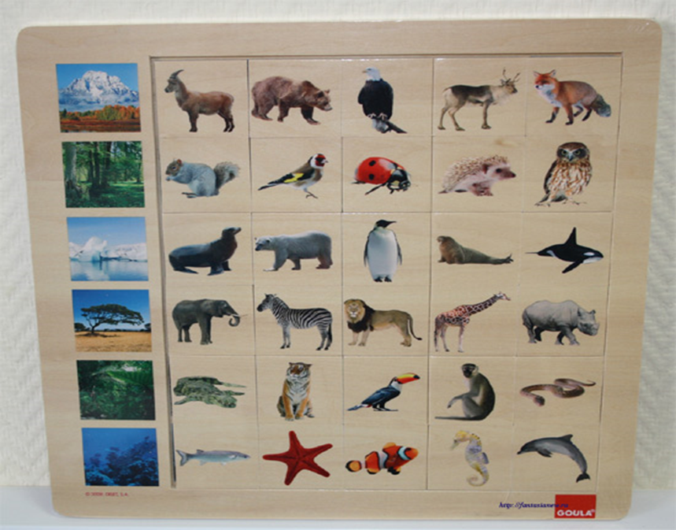

70. Activity title: „ Animal World“
Activity type: Ecological game "Earth, water, air"
Purpose: Development of memory, attention, ability to listen to others.
Participants: group of children
Level: 6-7 year old
Materials: ball
Time: 15-30 minutes
Activity description and instructions, rules, comments:
At the beginning of the game, the driver is chosen, and the remaining players stand in or around the line.
The driver begins to walk in front of the players and touch each hand in turn. At the same time he says: “Water”, “earth”, “air” (in any order). In front of some player he stops. The driver begins to walk in front of the players and touch each hand in turn. At the same time he says: “Water”, “earth”, “air” (in any order). In front of some player he stops.
If the driver stopped on the word "Air", then the player should call the bird or the flying animal. If you stopped on the word "Earth", then you need to call an animal-terrestrial inhabitant. If “Water” is a fish or an animal living in water. Of course, the names should not be repeated. If the player did not name the word before the score "three", or if such a word was already called, then he becomes leading.
Another version of the game. You will need a ball for it. Players become in a circle, and the driver - in its center. The driver throws the ball to the participants, pronouncing one of the words: “Fish,” “bird,” or “beast.” The participant must name the corresponding animal without repeating and throw the ball back. The one who did not say, was mistaken or repeated, leaves the circle. The last remaining becomes the winner. In this version of the game you can do without the driver. In this case, players simply throw the ball to each other.
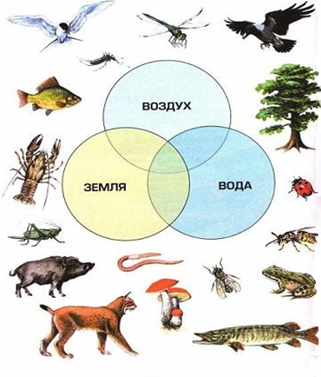
Teacher groups: Natalia Onuchak
Source: https://bosichkom.com/

