6. Activity title: „Crafts from leaves“
Activity type: Lesson
Purpose:
To teach to create plot compositions from natural material - dried leaves, petals;
develop a sense of color and composition, a desire to listen to music;
foster interest and respect for nature;
cause a desire to preserve her beauty in their works.
Participants: group of children
Level: 5-7 year old
Materials: Various dried leaves, petals; background for the base, glue, napkins; samples made by the teacher; recording of the musical works “The Seasons” by P. I. Tchaikovsky, the didactic game “From which tree leaf?”.
Time: 30 minutes
Activity description and instructions, rules, comments:
1. Introduction.
The work “Seasons” (autumn months) by P. I. Tchaikovsky sounds. Before the children on the tables lie a variety of dried-up leaves, seeds, and petals beautiful in color and shape. Children view them.
2. Conversation
Teacher: Let us together with you consider the natural material laid out on the table and listen to the music of P. Tchaikovsky.
Teacher: And now we will be reading poems about autumn leaves (children prepared in advance are prepared to read verses).
Teacher: Children, and now let's look at leaf fallings with you (watching the window or in the illustrations).
3. Didactic game "From which tree leaf?"
Objective: to consolidate the knowledge of children about trees; to learn to find a leaflet by similarity, to select leaves that are sharply distinguished in shape - maple, linden, birch (or other trees common in a given area).
The teacher offers the children to help the trees to collect the leaves, which they have lost. Children look at pictures and pick up leaflets according to the pattern.
4. The practical part.
The teacher explains the sequence of creating pictures from natural material: first you need to imagine a picture, determine who and what will be on it, choose suitable leaves or petals, make an image of them on a separate white sheet, and then paste it on colored cardboard, starting with large parts .

Sounds calm melody.

Children choose their own materials and make up the paintings according to the plan. The teacher helps to determine the color and shape of the sheet of cardboard - the basics.

5. The final part.
The teacher analyzes the finished work and praises children for beautiful and original compositions. Organized by the exhibition of children's works "Museum of unusual paintings"

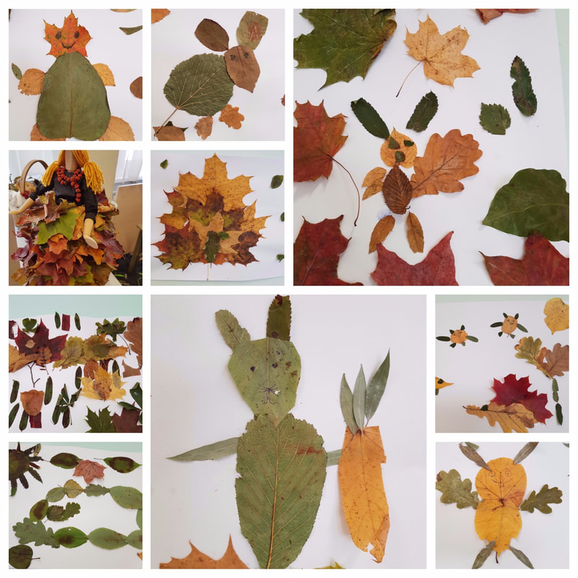
Ene Kruzman
Kindergarten Tareke, Estonia

7. Activity title: „Ecological game - design from autumn leaves.“
Activity type: GAME
Purpose:
Develop the imagination of children.
Instill in children a love of nature.
Participants: group of children
Level: 5-7 year old
Materials: tree leaves and chalk
Time: 15-45 minutes
Activity description and instructions, rules, comments:
The activity was held in the nearest park. The children were divided into 5 teams, each team received a task.
1. Draw an autumn leaf pattern.
2. Draw a hedgehog with a chalk (with the help of a teacher) and paint it with autumn leaves.
3. Draw a chalk mushroom (with the help of a teacher) and paint it with autumn leaves.
4. Make a labyrinth of autumn leaves.
5. Lay out the cake from the autumn leaves.
The guys really tried, that's what they got.
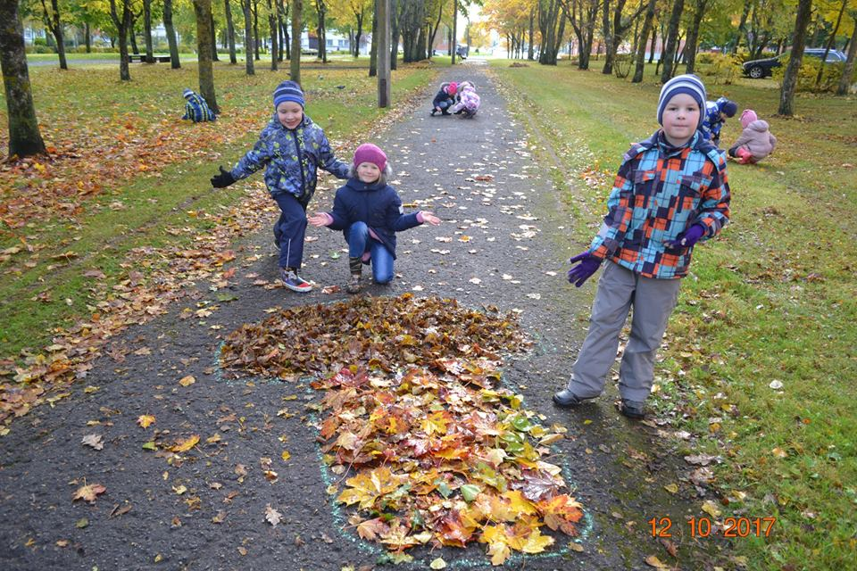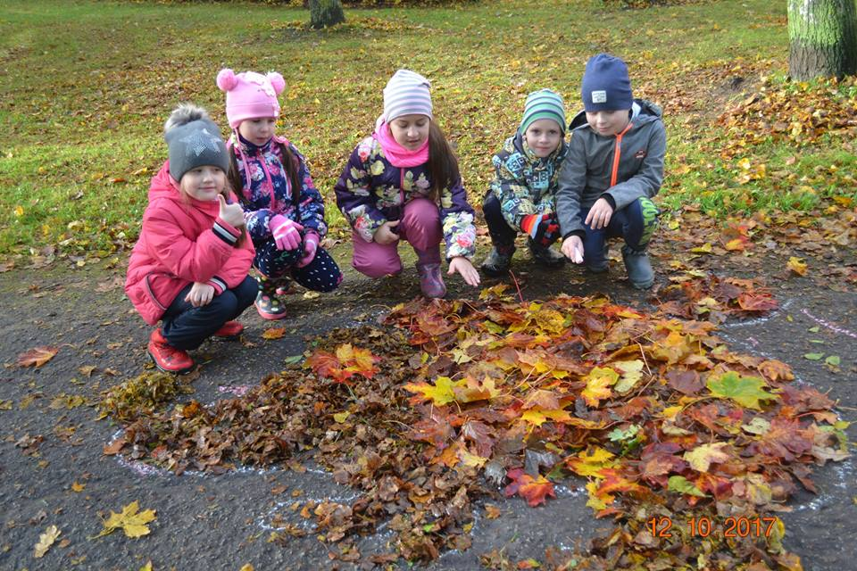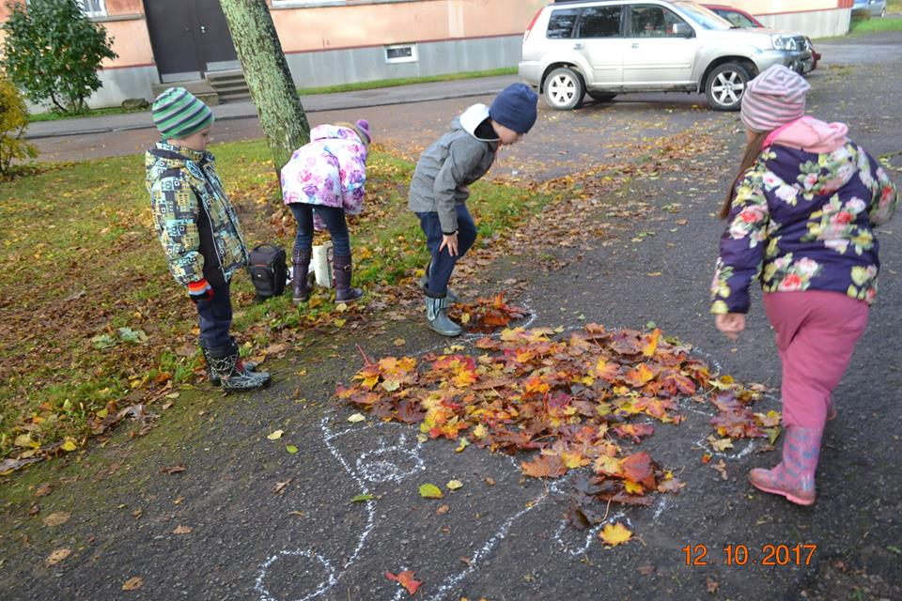
Ene Kruzman
Kindergarten Tareke, Estonia

8. Activity title: „Study of the structure of the leaf.“
Activity type: Lesson
Purpose:
Summarize knowledge of autumnal changes in nature.
Investigate the structure of the leaf, empirically conclude that there is a green substance in the leaves.
During the experiment, show the children the dependence of the flight of the falling leaf on its size and shape.
To consolidate knowledge of familiar trees, the shape of their leaves, the meaning of leaves for a tree.
Improve modeling skills.
Dictionary: petiole, hem.
Improve the ability to navigate in space.
Develop attention, coherent speech, general and fine motor skills.
Cultivate curiosity.
Preliminary work:
On a walk to observe how the leaves fall from the trees.
Collection of leaves of different shapes and colors.
Games "Run to the tree, which I will call," "From whose branch kids."
Participants: group of children
Level: 5-7 year old
Materials:
Loops; pieces of white cloth folded in half; wooden cubes.
Colored pencils, plasticine, equipment for modeling.
Leaves are green and other flowers.
The leaves are large and small, of different shapes.
Cut out of colored paper leaves of different trees.
Boxes with pictures attached to them depicting trees familiar to children.
Sheets of paper with the tasks "Find the Shadow" and "Flight of the leaves."
Sheets of paper green.
Time: 45 minutes
Activity description and instructions, rules, comments:
Teacher: We will conduct an experiment and experiment in order to get answers to questions. In addition, you will find a lot of interesting tasks and games. But first, listen to the story about children like you from another kindergarten.
In one kindergarten the children went out for a walk in the morning. Suddenly a cool breeze blew up, the sun hid behind the clouds. The children shivered and asked:
- What happened
- Nothing special! Just ended the summer! - smiled, said teacher. - It is autumn in the yard.
- And really! - said one boy in frustration. - Autumn is a very sad time of the year. It rains almost every day and a strong wind blows ...
- No, children, - said the teacher, - every season is beautiful in its own way!
Teacher: What do you guys think? Explain why you think so. (If children are at a loss, the educator uses leading questions: "Why is it so pleasant in the fall to walk in the park? What does autumn forest give? Is it bad when adults bring ripe bunches of grapes, watermelons and other goodies from a store or market? birthday in the fall? And although some birds fly away from us to warm lands, other birds fly over to winter with us. What kind of birds are these?)
Autumn is a very beautiful time of the year because the trees change their green outfits to multi-colored. Leaves not only decorate the tree, thanks to the leaves the tree breathes. Let's look at how the sheet works. And in order to get a better look, we will use a magnifying device - a magnifying glass.
Study of the structure of the leaves with a magnifying glass
Teacher: Consider first the scape - this is the part that connects the leaf with the branch. Now consider the top surface of the sheet. You see veins - thin tubes. Who go from the stem on the whole leaf. It absorbs sunlight and is therefore always darker than the underside of the leaf. See for yourself if you flip the sheet and examine its bottom surface. The edge of the sheet is called the "edge." Consider the edge of the sheet. The top of the leaf is sharp or rounded. Look at and tell me what your leaf is like.
Dynamic pause "We are autumn leaves"
We are autumn leaves,
We sat on the branches,
(Smoothly wiggle his hands above the head.)
The wind blew - flew,
We flew, we flew
(Hands to the sides, swinging smooth movements, running.)
And they sat quietly on the ground.
(Slowly squat down.)
The wind came running again
And the leaves are all picked up.
(Stand up, arms to the side.)
Spun, flew
(Running with smooth swinging movements.)
And they sat down again on the ground,
(Sit down.)
Teacher: Why are the leaves turning yellow in the fall? The fact is that the leaves are green due to the green substance. We will conduct an experiment and see this substance.

Experience "Why is the leaf green?"
Teacher: Take a piece of paper and put it inside a piece of white cloth bent in half. Now with a wooden cube, tap the leaf strongly through the fabric. What did you discover during the course of the experiment? Green spots appeared on the fabric. It is a green substance from a leaflet and colors it green. (For this experience it is better to take the juicy leaves of indoor plants).
Teacher: When autumn comes and it gets colder and less sunny. This green substance gradually decreases until it disappears completely. Then the leaf turns yellow or ... what color are the leaves of the trees in the fall? Orange, red, brown.

Teacher: But back to our story.
All that you told about autumn, their teacher explained to the children. And the children agreed with her that autumn is really not so bad. Meanwhile, a strong gust of wind in the yard swept and lifted dust and fallen leaves into the air.

- Here you go! said the stubborn boy. - I told you.
And when the wind calmed down, he exclaimed:
- See from this tree circled almost all the leaves.

Experiment "How the leaves fall"

Teacher: On walks, you noticed that the leaves fall from the trees in different ways. Let's conduct an experiment in order to find out which leaves fall quickly and which slowly, and which leaf is the prettiest to spin.
To do this, take the sheet in hand and stand up. Raise your hand with a leaf up and release the leaf from your fingers. While the leaf is flying, carefully watch its flight and remember: did it quickly or slowly fall, fly straight down or spin?

What conclusions can be drawn from this experiment? Large leaves fall more slowly and almost do not spin. Small leaves fall faster and spin more.

Didactic graphic exercise "Flight leaflet"

Take the pencils and circle the dotted lines representing the path of the leaves from the tree to the ground. You can color the leaves with colored pencils.

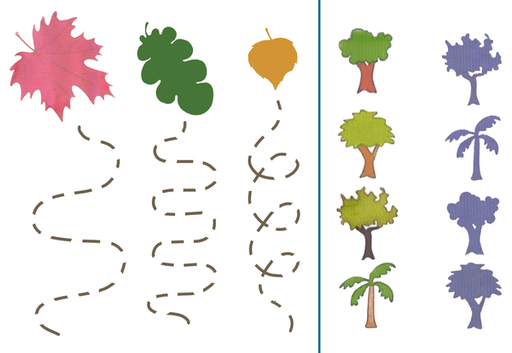

Teacher: Now listen to what happened next in our story.
- Oh oh oh! - the boy sighed. - And how poor trees will be without leaves, completely bare to escape from the cold. Maybe we can somehow help them?
And they came up with the children to attach the leaves to the tree with glue or adhesive tape. But first they had to determine from which tree a leaf came off.
Are you able to determine from which tree a leaf? Now check.

Dynamic pause "From which tree leaf"

Fallen leaves are scattered on the carpet. The boxes show familiar trees. Run to the carpet, collect the leaves and put them in the box, which shows exactly the tree from which this leaf has flown. (The teacher specifies how many different leaves each child can take to be enough for everyone)
“See how many leaves are fallen,” one girl remarked. “How much time do we need to attach all the leaves?”
“Don't waste your time,” the teacher told the children. - After all, the glued leaves will not help the trees to warm up. Moreover, trees are not at all afraid of the cold. But you can help them. Want to know how?
- Of course we want! - the children were delighted.
- Take a rake and collect dry foliage in a pile around a tree trunk. Over the winter, the foliage will rot and become fertilizer for the tree. In the spring, before the flowering of the tree, fertilizer will be handy.
The kids did just that. And then they wished the trees to winter well.

Teacher: Why don't we help our trees? Moreover, we have a rake. Let's take this for a walk, and now we still have a lot of interesting tasks.

Didactic exercise "Wind and leaf"

Before you are green sheets of paper depicting the earth with grass. Take a yellow sheet and lift it over a green sheet of paper. Now listen carefully and follow:
Slowly drop the sheet into the very center of the green sheet of paper.
A breeze blew and the sheet flew to the left.
Again a breeze blew and brought the leaf to the right.
The wind swirled the leaf in a circle.
The wind moved the leaf in the upper right corner.
And now the leaf flew to the bottom left corner.
The leaflet was again transferred to the center.
Blow off the leaf with a strong exhalation, without puffing up the cheeks.

Didactic exercise "Find the shadow of the leaf”

Before you painted colored leaves and their shadows. Your task: to find the shadow of each leaf and connect the line of the leaf and its shadow.

Finger gymnastics "Autumn"
Autumn, autumn, (Three palms together)
Come on! (We tighten the fists in turn)
Autumn, autumn, (Three palms together)
Look! (Palms on cheeks)
Yellow leaves whirl, (Smooth movement with palms)
Quietly go to the ground. (Palms stroking his knees)
The sun no longer warms us, (Squeeze and unclench fists in turn)
The wind is blowing ever stronger (Synchronously tilt hands in different directions)
Birds flew to the south, ("Bird" of two crossed hands)
The rain knocks on our window. (Drum your fingers on one, then on the other hand)
Hats, jackets put on (Imitate)
And shoes shod (Stamping feet)
We know the months: (Palms banging on knees)
September, and October, and November. (Fist, rib, palm)

Sculpting bas-relief "Autumn Tree"

Teacher: To make a tree, we need to take a piece of plasticine brown. Divide this piece in half. From one half by straight motions we roll a thick sausage. It will be a tree trunk. But the top of the tree is always thinner than the whole trunk, so put your finger on one side of the sausage and slightly roll it out, too, with direct movements.

Teacher: Now attach the resulting trunk to a piece of cardboard. Notice that the top is blue and the bottom is green. Guess why? Top of the sky below the grass. Apply a tree trunk so that it does not hang in the sky. And growing out of the ground with grass. Apply with a slight pressure with your fingers to plasticine stuck to the cardboard.

Teacher: From the rest of the brown clay, tear off the pieces, roll the sausages from them thinner and attach to the trunk of the tree.

Teacher: The tree is ready, let's take the leaves. You have more pieces of clay. What color are they? Green, yellow, orange. Pinch off small pieces of them and attach to the branches of the tree by pressing. (In the course of the work of children, the tutor ensures that the leaves do not cling to the trunk, encourages manifestations of creativity, such as leaflets falling on the ground or flying).
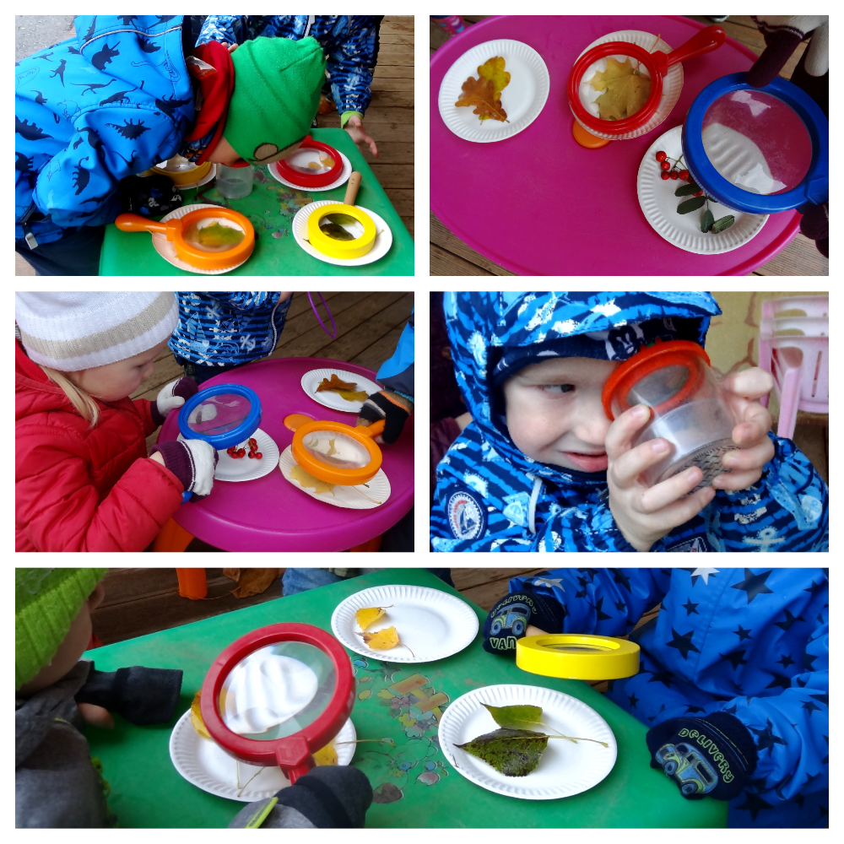
Ene Kruzman
Kindergarten Tareke, Estonia

9. Activity title: „Study of the cause of leaf fall.
Activity type: Lesson
Purpose:
Expand children's knowledge about the phenomena of animate and inanimate nature: why the leaves turn yellow and fall off. Learn to establish cause and effect relationships.
To fix the ability to use generalizing words in speech: vegetables, fruits, berries, mushrooms. Learn to use common, complex sentences in speech when answering questions; select words that answer the question, distinguish between them: which one, which one? what are they doing? Expand the dictionary with verbs, adjectives. To activate the dictionary: leaf fall, juice flow, layout.
Develop attention, mental operations.
To consolidate the ability to create a collective work, using printing autumn leaves. To cultivate aesthetic feelings.
Participants: group of children
Level: 3-7 year old
Materials: A model of a tree, autumn leaves, the painting “Autumn”, drawing paper, dried leaves, paints, brushes, napkins, glasses with juice, cocktail tubes.
Time: 45 minutes
Activity description and instructions, rules, comments:
Children consider autumn leaves (birch, poplar, maple). What time of year do these leaves resemble? What signs of autumn do you know?

Guess the riddle. What is the time of year called?
If the leaves are yellow in the trees,
If the distant birds flew to the land,
If the sky is frowning, if it is raining,
This time of year ... in the fall is called.

Tell me and start the answer with the word "Autumn." And this picture will help you.

In autumn, the leaves turn yellow and fall.
Autumn is cold outside.
In the fall, they collect vegetables in their dachas: they dig potatoes, pick carrots, beets, cabbage, tomatoes, cucumbers.
In the autumn at the cottages they pick berries: raspberries, currants, strawberries.
In the autumn, mushrooms and berries are gathered in the forest.
In the autumn a cold wind blows.
It is cold in the fall.
In autumn, birds fly to warm lands.
In autumn, beetles, worms, spiders hid in the ground.
In the fall, the bear prepares his lair and goes to bed.
In autumn, the day is short and the night is long.
In the fall, wheat is harvested in the fields from which bread is made.
In the autumn the sun shines, but does not warm.

Teacher: You have already said that in the fall the leaves turn yellow and fall on the trees. And why leaves turn yellow and fall? (Because it became cold. Because the trees do not have enough power).
Teacher: And how do they eat: eat porridge, soup? (The roots suck in (drink, take out) water: water in the trunk, branches, goes to the leaves).
Teacher: Why do they need food? (Because trees are a living nature: they feed and grow).
Teacher: Why do you eat, drink? (To grow, live, be healthy).
Teacher: I suggest you drink the juice of these tubes.
Teacher: What did you do to get the juice in your mouth? (sucked, pulled in, sucked, pulled).
Teacher: And the trees also suck water from the ground with their roots.
Teacher: What is this? (Layout tree).
Teacher: What tree? Autumn tree (rare yellow leaves).
Teacher: Let's pretend we got inside the tree (trunk).
Teacher: What do you see? (tubules) And in the tree there are invisible veins, through which water flows along the trunk to the sprigs, along the twigs to the leaves. And with the onset of cold weather, the movement of water (sap flow) slows down, stops. Nutrition leaves are not enough and they turn yellow, die. Sprigs hard to keep them, so the tree and sheds leaves.
Teacher: What is the name of the phenomenon of nature when the leaves fall from the tree? (Falling leaves.)
Teacher: Let's imagine that we are autumn leaves, how beautiful they are, how beautiful they are falling, spinning.

Musical pause

We are leaves, we are leaves,

we are autumn leaves.
We sat on a branch.
Blew the wind, flew.
We flew, we flew,
All the leaves are so tired.
The wind stopped blowing
And we sat down in a circle.
The wind suddenly blew again
And the leaves from the branches blew away.
All the leaves flew
And they sat quietly on the ground.

We will pick up words, answering questions.

Teacher: What do the leaves do? (fall, fall, fly, lie down, rustle, rustle, crunch, turn yellow, redden, dry, perish).
Teacher: What leaves? (beautiful, dry, yellow, red, purple, orange, gold, multi-colored, brown, green, light, purple)
Teacher: Autumn is what? (beautiful, early, late, warm, cold, rainy, windy, gloomy, overcast, golden, multi-colored, bright, rich, fruitful, generous).

Teacher: Help me finish the sentences by proving my answer.
1. Today I will not go for a walk ... because it is cold rain outside.
2. Trees, flowers are wildlife ... because they feed and grow.
3. Autumn is called generous, fruitful ... because in the fall they harvest vegetables, fruits, berries, mushrooms (wheat is harvested in the fields).
4. It is very beautiful in early autumn ... because there are colorful leaves on the trees: yellow, red, green.

Teacher: Let's remember how beautiful fall is and draw a bright autumn landscape (go to the table with colors).

Collective unconventional drawing "Autumn Landscape"

When drawing music sounds (children read poetry).

On the street, children build a maze of leaves.
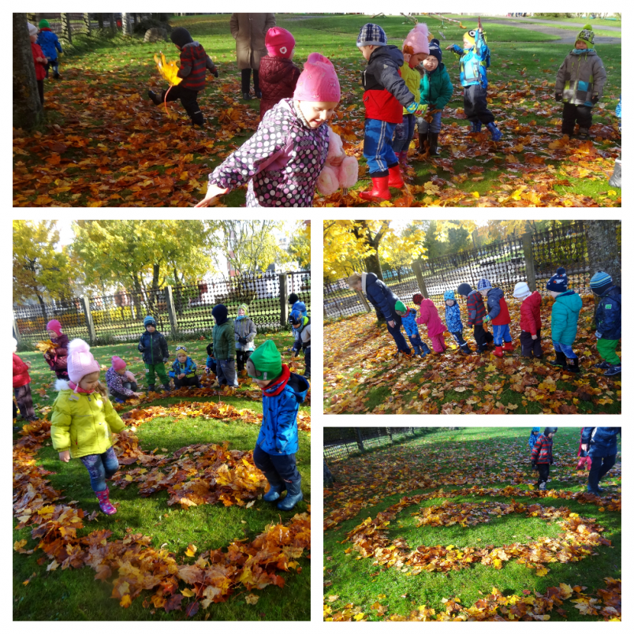
Ene Kruzman
Kindergarten Tareke, Estonia

10. Activity title: „Drawing with leaves“
Activity type: Art
Purpose:
Children can draw the leaves of trees in an easy way.
Participants: group of children
Level: 5-7 year old
Materials:
leaves, not dry, with pronounced veins, sheets for drawing, pencils
Time: 15-30 minutes
Activity description and instructions, rules, comments:
We collect beautiful leaves, not dry, with pronounced veins.

We put a sheet of veins up under a clean sheet and with the back of a pencil, without pressing, we drive on the paper above the sheet, we get the outline of a leaf, then we trace the veins more clearly.

For drawing leaves we use autumn colors, all shades of yellow, red and orange.
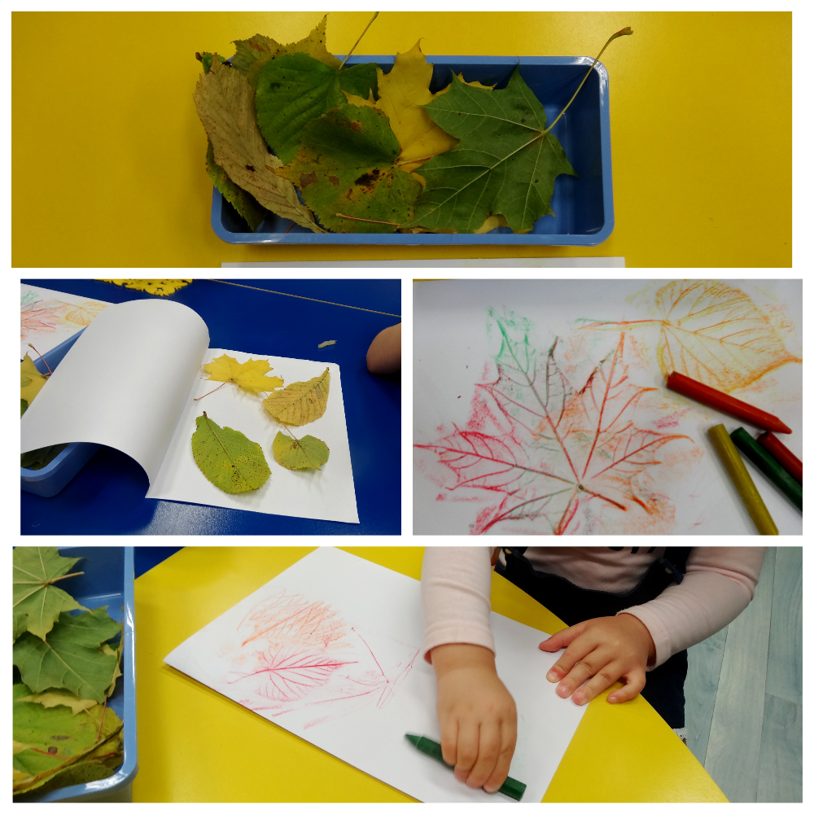

Ene Kruzman
Kindergarten Tareke, Estonia

