41. Activity title: „Summer“
Activity type: games and exercises
Purpose:
Expand children's knowledge about summer.
Enrich the vocabulary of children on the topic.
To form sustainable ideas about the size, quantity, color, geometric shapes.
Continue to teach children to denote by the number of objects, to determine the position of the object in space.
Exercise in sculpting sculptural and bas-relief, sticking, drawing with fingers, stamps and pencils.
Develop the ability to repeat movements for the teacher.
Develop thinking, motility, visual and auditory focusing, coordination of movements.
Participants: group of children
Level: 2-4 year old
Materials:
Pencils in black, picture-blank with the image of the train on the rails without sleepers, gluing pencils, colorful silhouette pictures "flower", "strawberry", "pear", "cucumber", "mushroom", "hare".
The picture-background with the image of flowers of different colors, the center of the cork plastic of the same colors.
Picture-blank "sunflower", black plasticine, sunflower seeds.
Cardboard "pies" - folded in half triangles made of cardboard of different sizes, "strawberries" of different sizes.
Colored silhouette pictures of vegetables and fruits, picture background with painted boxes in the form of geometric shapes.
Finger paints of yellow and red color, picture preparation "apple".
Stamps "apple", red gouache, pictures-blanks "apple".
Clothespins, rope, colored silhouette pictures with the image of mushrooms.
White plasticine, blank image "mushroom" without white spots on the hat.
The picture with the image of four mushrooms, among which three are the same, and one is different from the others.
Picture-background with the image of the legs of mushrooms of different sizes, cut out of colored cardboard of the appropriate size of the cap of mushrooms, leaves, snails.
Flat shells, glass, glue, picture-blank "On the seashore."
Picture-background with the image of three bears of different size, cut out of colored cardboard inflatable circles corresponding to the size of the bears.
Sand tank, in which a variety of pebbles are buried.
Audio recording: “This is how it is - our summer!”
"Time: 15-30 minutes
Activity description and instructions, rules, comments:
Game greeting "Our smart heads"
Hello guys, how nice it is that you all came today!
Our smart heads
They will think a lot, deftly.
Ears will listen,
Mouth to speak clearly.
The handles will clap,
Feet will stomp.
Backrest straightened
Smile at each other.

Reading a poem - Train "The Gifts of Summer"
Like a train speeding summer
All tickets sold out -
Summer train goes to us
In the fields and forests.
The locomotive is buzzing loudly -
Hare gray sitting in it.
He is not a clown, not an artist -
He is an eared machinist!

Drawing "Summer train"
- Draw with black pencil sleepers - short vertical stripes and smoke from the pipe of the locomotive - curls.

Number one, I know for sure
In the train car floral!
"The path until the autumn is far!" -
He says to all cornflower.
And nods his head
Field bell,
And the sunflower looks into the distance -
He is watching the sun!
Let it be small, but still
He looks like the sun!
Didactic game "Pick up a flower in the middle"
- Pick each flower center in exactly the same color as the petals.
Manual labor "Sunflower"
- Let's make a sunflower like a real one: we put black clay in the middle, and put sunflower seeds on top of the black clay.

And in car number two
Not flowers or grass -
The berries in it are notable,
Very fragrant.
Strawberry and raspberry
Ran away from the basket -
They do not want to divide
And in the jam to get to us!
Didactic game "Strawberry Pies"
- Before you pies. Show the biggest pie, medium, smallest. Now you need to put the stuffing in the pies - strawberries. Just be careful, in the largest pie put the biggest berries, in the middle pie - medium berries, in a small pie - small berries.

Carriage number three
Only vegetables inside!
Carrot says: "Guys,
Better not have our beds! ”
Immediately with her entered into an argument
Cucumber and tomato.
Didactic game "Spread out vegetables and fruits in boxes"
- Spread fruits and vegetables in boxes of suitable shape.

Modeling "Salad of cucumbers and tomatoes"
Children make cucumber by direct rolling out of green plasticine, and tomatoes are made by circular rolling out of red plasticine. Then cut the fashioned vegetables into pieces and put on a plate. Sprinkle with greens on top - torn into small pieces with a napkin of green color.

And in the fourth to our gardens
Ripe fruits are coming!
Apple scares the pear,
That they want to eat it all.
Pear is very timid,
And over her laugh plum.

Didactic game "Count the fruit in vases"
- Count the fruits in the basics and mark them with a number.

Drawing stamps "Apple"
- Dip stamps in the paint and leave prints on the tree.

Drawing paints "Apple bulk"
- Look at this apple. He has one flank yellow and the other red. Let's draw the exact same apple with yellow and red barrels.

Dynamic pause "Here it is, our summer"
Children take mats under the song of the same name, lay on them on their stomachs, wave their legs, then with their hands, turn over on their side, then on their backs, raise their legs and arms. They get up, run around with circular movements of the hands in front of the chest - they “float”.

And in the mushroom car - the fifth
Go to the summer forest mushrooms.
And dreaming for a day
Before all take a stump.
The white mushroom asked the chanterelle:
"Where are you growing, sis?"
"I grow in the grass,
In other matters, where you are! ”

Didactic game "Pick up hats for mushrooms"
- Pick each mushroom hat, suitable for size. and put a piece of paper on top of the cap. And below the mushrooms, plant snails.

Sculpture bas-relief "Poisonous mushroom mushroom"
- Make a poisonous mushroom amanita white dots of plasticine.

Didactic exercise "Find a mushroom unlike the others"
- Show a mushroom that is not like all other mushrooms.

Exercise "Spread mushrooms for drying"
Children hang "mushrooms" on the rope, using clothespins.

From dusk to dawn
Rushing train through the summer.
Train sings a song
And gives gifts!

Application "Summer train"
- In the train sits eared engineer - glue the hare on the engine. In the first carriage, a flower travels, in the second, a fagot, in the third, a cucumber, in the fourth, a pear, and in the fifth, a mushroom.

Sculpture "On the seashore"
The children tear pieces of plasticine, stick them to the background image and put them on top, pressing flat shells and pieces of glass pieces trimmed with sea water.

Didactic game "Give the bears inflatable circles"
- The bears decided to swim in the warm sea, give them inflatable circles for swimming. Pick up the circles on the size.

Didactic exercise "Find the pebbles in the sand"
- Try to find in the sand various beautiful pebbles.

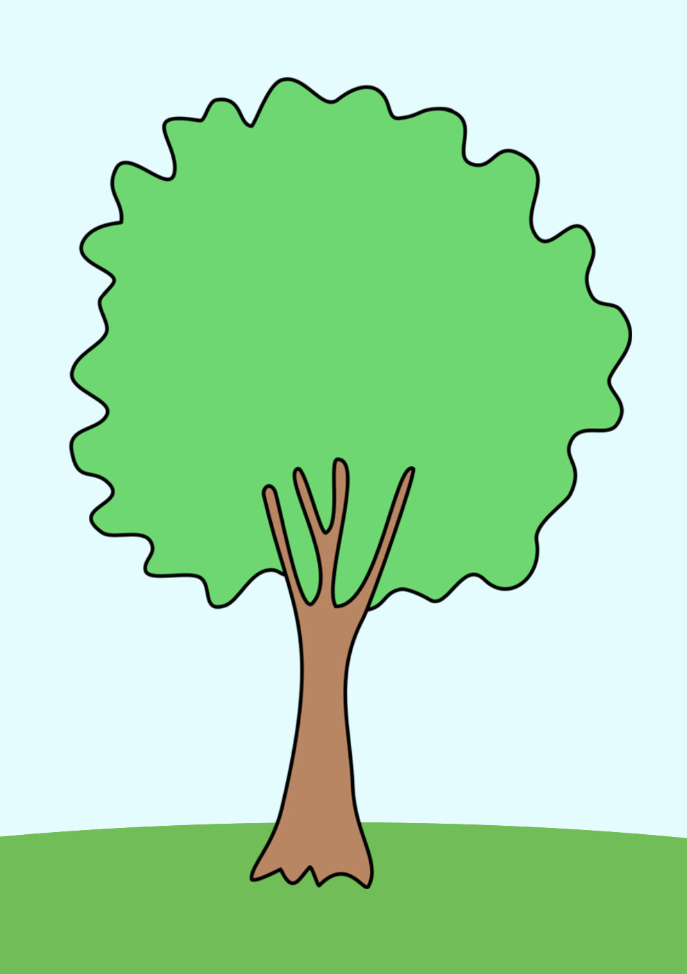

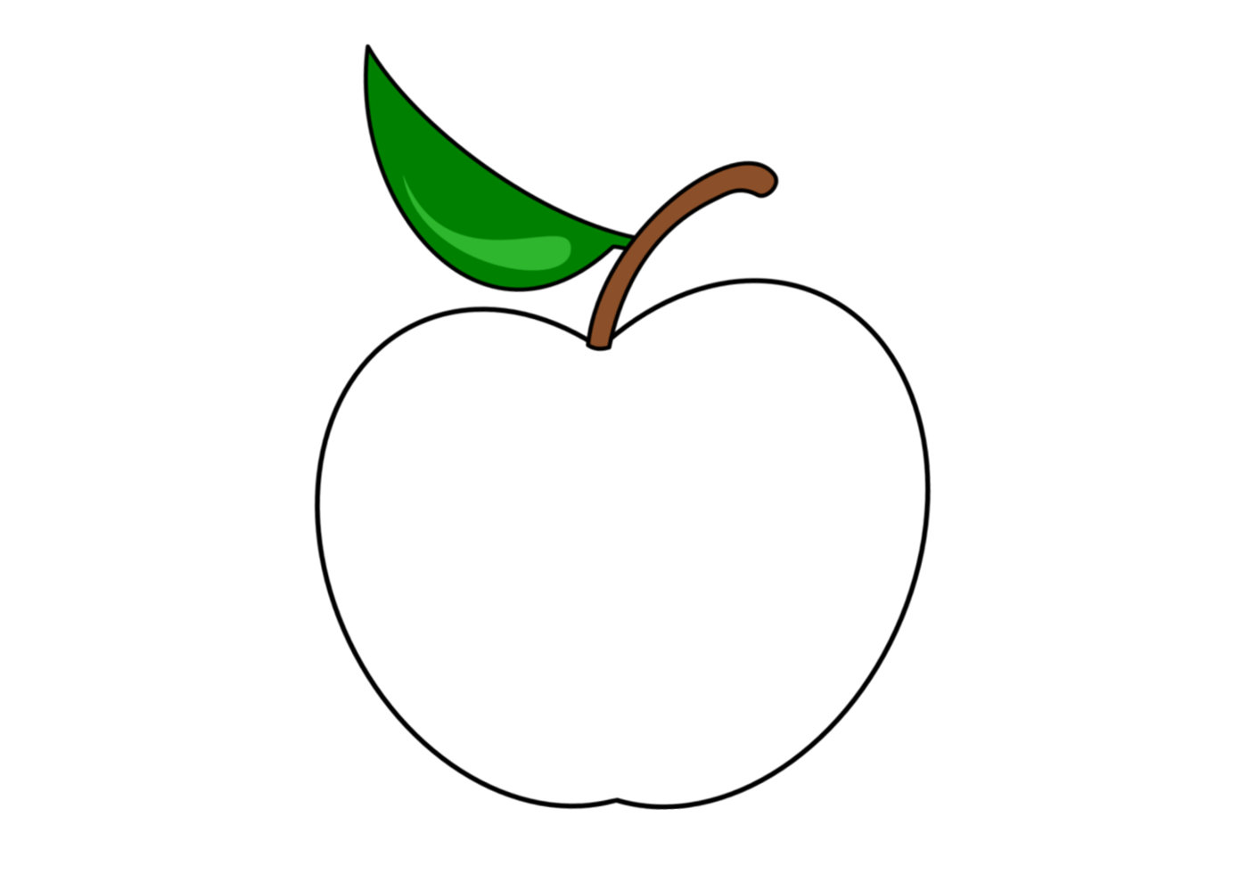
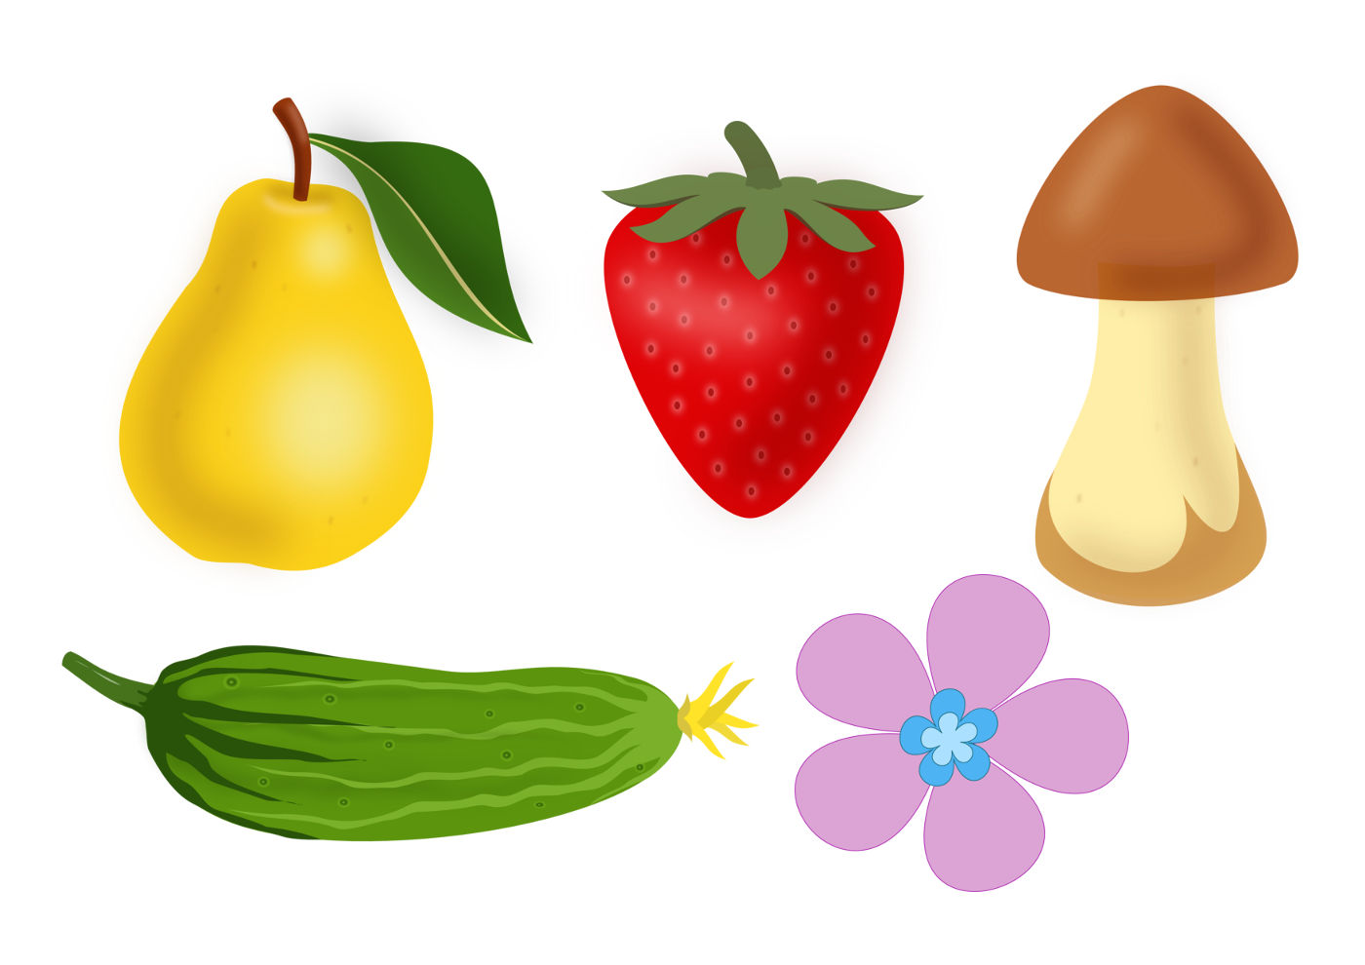
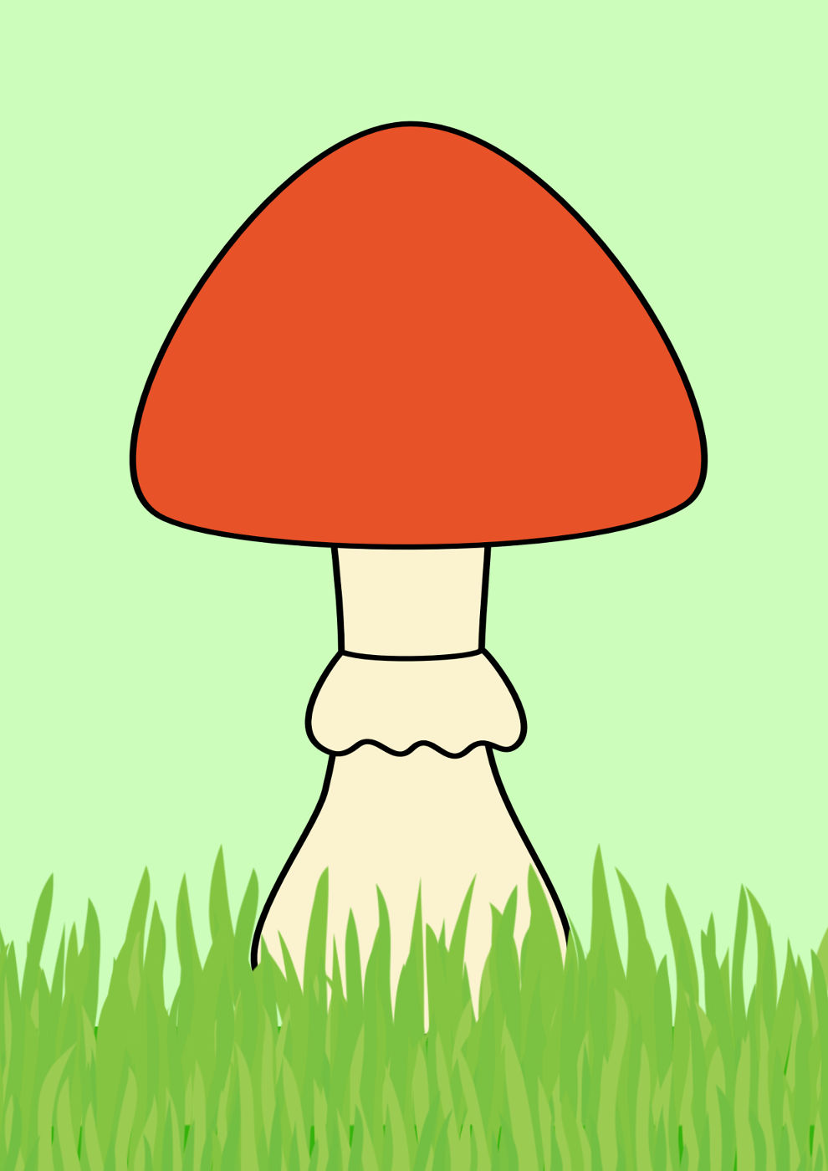
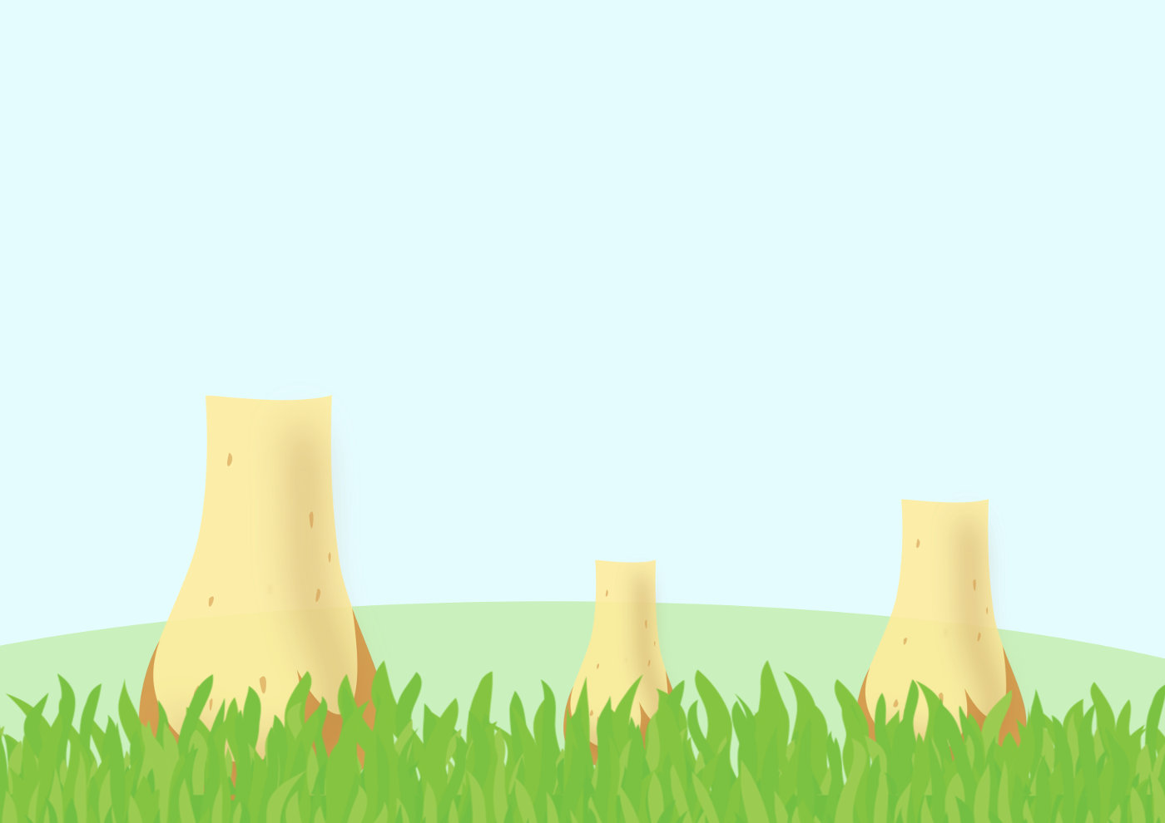
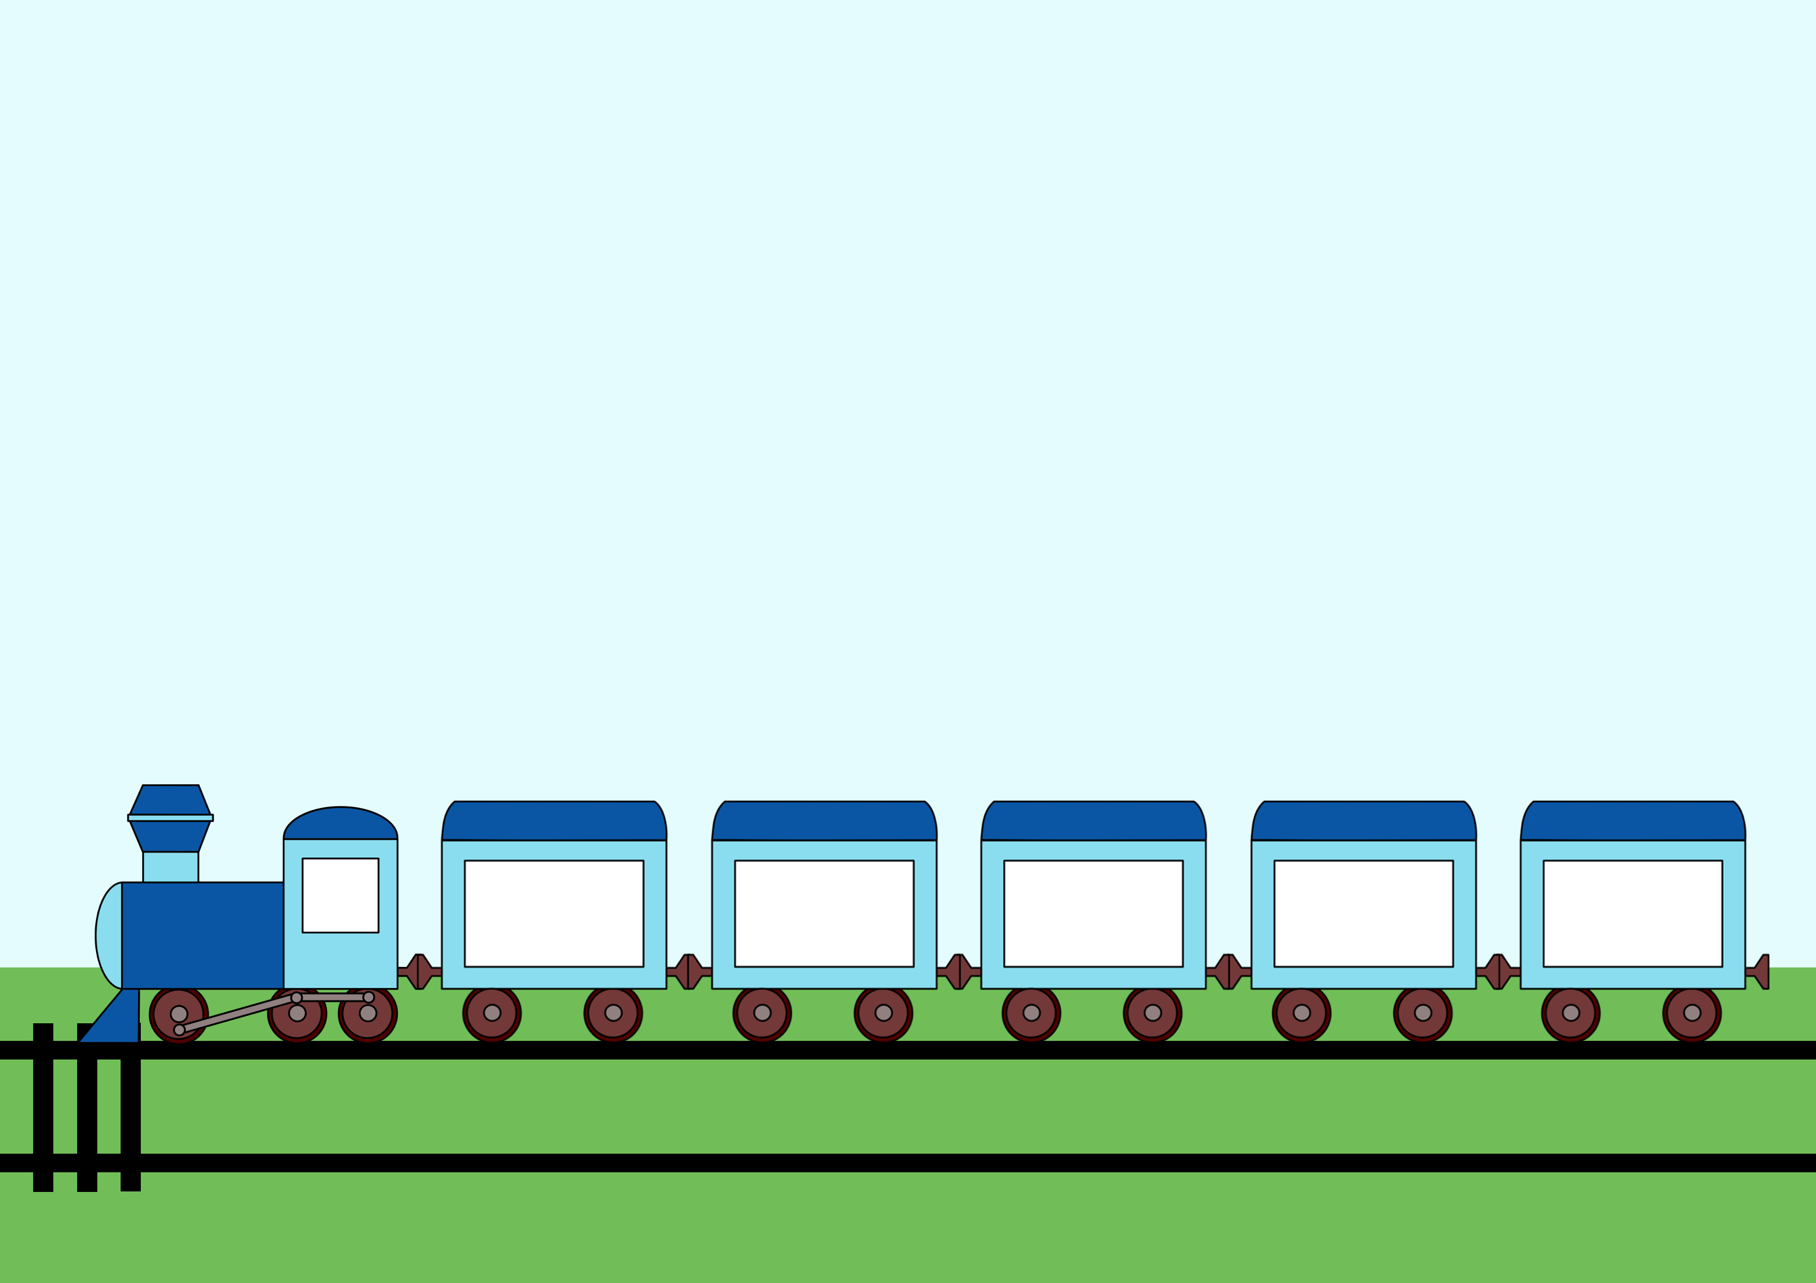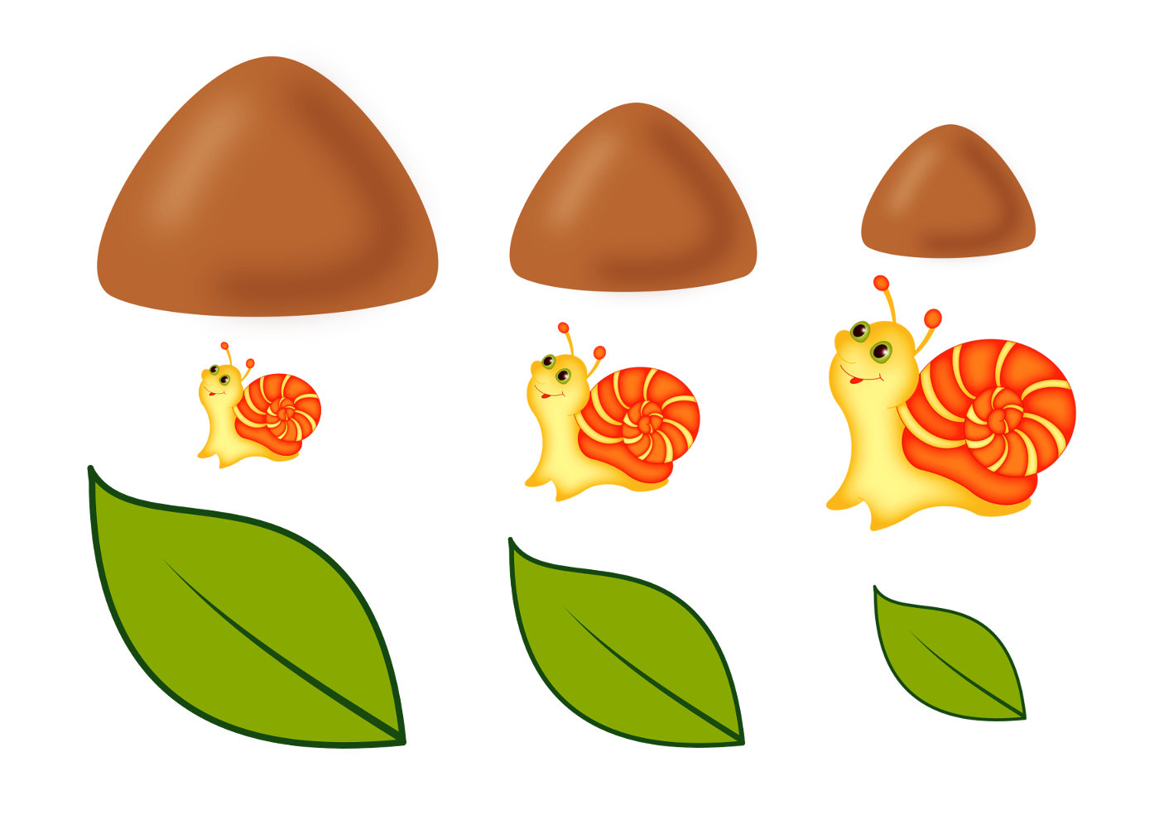

Kindergarten Tareke, Estonia

42. Activity title: „FOREST“
Activity type: games and exercises
Purpose:
Expand children's knowledge about the forest and its inhabitants.
Enrich the vocabulary of children on this topic.
To acquaint children with the concepts of "dark" and "light."
Continue to teach children to listen to a piece of music.
To form sustainable ideas about color, shape, geometric shapes, quantity, size, position in space.
Teach children to perform collective work without interfering with their comrades.
Improve the skills of modeling, non-traditional drawing (with fingers and toothbrushes).
Exercise in neat sticking details of the image.
To develop visual and auditory concentration, thinking, fine and general motor skills.
Participants: group of children
Level: 2-4 year old
Materials:
The image-background with the image of the forest edge with the geometrical figures of green and brown colors inscribed in the image.
Squares of dark green and light green colors.
The image of a tree without leaves on a large sheet of paper; Flexic: leaves are light and dark green.
Picture-background with the image of a tree with shadows, geometric shapes, color images of owls in the form of these geometric shapes.
The picture with the image of three trees and one mushroom.
Preparation for drawing "willow", green gouache, toothbrushes.
Picture-background with the image of the forest (high and low tree, spruce, two clouds, stump, lake, three lilies), silhouette pictures (bird, 2 mushrooms. 3 flowers, snake, frog, sun, duck).
Game "Who lives in the forest": picture-background "forest", colored silhouette pictures of animals.
Game “Whose tail?”: A picture of animals without tails, colored silhouette tails of these animals.
A picture of trees with hollows of three sizes, silhouette images of squirrels, leaves, and acorns of three corresponding sizes.
Picture-blank with the image of a bush, brown plasticine.
Hazelnuts. Cones, basket, saucer from dollware.
Picture-background for appliqués, treetops, cut from colored paper, glue, finger paints.
Equipment for dynamic pause: hemp, artificial Christmas tree, bench, "trickle".
Audio recordings: “Morning in the forest” by E. Grieg, “In the forest” by Zheleznova, “Noise of the forest” by Ferens List.
Time: 15-30 minutes
Activity description and instructions, rules, comments:
Greeting "Our smart heads"
Hello guys, how nice it is that you all came today!
Our smart heads
They will think a lot, deftly.
Ears will listen,
Mouth to speak clearly.
The handles will clap,
Feet will stomp.
Backrest straightened
Smile at each other.

Game situation "Going to the forest"
Today we go for a walk in the forest. Let's build a bus out of chairs and hit the road. (Under the "Song of Friends")

Edward Grieg's Listening to Morning in the Forest

Construction "On the edge of the forest"
Put the geometric shapes in their places. Show a narrow path, a wide path. What color is the circle, oval and triangle? Green color. What color is a square and a rectangle? Brown color.

Acquaintance with shades of green.
Squares in front of you. What color are they? Green. And this color is green and that color is green, but they are different. This green is light, and this green is dark.
Show light green color, dark green color.

Collective application "Tree"
Now we stick light green and dark green leaves on this tree.

Didactic game "Owls on the tree"
Sow owls on the tree. Plant each owl on its shadow, which is suitable in shape.

Didactic exercise "What is superfluous?"
Look carefully at the picture and tell me what's wrong with it? Excess mushroom because everyone else is trees.

Drawing a toothbrush "Willow"
At the willow tree twigs down, draw green branches with leaves. To draw, use toothbrushes.

Musical exercise "In the forest"
Children go around the room under the words of the song "In the Forest" by Zheleznova. Then utter "ay."

Didactic game "In the forest"
Children lay out small colored silhouette images on the image-background.
Here is a picture of a forest. Let's add this beautiful picture.
Let a bird sit on the highest tree. And under a low tree will grow two mushrooms.
And around the hemp bloom three flowers. On the stump climbed a snake. On the tree grew cones. In the sky the sun shines brightly. A frog is sitting near the lake, and a duck is swimming along the lake. Count how many water lilies bloomed in the lake? How many clouds are in the sky?

Didactic game "Who lives in the forest"
Let's lay out the picture of the inhabitants of the forest and call each of them.

Didactic game "Squirrels"
Help each squirrel find its hollow. Treat the squirrel with an acorn. Pick a hollow and an acorn in the size of each protein. Now try to guess from which tree these leaves fell.

Sculpture "Nut Bush"
On the nut bush ripened nuts. Let's make them out of clay. What color is plasticine? Brown color. Tear off pieces of clay, roll the balls-nuts from them, apply to the bush and press down with your finger.

Dynamic pause "Walk through the forest"
Children walk along the stumps, go around the Christmas tree, jump over a streamlet, walk along the bench. (An audio recording of “The Noise of the Forest” by Ferens Liszt is being played)

Didactic exercise "Whose tail?"
Help the beasts find their tails.

Graphic activity "Forest"
Attach foliage to tree trunks. Here are some trees in the forest! Stick them. And the leaves on the birch draw with your finger.

Games with cones
Count the cones, throw the cone in the basket, do not drop the cone (carry it on the saucer).

Hazelnut tasting.
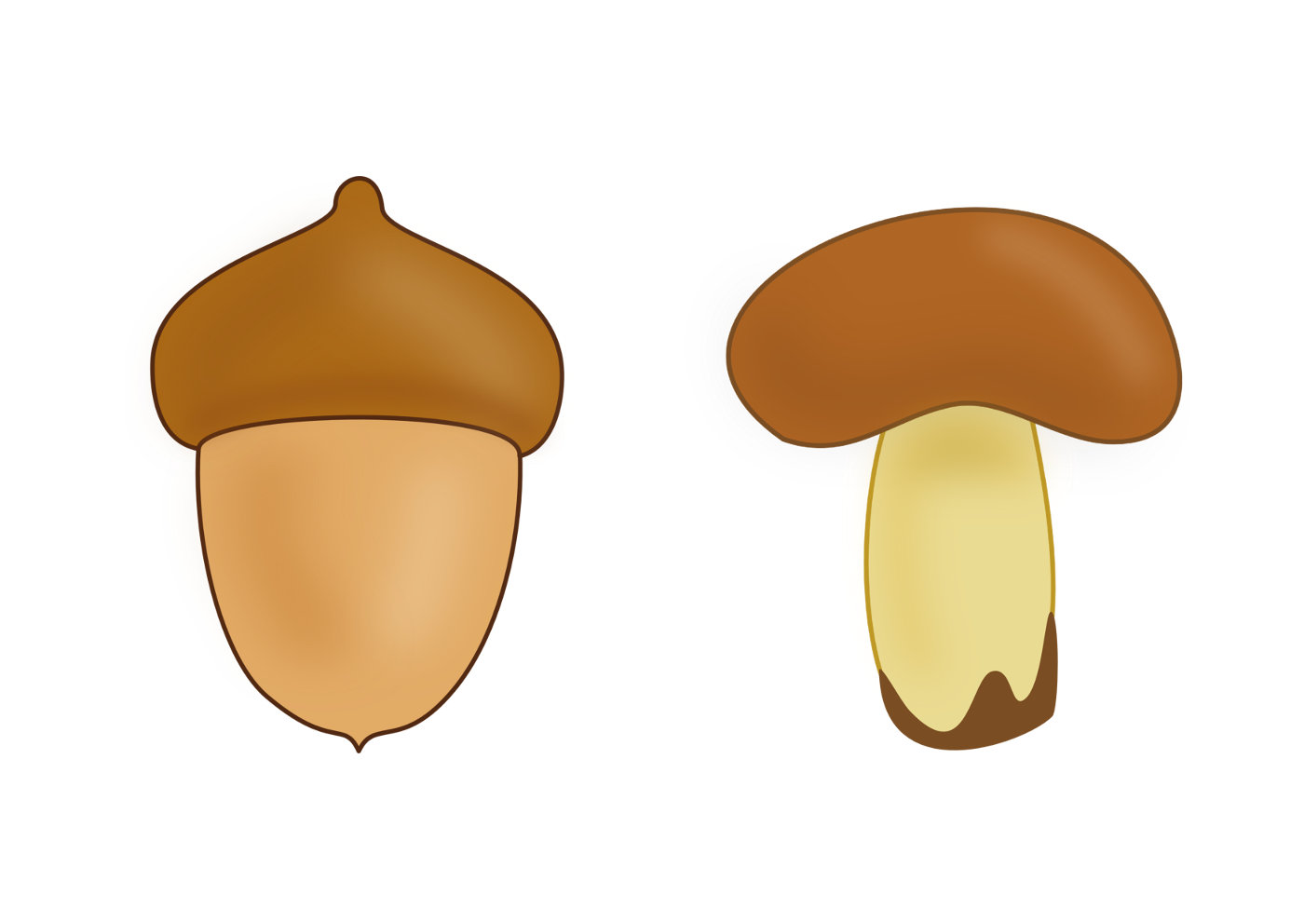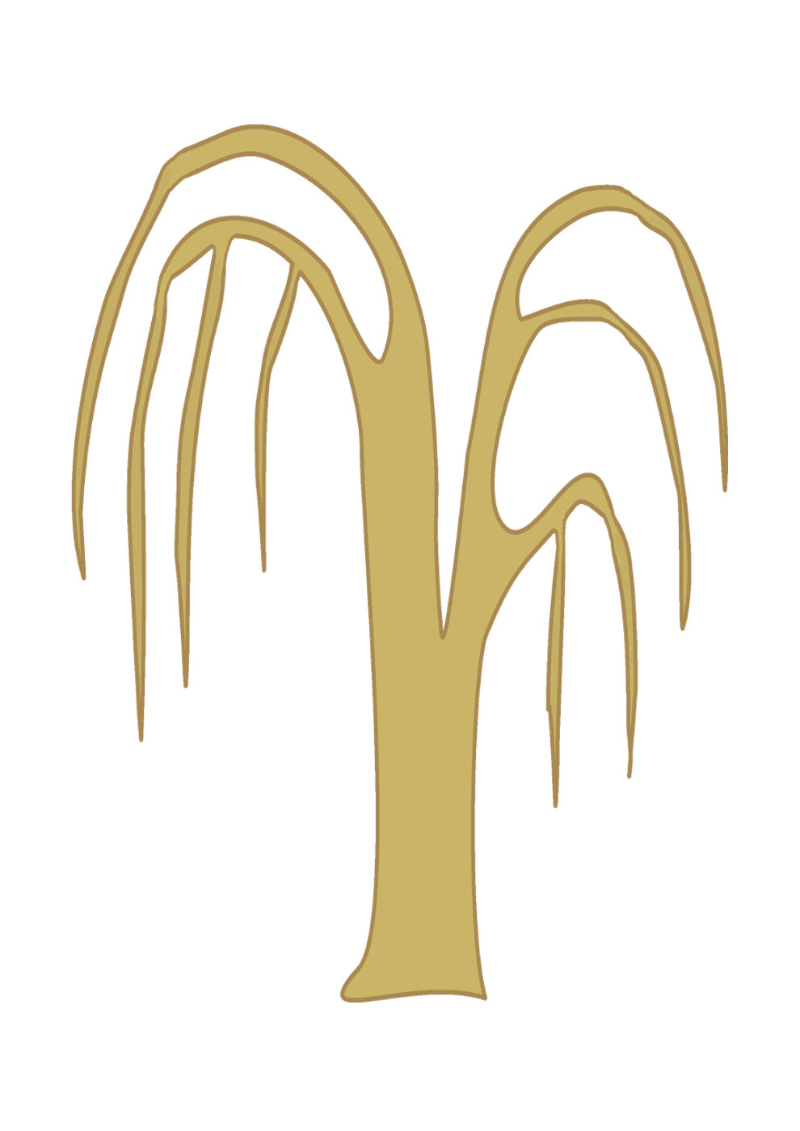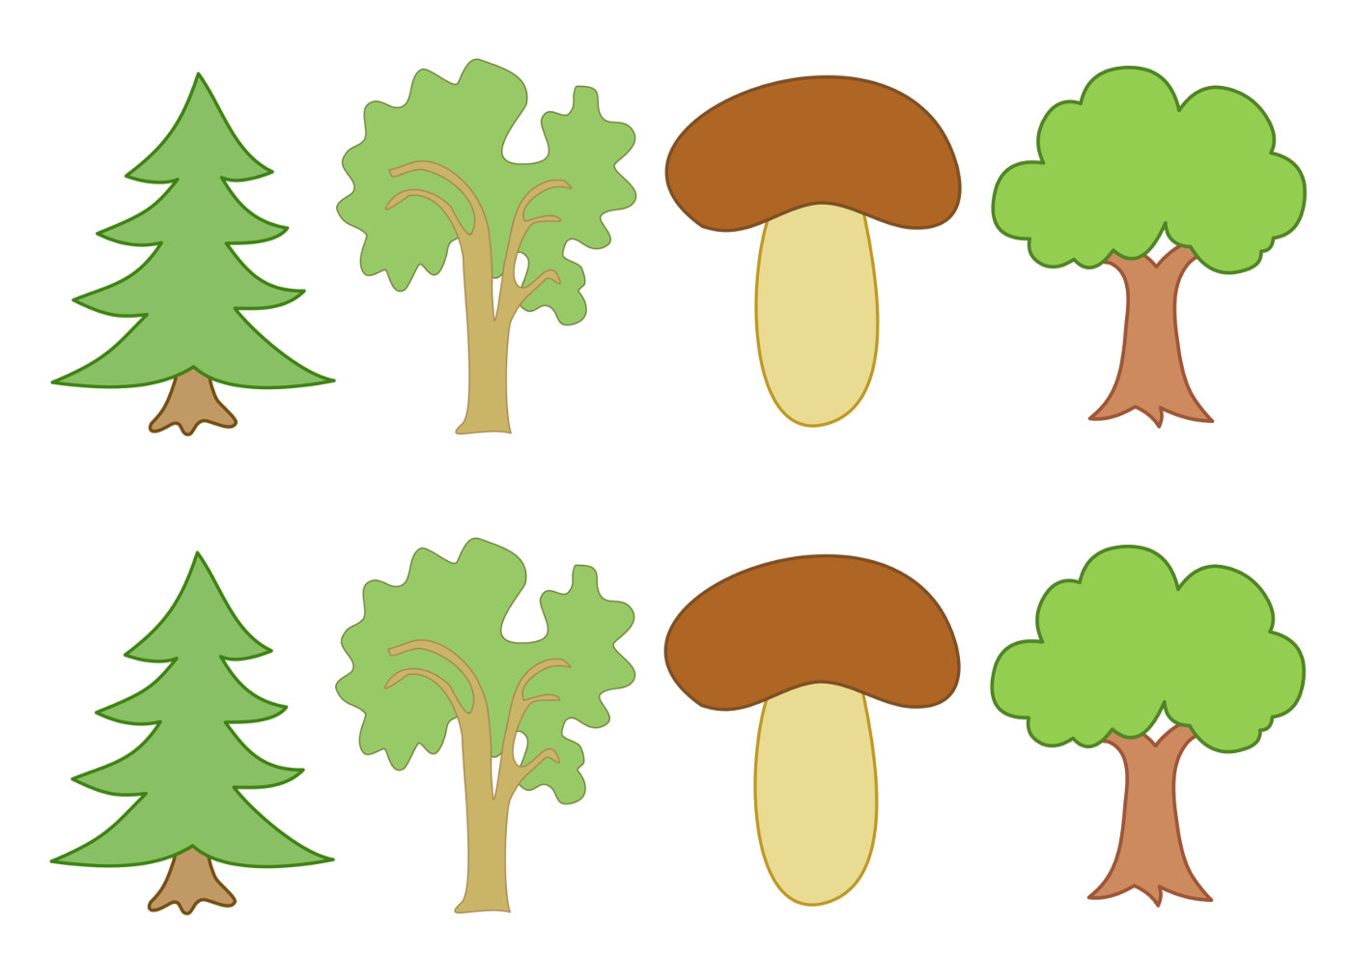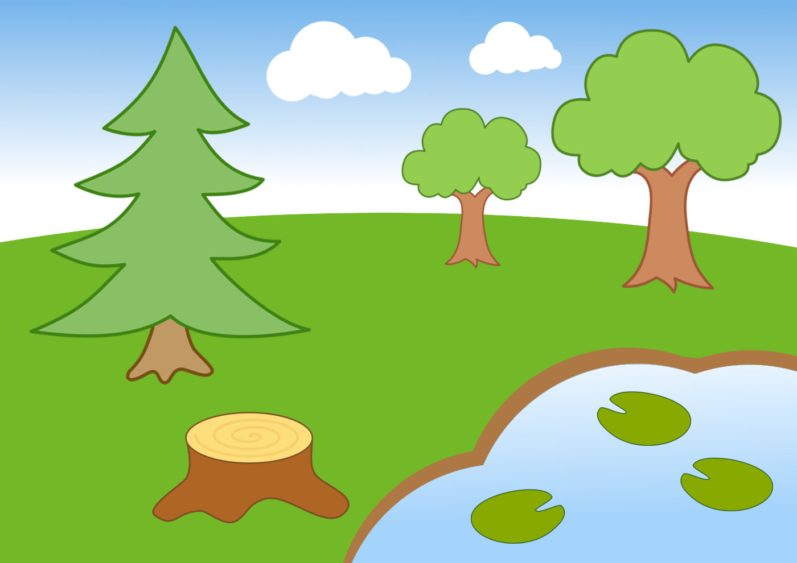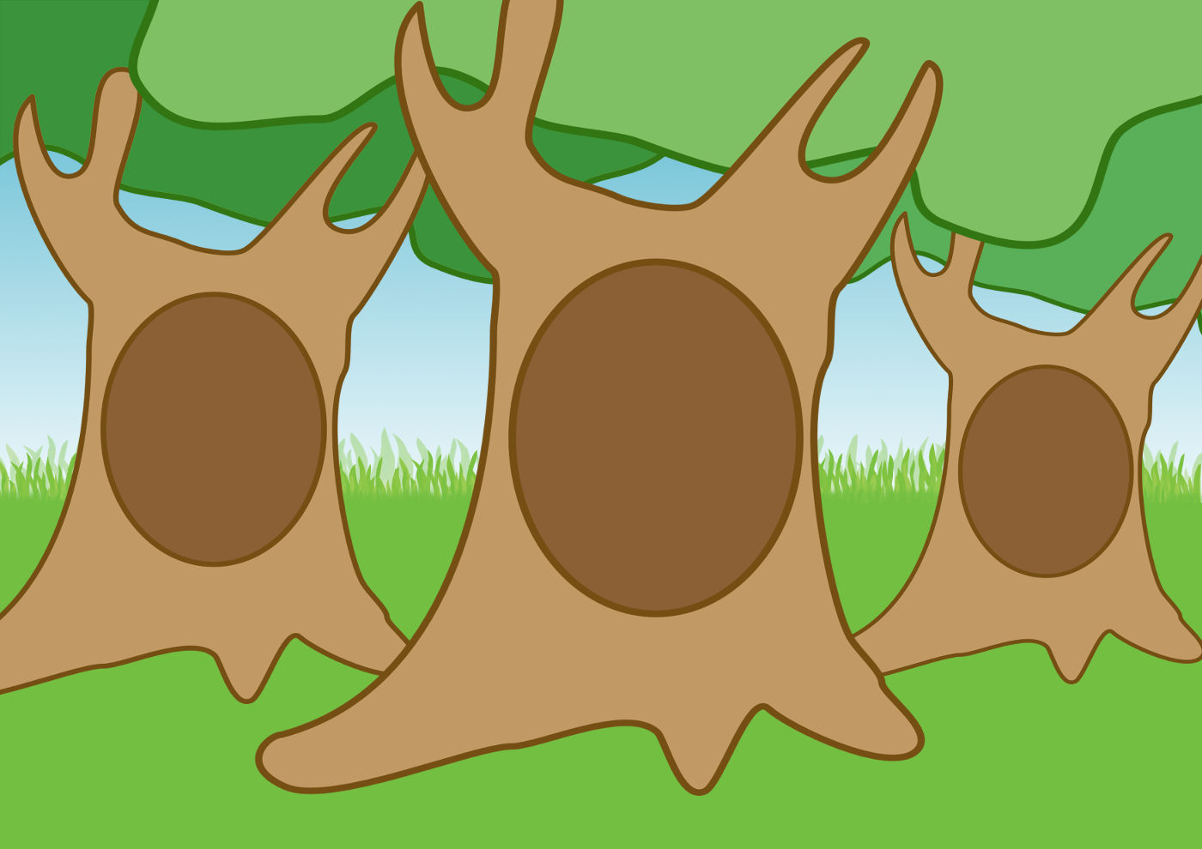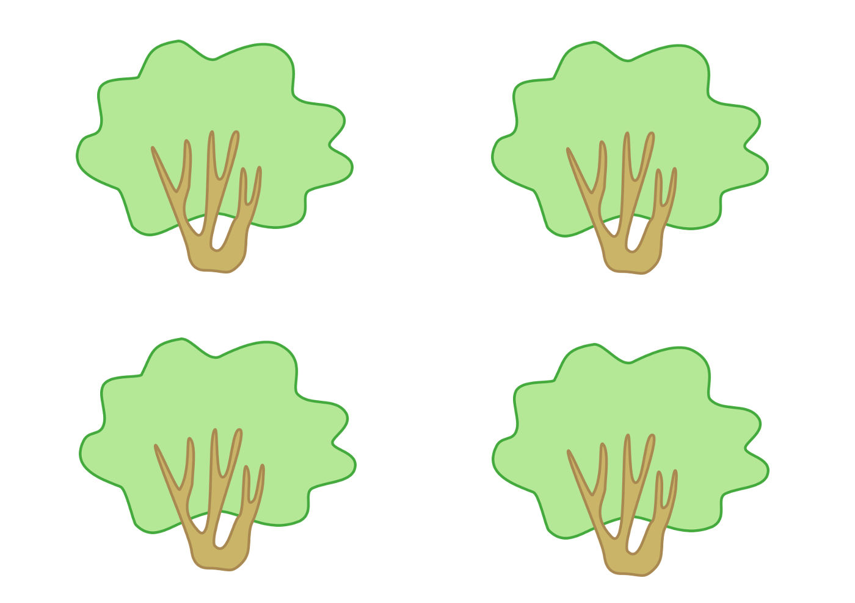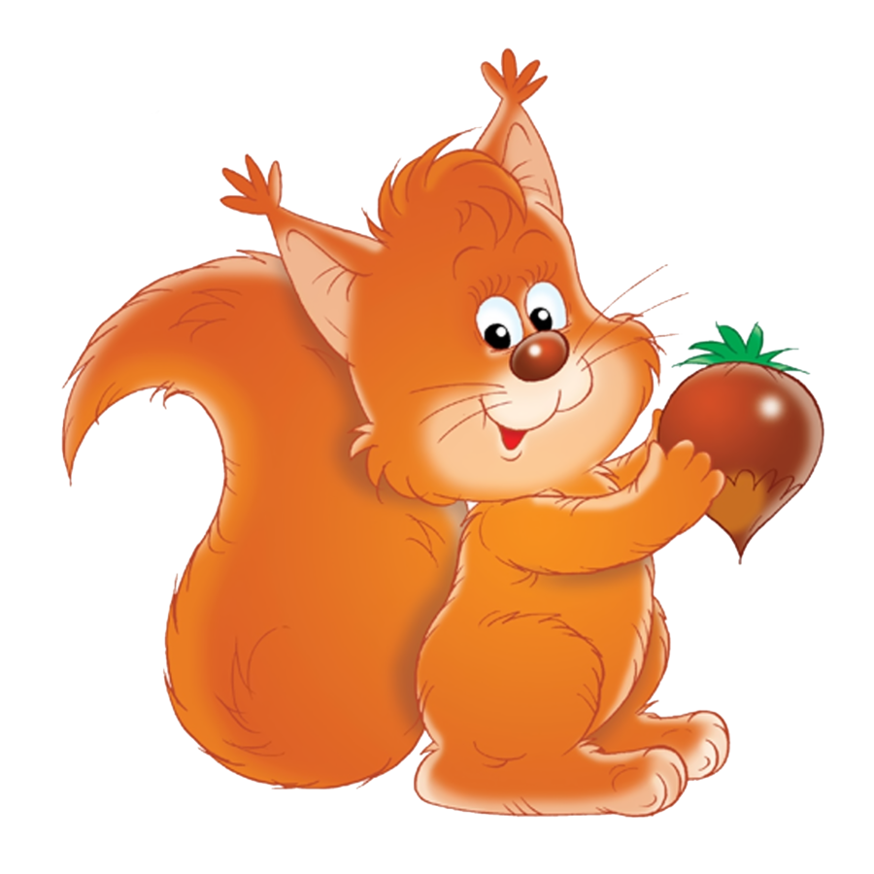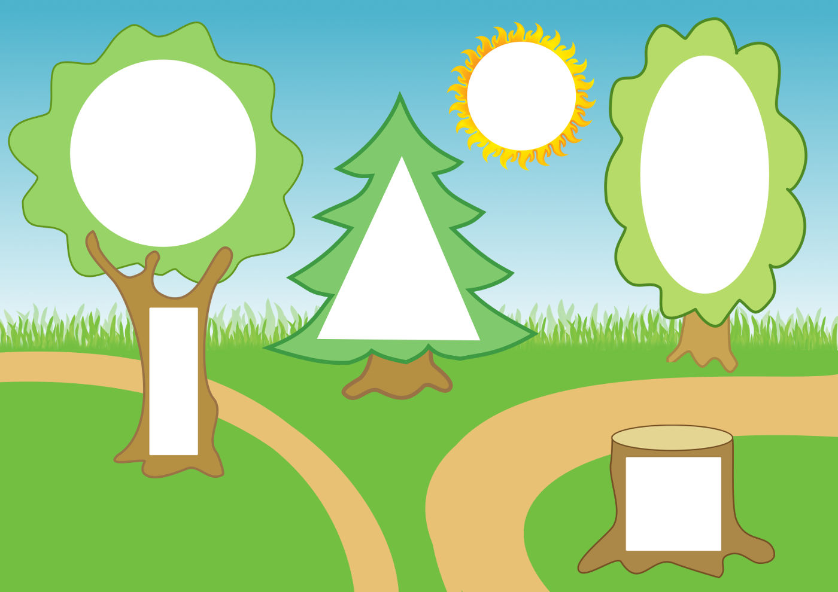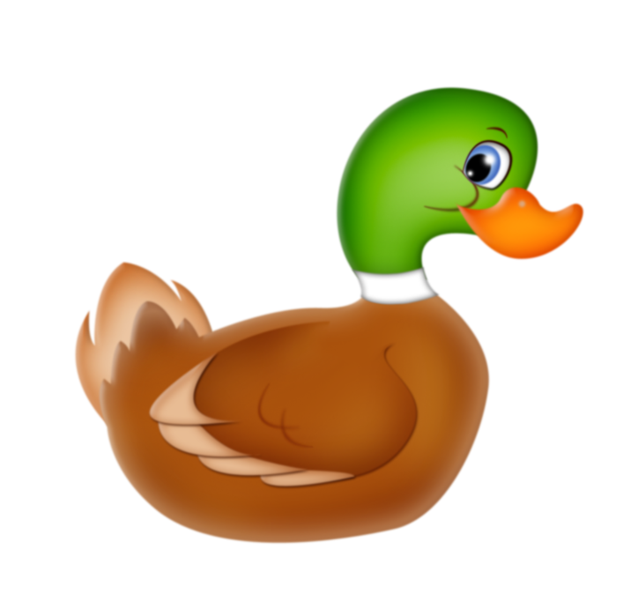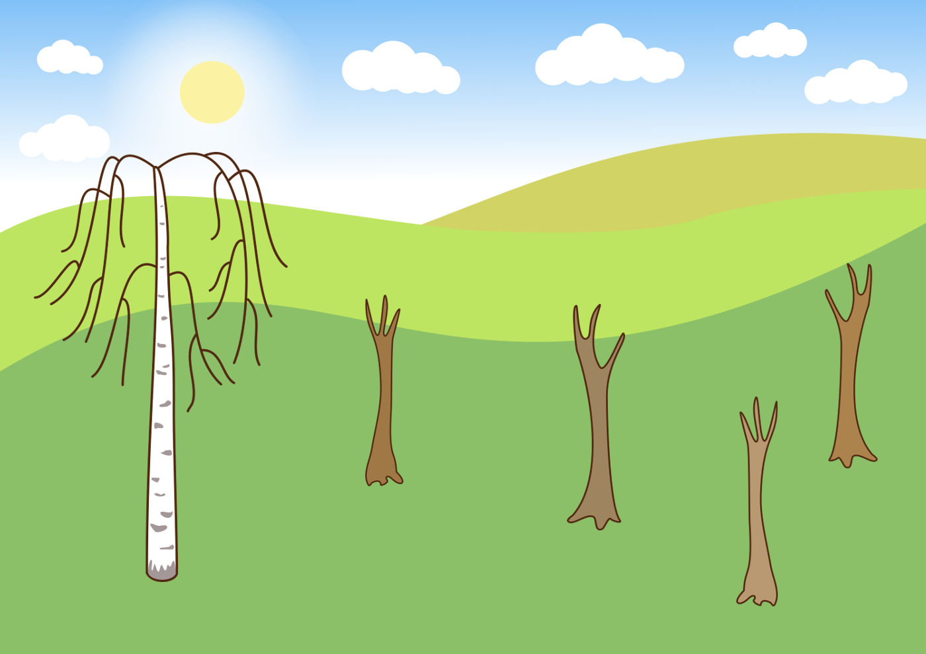

43. Activity title: „Cat with kittens“
Activity type: games and exercises
Purpose:
To form in children stable ideas about color (red, yellow, blue, green), size (large-small), quantity (one-many), geometric shapes (circle, oval, triangle).
To fix the ability to navigate in space (on, under, behind, next).
Learn to carefully listen to fiction.
Encourage children to answer questions, facilitate the transition of words from a passive dictionary to an active one.
Exercise in drawing straight lines, gluing and modeling.
To develop visual and auditory concentration, fine motor skills, coordination of movements, articulatory apparatus.
Participants: group of children
Level: 2-4 year old
Materials:
Toy "Cat"
Audio recording of cat meows.
Picture-background with the image of a cat with empty places in the form of geometric shapes (circle, oval, triangle), these figures are cut out of orange cardboard.
Picture-blank with the image of a cat, clay, black, white, brown.
Basket with colorful balls.
A blank picture with the image of a kitten, cut out of paper round large and small balls of yellow, green, blue and yellow colors, colored pencils of the same color, glue stick.
Salted dough, cut out of cardboard silhouettes of fish.
A small house built of large building material, a scarf in red.
Groats, spoons, saucepans, plates.
The book "cat's house" with colorful illustrations.
Soft toys-cats.
Toy buckets, ladles, saucepans.
Time: 15-30 minutes
Activity description and instructions, rules, comments:
Surprise moment
Who is hiding under a chair? Listen up (An audio recording of a cat's meow sounds, or the teacher himself imitates it). So who hid there under the chair? It's a cat.

Examination toys.
Look at the cat. Her name is Mura. Let's call the cat by name, say: "Mura."
Do you like cat Moore? Yes, a beautiful cat. Muzzle cat baleen. Show where the cat has a mustache. What else is the cat on the head? Eyes, mouth, ears. Show them.
And what a soft cat fur coat. Pet the cat with your palms. What is the touch of her coat? Soft
And in order to run and jump a cat needs ... what? Paws need a cat. To run and jump.
And the cat has this. What is it? This is the tail.

Didactic game "Cat"
This is a circle, find its place in the picture. This is the torso of a cat. And this is an oval, find its place in the picture. This is the tail of the cat. And this is a triangle, and I will give you not one, but two triangles, find a place in the picture for triangles. This is cat ears.

Bas-relief modeling "Fingers on a cat"
Tear off small pieces of clay, apply to the cat and press down with your finger. That's how beautiful the cat's fur has become.

Dynamic pause "Little Cat is sitting"
Little cat sits
And moves his ears.
Here, how, how,
As ears wiggles.
Open palms attach to the ears, bend and unbend closed fingers, as the cat wiggles his ears.
Little cat froze,
Covers the nose
Rubbing the nose alternately with one palm or the other.
Cat-cat, Kotofey!
Quickly we will warm you!
Rubbing one hand about another.
Jump-Jump, Jump-Jump!
Jump from heel to toe!
We jump, moving feet from heel to toe.

Articulation gymnastics "Cat"
Show how the cat shows the tongue, lacquer the milk, lick, smile, yawn.

Didactic game "Cat and Kittens"
Our cat has kids. Do you know how kids are called cats? Kittens Look, the cat is big, and what kittens? Little kittens. Cat alone, and how many kittens? Kittens are many. The cat meows loudly. So “Meow!” And the kittens meow quietly. Like this. (Show tutor) Let you mew loudly, like a mom-cat. And now mew silently, like kittens, guys.

Respiratory exercise "Blow on the bow"
Love kittens to play with bows. Take the bows by the string and blow on them, so that the bows begin to sway.

Didactic game "Balls"
And how do kittens like to play with balls. How many balls do I have in my hands? One ball. And how many balls are in a basket? A lot of glomeruli. You, probably, like kittens want to play with balls.

Rolling game "Rolling balls and collect in a basket"
Take yourself the balls. Put them in front of you on the floor and push them so that they roll forward.
Oh, our balls scattered! Rather, collect them and put them in the basket.

Graphic activity "Kitten and balls"
On a sheet of paper with a picture of a kitten, the children paste colorful balls (large and small), and then draw color lines from the balls in pencils. The educator pays attention to the color of the ball and size.

Reading the poem "Cat's House" with showing illustrations
Tili-bom! Tili-bom!
Cat lit up house!
Cat lit up house,
There is a smoke post!
The cat jumped out!
Eyes bulging.
Chicken runs with a bucket
Pour cat house
And the horse - with a lantern,
And the dog - with pomelo,
Gray hare - with a sheet.
Time! Time!
Time! Time!
And the fire went out!
Dramatization "Let's put out the cat's house"
(The teacher throws a scarf of red color onto the house of building material and twitches it). Oh, what a fire! Our cat's house caught fire. It is urgent to put out the fire.
Rather, pick up the buckets. Pots, pots and run to extinguish the cat house. (The teacher shows how to take the bucket, bring it to the house and turn it around, as if pouring water. When all the children have completed the task to remove the red scarf from the house, they “put out the fire”).

Didactic exercise "Porridge for kittens"
In this pan kittens porridge. Feed your kittens, take a spoon, scoop porridge and put on a plate. Like this. (Show tutor). Eat kittens porridge and grow up. (Instead of porridge, you can feed the kittens with fish, which the children "catch" from the tank with millet).

Didactic game "Where are the kittens?"
Ate the kittens and decided to fool around - climbed on the table. Take your kittens to the table.
Ah ah ah! Kittens, you can not sit on the table! The kittens were frightened that we scolded them and hid under the table. Put the kittens under the table.
Okay, kittens, get out and sit down next to the easel. Put the kittens next to the easel.
The kittens wanted to hide from us behind the bench. Put the kittens behind the bench.
Tired kittens, wanted to sleep. Put the kittens to sleep on the pillows.

Finger gymnastics "Patties for cats"
Quickly knead the dough,
Divided into pieces.
We imitate the dough kneading and cutting it into pieces
Roll out all the pieces
With open palms with closed fingers, we make movements back and forth along the surface of the table.
And blinded patties.
We “pinch” imaginary cakes with the fingers of both hands
Fish patties -
Treat cats!
Putting palm to palm, “sculpt pies”.

Sculpture "Pies"
Cat with kittens are very fond of fish pies. Here we have ready circles from the test. Put the fish on top of them. Now fold the circle in half, like this. It remains only to pinch the edges of the pie. (Show tutor). These are the cakes the guys have made. Help your cat with kittens. Tell them: “Help yourself!”

44. Activity title: „COW“
Activity type: games and exercises
Purpose:
Expand children's knowledge about the cow.
To teach children comparing subjects, to find similarities and differences.
Introduce the words "bull", "calf", "shepherd" into the dictionary.
To form sustainable ideas about size, color, quantity.
Continue to teach children to draw straight lines with a pencil.
Learn to perform crafts with glue and cereals.
Develop attention, fine and general motor skills, sense of rhythm.
Continue to teach children to listen carefully, understand and respond emotionally to a poetic speech.
Participants: group of children
Level: 2-4 year old
Materials:
Toys: cow, bull, calf, trucks.
Figures of cows.
Building material - bars.
Multi-colored cardboard flowers.
Green pencils. Leaf background with sky, earth and cow. Yellow circles are the sun, colored silhouette images of a cow and calf.
Pictures-backgrounds with the image of one and two cows with a white window for the number above the cows. Cards are the numbers "1" and "2".
Pyramids in the form of buckets.
The threads are green, scissors.
Clothespins, cardboard silhouettes of cows.
Drums. Fife
Picture-background with the image of a cow and flowers with empty centers. Corresponding in color and size buttons.
A picture-background with the image of a cow and a house scheme (square and triangle of white color), a circle of white color in the sky. Similarly sized blue squares, red triangles and yellow circles.
Picture with a painted cow, PVA glue with a brush, buckwheat.
Sheet of green cardboard with glued winding path, a rectangle, a large blue circle, five small green circles. Five silhouette flowers for each child.
Audio recordings: the mooing of a cow, “A bull is coming to us” by E. Zheleznova, “A cow has no other worries”, “33 cows”.
Time: 15-30 minutes
Activity description and instructions, rules, comments:
Surprise moment "Whose voice?"
- Who came to visit us, find out by his voice. (The cow moo sounds). Who is it mooing? Cow. And here's another hurry to visit us.

Listening to the song "Going to Us"
Bullhead is a bull. If the cow is mom, then the bull is dad.
What then is the name of the child of the cow and the bull? Calf.

Reading a poem by M. Druzhinina
Among the trees and pines
Mom lost calf.
- Where is m-ma-a-ma?
I do not understand!
- Here I am, my good!
Hoo-hoo!

Didactic exercise "What a cow, what calf?"
The teacher and the children consider the cow and calf, compare them.
Guys, look: the calf is small, and the cow (big).
The calf has a short tail, and the cow has a tail (long).
The calf has thin sides, and the cow (thick).
The calf has no horns, and the cow has some horns (steep).
The calf is small, it does not have an udder, and the cow is large: it has an udder with which (with milk).

Application and drawing pencils "Green grass for cow and calf"
- Here is a picture. It depicts heaven and earth. Show the sky, the earth.
The morning came and the sun shone in the sky. Attach a yellow circle to the sky - that's the sun. Now glue the sun-yellow circle.
It became light and warm when the sun shone in the sky. A mother-cow and a calf-child came out on the meadow. Show the cow, show the calf. Who is big? Cow. Is that small? Calf. Let them graze - put on a green meadow. Now glue on.
That would have grown weed, cow would eat her. Let's draw a grass for a cow. What color will we draw grass? Green color. Take the pencil correctly and draw short vertical strokes.

Articulation Exercise "Cow"
- Let's rumble loudly, like a cow: yo. And now we will whisper softly, like a calf: Muh. Like a cow shake. (Chewing movements of the lower jaw).

Didactic game "How many cows?"
- Show in the picture one cow. Find the number “one” and attach it to the window above one cow. The number one indicates that the cow is one.
And how many cows in the other picture, count? Two cows. Find the number “two” and attach it to the window above the two cows. The number "two" shows. What two cows.

Didactic game "House for the Cow"
- Let's build a house for the cow.
This figure is called “square”. Take your square and find him a place on your picture. What color is a square? Blue square.
This figure is called a triangle. Take your triangle and find him a place in your picture. This is the roof of the house. What color is a triangle? Red triangle.
House for the cow is ready. But we still have one more figure. Here she is. What is this figure called? This is a circle. What color is the circle? Yellow. Where do we put the yellow circle? Is there a place for him in our picture? From the yellow circle we will make the sun. Take your lap and make the sun.
Designing "Fence for a calf"
- But listen to what happened today. While the mistress milked her cow, the calf ran away from the yard. The mistress was looking for him for half a day, but it turns out the calf was walking along the road. But this is very dangerous. He could get under the car. We must help the hostess. Let's see for the cow and calf fence. Then the calf will not leave without mom or where. How to build a fence? Prepare bricks for work. Now we will place the bricks in such a way that the fence is turned out (they are put bricks vertically on a narrow edge.) That's how the brick is to the brick, and the fence is ready.
Who did we build the fence for? (Children's answers). Now the calf is not going anywhere!

The mobile game "Cow and Calf"
Sweet at dawn
Children sleep in cots
A calf is necessary
Run after mom in the herd.
We run like calves for moms. Hold the handle - and run. "Mu Mu".

Didactic game with buttons "Cow eats flowers"
Children lay out the buttons in the empty middle of the flowers, selecting them in size and color.

Dynamic pause "Collect flowers for the calf"
White bull goes
With a black speck flank,
Wants to eat a daisy flower
I saw a bug on it
And screaming "Mu-Mu-Mu-Mu"
It is very difficult to tear the grass yourself.
Let's collect flowers for the calf. Each child is given the task to collect flowers of a certain color.
Eat, eat, calf, grow big and strong.

Finger gymnastics "Bull and shepherd"
Chok-chok-chok, chok-chok. choke!
Go to the shepherd bull.
“Run,” tapping the table with your fingertips.
Beat up wants very much
Maybe he is very bored.
On each hand, expose the "horns" of the index finger and little finger and turn the brush in different directions.
A shepherd and not afraid -
Give the goby water to drink.
We leave one hand in the described position, with circular movements, stroke its back side with the fingers of the other hand.
He will take him by the horns
And lead to weed.
Grab the "horned" hand with your other hand and set it aside.

Staging a poem by A. Barto "Bull-calf"
Going go, swinging
Children on the tutor show "make horns", putting cams to the forehead with forefingers stretched forward and walking, swaying from one foot to the other.
Sighs on the go:
A deep breath and a noisy exhalation.
“Oh, the board is running out!
Raise your hands up, shake your head.
Now I will fall! ”
Fall - lie on the floor.

Didactic game "Take the cow along the path"
Oh, how I love my cow.
Fresh grass we feed
You go my cows home.
I will give you a key water.

- Here is a picture in front of you. Here is a rectangle - the house of a cow. Put a cow in this house. It is morning. Cockerel zakkarekal: Kukareku! A cow came out of the house and went along the path. Take the cow along the path. Here came the cow to the lake to drink water. Touch the lake with your fingers - the blue circle. Let the cow be drunk. And now the cow wanted to eat. Let's plant flowers for her. Take flowers and lay them on top of the green circles. How many flowers have you planted? Many flowers. Eat cow I ate and went home. Take the cow along the path to her house. Rest, cow.

Didactic exercise "Buckets for milk"
Children assemble and fold the pyramid in the form of buckets.

- You can make a lot of healthy and tasty products from milk.

What does a cow give us?
And sour cream, and kefir
Cream, ryazhenka and cheese,
Cottage cheese, butter, sour milk,
Milk for delicious cereal,
Burenka gives us ours!

Finger drawing "Bucket with milk"
Children paint with white paint with their fingers milk in a bucket, trying not to go beyond the contour.

Musical and rhythmic exercise "A cow has no other worries"
Children are drumming to the same song.

Finger play "Cow"
The Cow, the Cow, (we shake our head)
Horned little head. (Show index fingers on the horns on the head)
Small kids do not boda, (Thunderstorm with a finger)
Milk give them better! (We put the palms together, in the "pan").

The game with clothespins "Cow"
- With the help of clothespins we will make the cow legs - two in front and two in the back. Calculate how many legs a cow has? Just four legs. And do not forget to attach the cow tail. How can she flies away without a tail?

Manual work "Stains on a cow"
- Put glue on the stains on the cow and sprinkle with buckwheat on top. Get a very beautiful cow.

Didactic game "Prepare hay for a cow"
- In winter, there is no green grass, but what will the cow eat in winter? In winter, the cow will eat hay. Hay is dried grass. Now we will harvest hay for a cow. These green threads will be grass. Take scissors in hand and cut the threads into pieces. That's how much hay turned out. Need to transport it by car. Fold the hay into the back of a truck.
Reading poteshki
Early in the morning shepherd: "Too-ru-ru-ru!"
And the ladybirds in his tune sucked him: “Mu-mu-mu!”
You, little cow, go, take a walk in the open field,
And come back in the evening, give us some milk.
Every morning the shepherd boy plays the pipe, while the cows hear and go to the cowgirl. But one day what happened:
Oh, doo-doo, doo-doo, doo-doo!
Lost the shepherd doudou!
Yes, you need to collect cows, to play on a pipe, but no pipes! She is looking for a shepherd's pipe (The teacher plays a search scene, invites the children to help the shepherd find the pipe. The pipe is located).
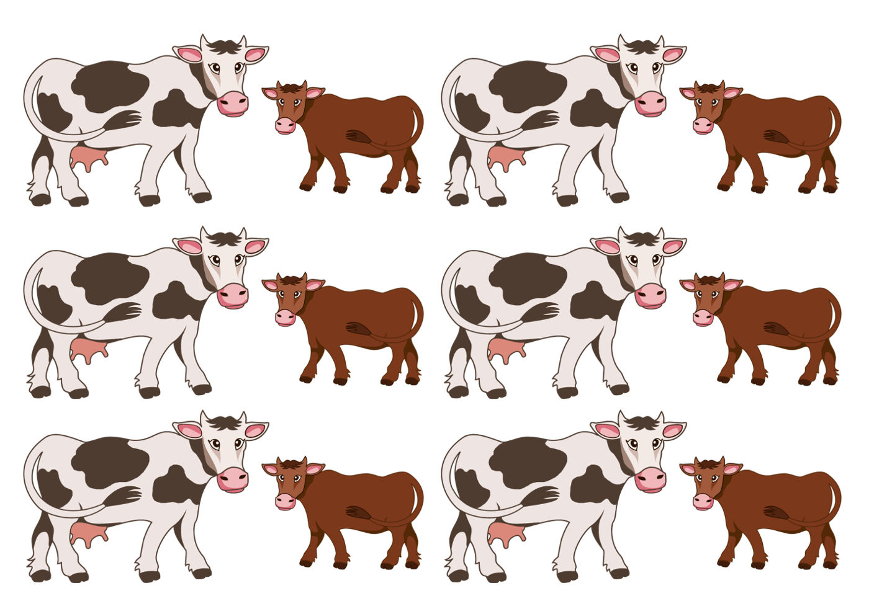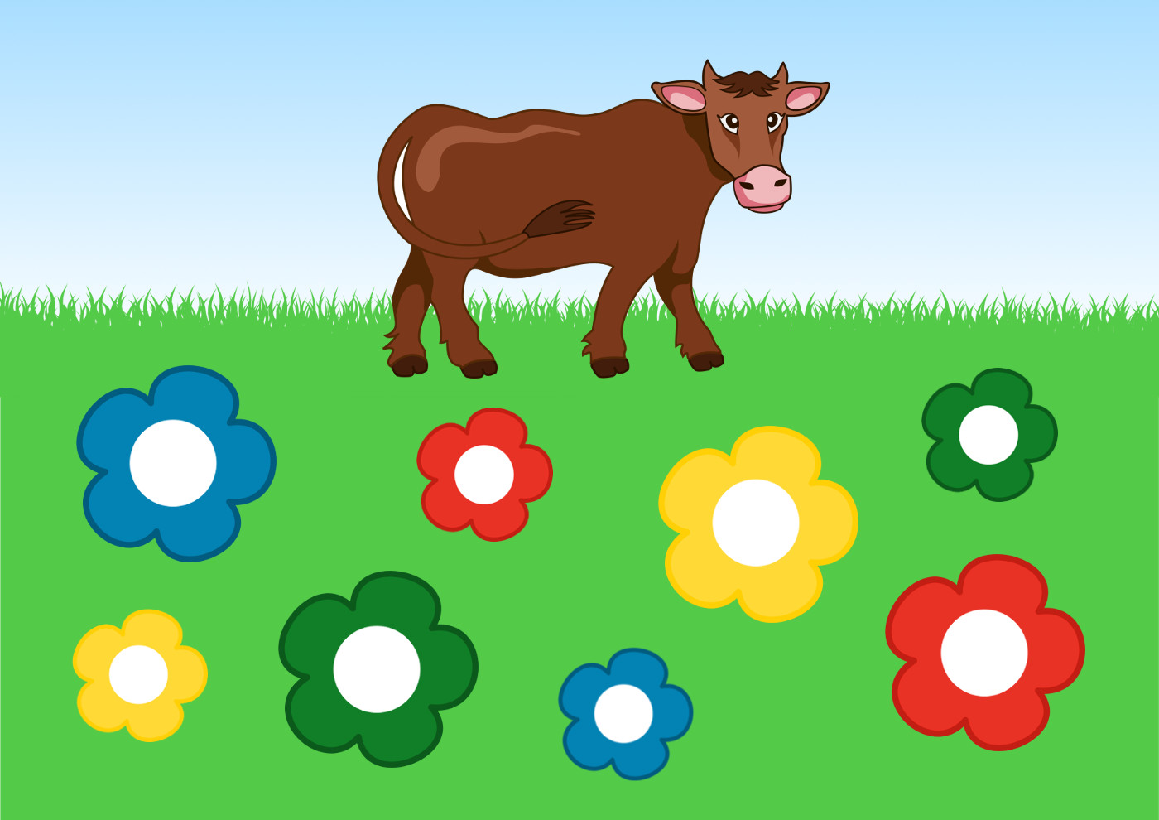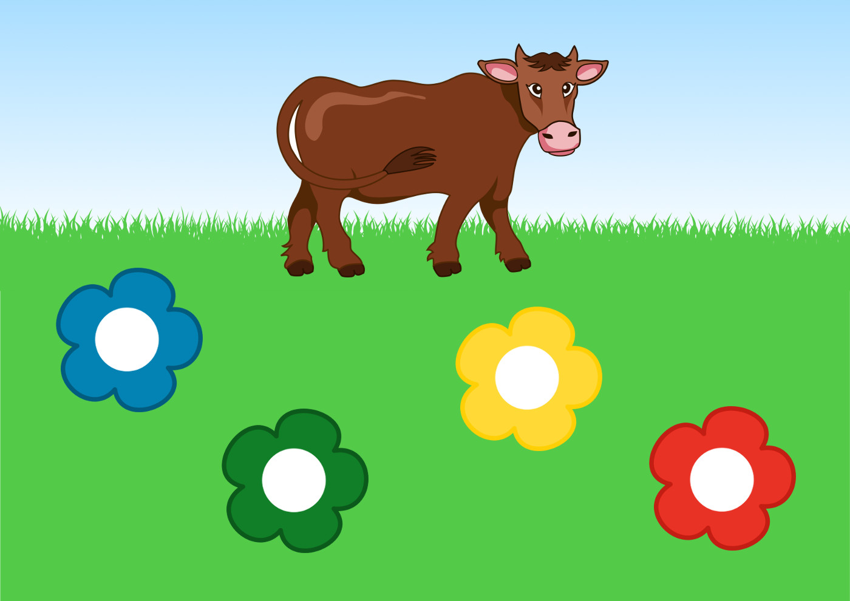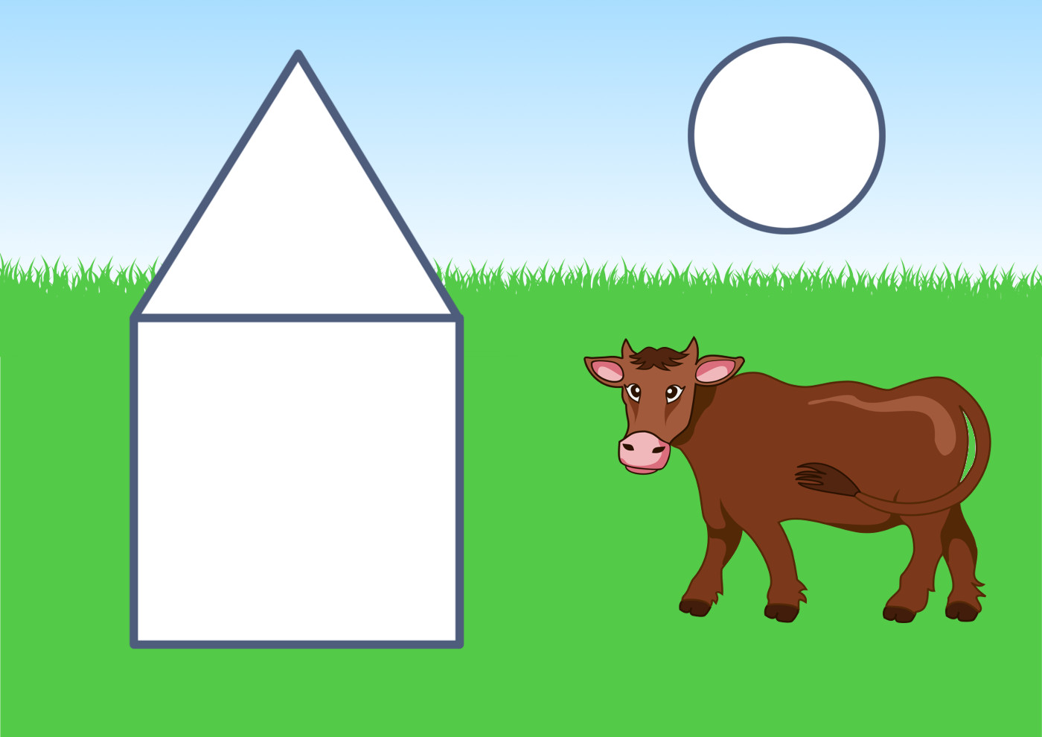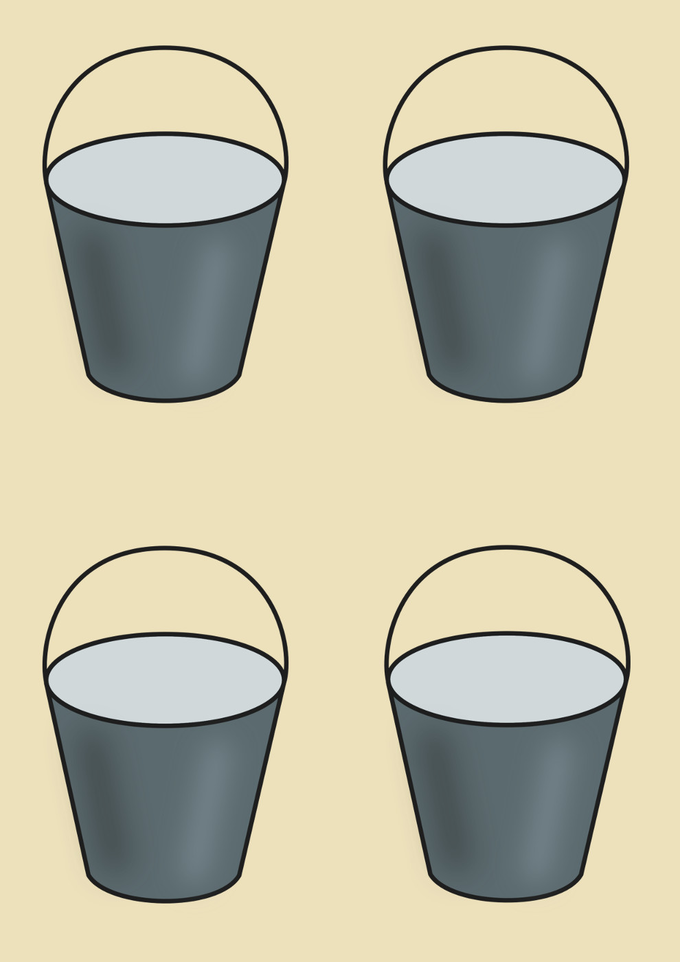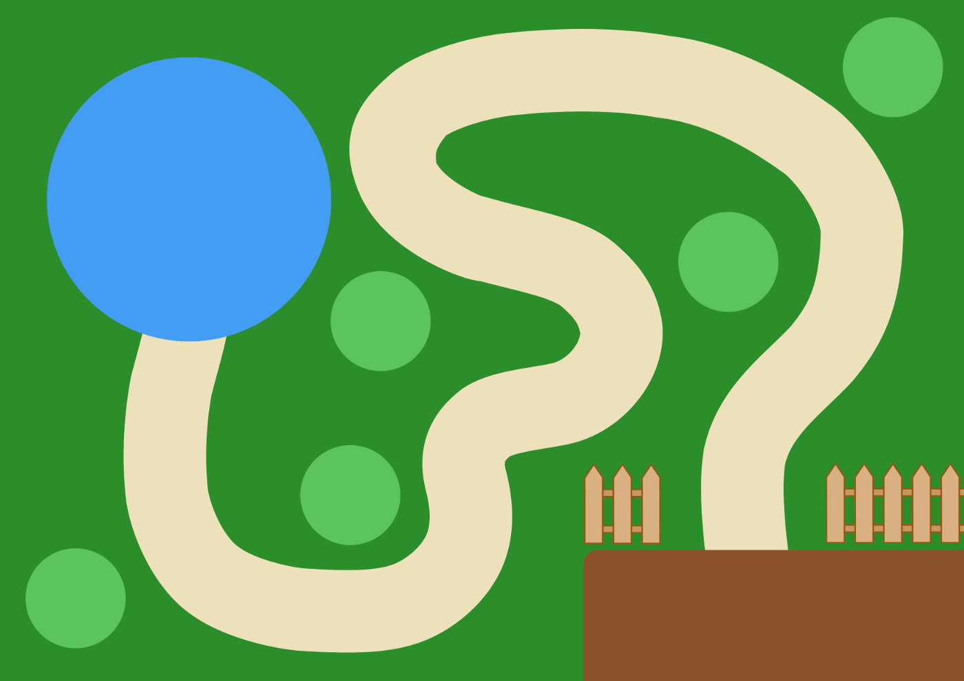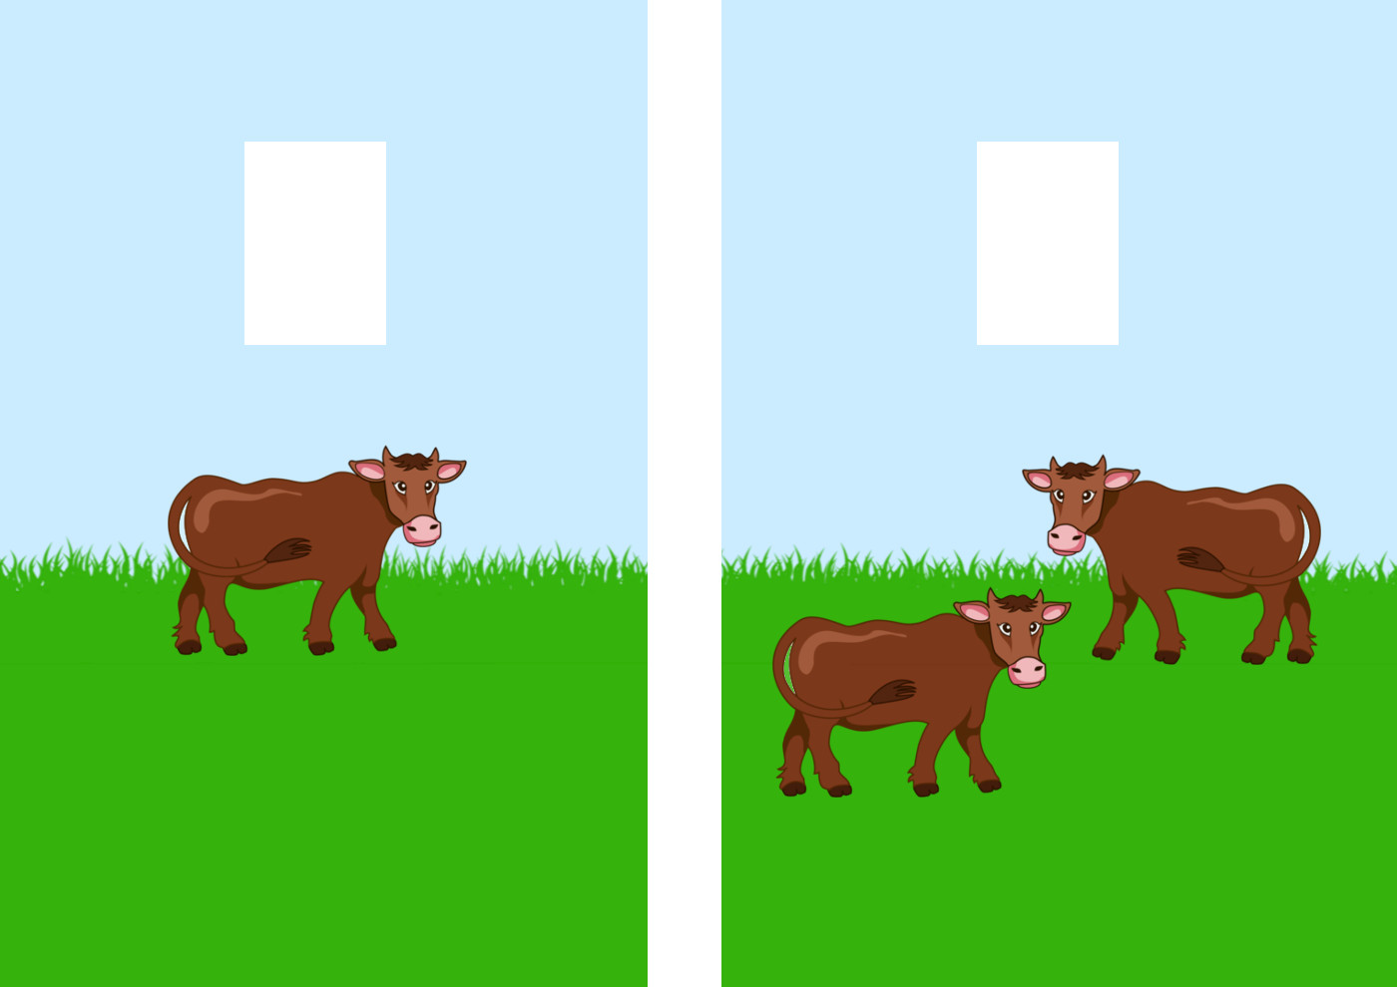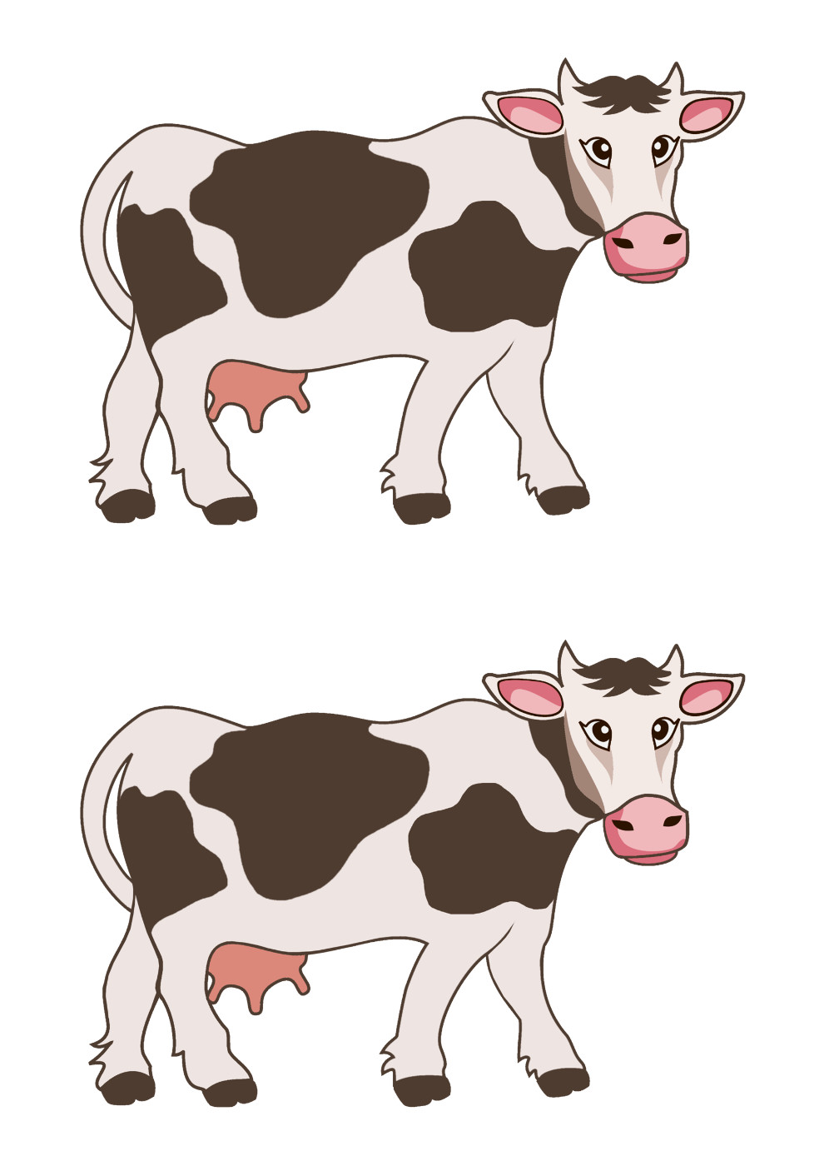

45. Activity title: „FARM“
Activity type: Construction and constructive game "Farm"
Purpose:
To form the ability of children to use the construction tabletop material, to act with it in various ways.
To teach yourself to select the necessary details in accordance with the nature of the building and to carry out the construction on the model of the educator.
Consolidate previously acquired knowledge about the farm.
To teach you to create the simplest models of real objects, to reflect the knowledge and impressions gained in playing around the building.
Educate friendships in the game.
Participants: group of children
Level: 2-4 year old
Materials:
Building material (bars, cubes, arches), a set of toys "Farm".
Time: 15-30 minutes
Activity description and instructions, rules, comments:
The teacher gives the children a set of toys "Farm" and offers to play. He draws attention to the fact that animals need to equip a safe place so that they do not run away, and no one has harmed them, leading children to the conclusion that it is necessary to build a fence around the farm. The children themselves choose the building material (bars) and by placing parts close to each other they build a fence. If the children forget to leave room for the gate, the caretaker asks how can a cistern for milk be able to drive into the farm. The teacher offers to populate the farm with small animals (piglets, sheep, poultry) and check whether the fence is high enough. Then large animals (cows, horses) are settled and children come to the conclusion that the fence is not sufficiently high. The tutor shows a sample of the superstructure of the fence (the cube alternates with an inverted arch, is placed close to each other from above on the fence of bars). Kids finish the construction. The teacher asks questions about the farm and offers to beat the building.

Questions to enhance gaming activities:
What animals are bred on the farm?
Who cares about them?
How do farmers care for cows? What do they get from them?
How do farmers care for pigs? What do they get from them?
How do farmers care about horses? How are they used?
How do farmers take care of birds? What do they get from them?
How do farmers care for goats, sheep? What do they get from them?
Why does a dog live on a farm?
What kind of cars help farmers?

