36. Activity title: „Animals of the Arctic“
Activity type: lesson
Purpose:
Fastening ideas about wild animals of the Arctic.
Formation of ideas about wild animals of the Arctic on their appearance, lifestyle and habits.
Formation of the ability to classify animals of the Arctic.
Expansion of children's outlook.
The development of attention and visual perception.
Expansion of vocabulary, clarification and activation of the dictionary on the topic "Wildlife of the Arctic"
Formation of skills of cooperation, mutual understanding, goodwill, independence, responsibility, initiative.
Education love and respect for nature.
Dictionary activation: (Arctic, iceberg, polar bear, continent, flippers, ice, floe, walrus, deer, arctic fox, polar wolf, polar owl, horns, northern, north, seal, etc.).
Preliminary work: viewing pictures on the topic.
Participants: group of children
Level: 4-6 year old
Materials: pictures on the topic.
Time: 15-30 minutes
Activity description and instructions, rules, comments:
Introductory word of the teacher:
Teacher: Guys, postman Pechkin brought us a musical letter. But bad luck! For whom this letter is known, for us, and from whom - no! Let's listen to this letter, maybe then it will become clear to us. (Children's answers)
Sounds of music.
Somewhere in this world
Where there is always frost,
Rubbing back bears
About the earth's axis.
Centuries are swimming past
They sleep under the ice of the sea.

Bears rub against an axis -
Twirling Earth.

Teacher: Guys, you guessed it, from what edge of the Earth did this letter come to us? (Children's answers)

Conversation:
Teacher: Today we will go to the North Pole and make a photo report about animals of the North. But before embarking on a journey, we must find out where in the world this extraordinary place is located.
Teacher: Let's look at the globe (showing). Here is the North Pole - the Arctic. Why is this place painted white? The Arctic is the central part of the Arctic Ocean with islands and adjacent coasts of the continents. Part of the land, which is adjacent to the Arctic Ocean, called tundra. Here is a cold and long winter and a cold, short summer. In summer, snow and ice melt in the tundra, plants appear: mosses and lichens. True, they have very short roots, because under the upper layer of thawed soil, the earth is still frozen and is called permafrost. All white is white here before the pain in the eyes. But suddenly there is a green ice floe. Where does she come from? It turns out that there are tiny plants that can live in the snow and in the ice. This is snow algae. In winter, a long polar night begins: dark, dark and very cold. Where can we go to the North Pole? By plane. Can we go there by train?
Teacher: What can we move on in the Arctic Ocean? (On the icebreaker) The icebreaker is a huge powerful ship that splits the ice floes, makes its way for itself and other ships across the ocean.
Teacher: Are you ready? We dress very warmly, do not forget to take cameras. So, we put on warm overalls, boots, hats, mittens and go (Imitation of dressing).

Physical moment

Hands to the side - in flight we send the plane.
Right wing forward, left wing forward.
One, two, three, four — our plane flew.

Teacher: Well, guys, we're with you on the spot. Around the big ice floes, floating icebergs. It is very cold in the Arctic, but in spite of the huge ice floes and permafrost, there are such inhabitants who are not found anywhere else. Who can we meet here in such harsh conditions?

The teacher offers to guess riddles:

Thick pleated hero -
In flippers and earless.
Picks from the bottom of the sea
Shells eat.
He has fangs like sabers,
The fur is short but thick.
Guess, guys,
What a hero like that. (Walrus).

Teacher: The walrus is a large predatory animal. It feeds on fish, hunting it in the sea. Look, guys, he has no paws, but there are flippers. The walrus is an excellent swimmer, despite the fact that it looks clumsy and awkward on land. They have two fangs, which are used in battles and to get out on the ice to rest. The walrus can eat 3000 clams a day. Weight reaches 1000 kg, and length 4m.

The recording of the sounds that the seal makes.

Teacher: Children, who do you think makes these sounds? (Seals)

Teacher: Seals live in both the Arctic and Antarctic. Seals do not allow to freeze a thick layer of subcutaneous fat. They are adapted to life in water, so they have an elongated streamlined body, covered with fur, comfortable for swimming, and all four limbs are turned into flippers. These animals swim quickly and quickly in the water, and on land they clumsily move, crawling on their belly. What do you think seals eat? Who hunts seals?

Teacher: Listen to the following riddle.

The long fur is white as snow.
Eats seals and fish for lunch.
He is a great swimmer -
And caring father.
Three-meter giant
Weighs a thousand pounds (polar bear)

Teacher: Polar bear is a wild predatory animal. It is larger, larger than a brown bear. It feeds on fish, walrus, and nerps. He has wide powerful paws that allow him not only to move by land, but also in water. The polar bear is an excellent swimmer and diver. Despite the fact that the water in the northern seas is very cold, the bear can stay there for a very long time and swim long distances because under the skin it has a thick layer of fat that does not allow it to freeze.
Teacher: But what other animals and birds can be found in the vast Arctic (reindeer, polar wolf, arctic fox, white geese, various gulls).

The teacher offers to guess the last riddle of the northern lights. Shows a slide with a picture of the northern landscape.

Teacher: Guess the riddle and find out what nature can be seen in the Arctic?

What a miracle, miracles:
The sky is burning!
Oh, burning-burning flame
Over the sparkling ices!
Who lit the fire wonderful
Golden bonfire?
There is no one behind the cloud.
It pours light from the sky. (Northern Lights)

Teacher: Guys, this phenomenon of inanimate nature in our country can be observed only in the far north, in the Arctic. Tell me, does it look like a rainbow?

Didactic game "Learn the contour"
The teacher demonstrates a slide with the contours of the animals of the North. Children will recognize and name animals. Then make sentences with these words. You can complicate the game and ask the children to name the young of these animals (deer, seal, bear, walrus).

Teacher: Guys, it's time for us to come back (physical gym):

Hands to the side - in flight we send the plane.
Right wing forward, left wing forward.
One, two, three, four — our plane flew.

Teacher: Here we are at home. Let's see what photos we got.

The result of the lesson:

The teacher together with the children sticks photos to the album.

Where have we been? (At the Arctica)
What unusual phenomenon in the sky we saw at the Arctica? (glued photo of the northern lights)
What is covered by the Arctic Ocean?
What happens with the change of day and night at the Arctica?
(the polar day lasts for half a year, the polar night for half a year)

What kind of animals have we met? (Polar bear, seal, walrus)
(Attached photos of animals)

Why are these animals not frozen? What is covered the body of a bear, seal, walrus?
What do these animals eat?
Did you like making a photo report? Our next report will be about the animals of Antarctica.

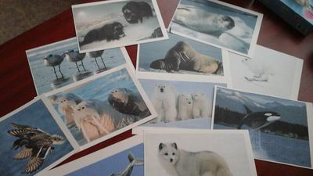
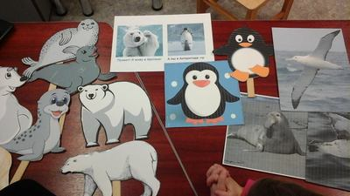
Kindergarten Tareke, Estonia

37. Activity title: „Animals of south countries“
Activity type: lesson
Purpose:
To consolidate and expand children's knowledge of animals from hot countries, reflecting their own impressions in artistic activities.
Refine and expand the horizons of children about the life of animals in hot countries;
Forming ideas about the relationship of living organisms with the environment;
Improve the dialogic form of speech;
Continue to learn to express your own opinions;
Continue to develop the skills of the simplest modeling, decoration and addition of the image with characteristic details using the combined pictorial technique (application and drawing);
Fix the ability to build a common composition.
To develop an interest in wildlife;
To expand the active conceptual vocabulary of pupils;
Develop attention in solving gaming and creative tasks;
Encourage originality of imagination;
To create conditions for the formation of visual-effective thinking in the process of cognition and creativity;
To develop the communicative qualities of preschoolers in the course of communication and the implementation of a common creative task;
To cultivate an interest in the surrounding world and the ability to talk about its objects with adults and peers, carefully listen to and complement each other's answers;
To encourage accuracy in work, respect for the work of their comrades.
Participants: group of children
Level: 5-6 year old
Materials:
1) Globe;
2) Presentation with the image of animals living in warm countries;
3) Details of animals in more than the number of children in class, felt-tip pens, oilcloths, napkins, glue brushes, glue for each child, ovals of light yellow and blue tones, general background.
4) Didactic game - presentation “Guess who?”, Board educational game “Who lives where?”, Etc .;
5) Recording the song "Africa", playing music massage - exercise "In giraffes ...".

The material remains in the corners for further independent activity.

Preliminary work
Organization of the developing environment (introduction of thematic albums “Animals of South Countries”, illustrations and photographs depicting animals from different countries for consideration);
Conversations about animals from different countries, inhabitants of Africa;
Making puzzles about animals, reading poems;
Examination of the pictures “Animals of the Zoo”, “Lions”, etc., drawing up stories on them;
Drawing and coloring animals from different countries in a free activity.
Time: 30 minutes
Activity description and instructions, rules, comments:
Children come into the hall, greet those present, the teacher draws the children's attention to the object standing on the table. This is a globe - a model of the Earth.
Teacher: Guys, do you know what it is?
Children respond.
Teacher: That's right, this is a globe - a model of the Earth. Do you guys like to travel? Want to go on a great trip with me? Guess where we go with you?
“The warmest continent is picturesque and great.
Here lives among the savanna many lions and monkeys. ”
Children: Africa.
Teacher: That's right, we'll go with you to a very hot continent. Africa is the realm of the hottest sun and hot sand in the world. Who can show Africa on the globe?
Teacher: Remember the magic words, repeat after me:
Magic globe I twist,
I want to get to Africa!
(Children turn around to the music)

Teacher: Here we are in Africa. What kind of animals do you want to see there? To answer my question, you must look at the symbols and answer with a full sentence with the appropriate intonation.
The children respond: “I want to see ...” (speaking with different intonations and pitch)
Teacher: Well, good. I hope your wishes come true. Let's sit down and look at the screen.
The teacher shows the presentation "Animals of south countries." Children take turns calling animals in Africa.
Teacher: And now I will make you a riddle:
The king of beasts - a big cat
Poke a little bit from evil
He sleeps in a den, eating
Wears a mane, a formidable ... (lion)
(show illustration, talk to clarify knowledge of the animal)
Why is it important for a lion to be inconspicuous? (he is a predator, stalking prey)
Why don't we see him? (coat color allows you to be invisible among the yellow dry grass).
Who goes hunting? Lions or lionesses? Why?
(As a rule, lionesses go hunting. They are more agile, clever, and more successful in hunting. Lions are heavy, slow, lazy. The lion’s harvested meat is first tasted by the owner. Therefore, he is always plump, full and not hunting.)
And how do lions look different from a lioness? (a lion has a big fluffy mane, and a lioness does not have one).
Who hunt lionesses? (Giraffes, antelopes, zebras become their prey).
What are the benefits of predators?
(Lions do not allow herbivores (antelopes, zebras, giraffes) to multiply in large quantities, saving the plant world from complete annihilation, and also destroy sick animals).
Teacher: Next riddle:
Here are horses, all in stripes,
Maybe they are in sailor?
No, they are of that color.
Guess who it is? (zebra)
(show illustration, talk to clarify knowledge of the animal)

Is a zebra a black striped white horse or a black striped white horse?
Each zebra is covered with stripes, and they do not repeat.
(According to the drawing, the zebra cub recognizes its mother. And also their color allows them to confuse predators, they cannot single out one zebra. There are many of them and they merge into one large striped spot).

Teacher: Listen to the following riddle?
Such a long neck
I have not seen people:
All higher in the world
Spotted ... (in rhyme I want to say "camel", but this is a giraffe)

Here is a live crane,
The inhabitant of hot countries.
From high-rise trunks
Tears and leaves, and a banana. (giraffe)

(show illustration, talk to clarify knowledge of the animal)

The height of the giraffe is 6 meters, it is 2-storey in height, half of the height is on the neck.
Why does he have such a neck? (easily reaches the very tops of tall trees, tearing leaves).
Next to the giraffe are zebra, antelope, ostrich, and roe deer.
What attracts them to a giraffe? (tall, sensitive ears and keen eyes help him see the predator and declare alarm to everyone. The eyes of the giraffe are so planted that, without turning their heads, he sees everything around.)
Teacher: Who is the next mystery?
Nose - hose giant
Washes, as in the soul.
This is a resident of hot countries
All the largest on land.

What is the biggest animal in Africa? ELEPHANT

(show illustration, talk to clarify knowledge of the animal)

Do you think a lion dares to attack an elephant? (no, the elephant is a powerful, very strong animal, the lion cannot cope with it).
The most amazing thing about an elephant is its trunk.
What makes them an elephant? (With the help of a trunk, an elephant tears leaves from trees, tears grass, drinks. It carries very thick trees. The trunk protects an elephant from enemies, expresses tenderness, strokes its youngs with love.)

Who can harm the elephant? (The mouse, when the elephant sleeps, climbs into the trunk and gnaws everything; and the ant, during the sleep of the elephant, gnaws the soles of the feet, and the elephant cannot walk).

Teacher: All of a sudden, eyes, ears, and nostrils of a huge beast appeared from the water. He sits all day in the water to guess who it is, you have to guess the riddle.

In Africa, the fat man lives, he has a huge mouth,
In the heat, he sits all day in the water, thinks only about food,
Grass in tons chews insatiable ... (hippo)

Only in Africa I will find
The beast of it in the pond.
If he comes out on dry land,
Will become very clumsy. (hippopotamus)

(show illustration, talk to clarify knowledge of the animal)

Our big hippo has a little friend. Who is it? (Hippo is friends with birds).
How do they help him? (The bird sits on the head of a hippopotamus when it sits in the water, so it catches fish for itself; the bird cleans the skin of insects from insects and heals wounds).
Educator: And what other animals of Africa have we not named?

(Children list: monkey, camel, rhino, antelope, etc.)

Teacher: Well done! You have told a lot of interesting things and learned about animals in Africa. And now let's rest.

(a game massage is held for the development of general motility - an exercise “In giraffes ...”)

Children stand in a circle. The teacher includes music.

Giraffes have spots, spots, spots, specks everywhere.
Giraffes have spots, spots, spots, specks everywhere.
(Pat themselves).
On the forehead, on the ears, on the neck, on the elbows,
There is on the nose, on the stomachs, knees and socks.
(Show the parts of the body).
Elephants have folds, folds, folds, folds everywhere,
Elephants have folds, folds, folds, folds everywhere,
(Pinch yourself).
On the forehead, on the ears, on the neck, on the elbows,
There is on the nose, on the stomachs, knees and socks.
(Show the parts of the body).
The kittens have fur, fur, fur, fur everywhere.
The kittens have fur, fur, fur, fur everywhere.
(Make shaking movements).
On the forehead, on the ears, on the neck, on the elbows,
There is on the nose, on the stomachs, knees and socks.
(Show the parts of the body).
And the zebra has stripes, there are stripes everywhere,
And the zebra has stripes, there are stripes everywhere.
(Show the stripes).
On the forehead, on the ears, on the neck, on the elbows,
There is on the nose, on the stomachs, knees and socks.
(Show the parts of the body).

Teacher: Since you know the animals of hot countries so well, I suggest you play “Guess Who?”

(a presentation game is shown on the screen, in which children must guess the animal by parts of the body)

Teacher: It's always very hot in Africa. What do you want most when it is hot? What do animals do when they are thirsty? (go to the watering)

What is a watering place? (At the watering place all the animals of the savannah gather: get drunk, swim)
Teacher: Guys, who can come to the watering? (Giraffe, zebra, lion). And who lives in the water almost all the time? (turtle, hippopotamus).

Teacher: In the last lesson, we made a panel depicting the nature of Africa. What are we portrayed?

(Children: "The sun, palm trees, pond, grass")

Who is not in our work? (animals) Let's paint them. Each of you can choose the details of the animal that you create (collect, paste, and then decorate with markers). When your animals are ready, you will place them in the part of nature that will be most convenient for him. If there are no questions, then you can proceed to the selection and work on the creation of images of animals.

(Children choose trays with the details of animals, sit at tables with glue, brushes, felt-tip pens, oilcloths, napkins on them.)

Teacher: But first we will do gymnastics for fingers.
(Children perform finger exercises).

-In hot countries
(Light, sliding, movements of all the fingers to hold on the table).
Rhinos
(Put hands on bent, spread fingers).
Just walk the road.
(With his hands to make the movement forward)
Soaked in the river hippos.
(Flip your hands with palms up, squeeze and unclench your fingers).
Lions go hunting.
Open your fingers like a fan).
Crocodiles,
(To open the hands at the wrists).
Monkey,
(Hands to attach to the head, show the "ears").
Zebras are inhabitants of savanna.
(Fingers of both hands intertwine with each other, perform "jumping"
movement on the table forward).
And tropical birds
(The thumbs of both hands intertwine
flap palms like wings).
There is something to marvel at.
The palms of both hands lying on the table turn up and down).

Before the children start sticking the animal, you can repeat the following procedure on behalf of the child:

1. lay out the image;
2. take turns (it is better starting from the body) to put the details on the oilcloth and glue them in place;
3. then, when the whole animal is glued, attach it with a napkin (otherwise the details can be brushed off and the image will have to be laid out again);
4. decorate the image with felt-tip pens (eyes, horns, specks, stripes, etc.)
5. Each child who has done the work sticks it to the general background.

If necessary, the teacher provides assistance to children.

Teacher: (when all the work is done) Guys, tell everyone in a few words about the animal that he created today.

(Each child speaks one sentence, making up a general story)

Teacher: Our journey is coming to an end
Magic globe I twist,
I want to get back!

(music, children turn around their axis)

Teacher: Where have we been with you today? (in Africa). What do you remember?

In memory of our journey, I give you the game. She is also about the animals of Africa, you can play it yourself in a group.

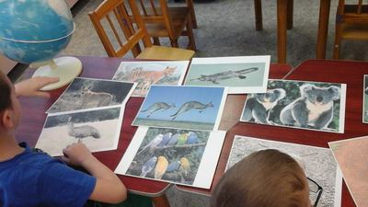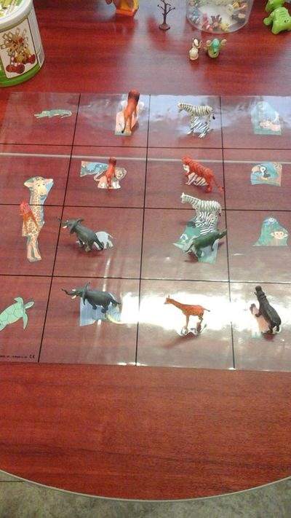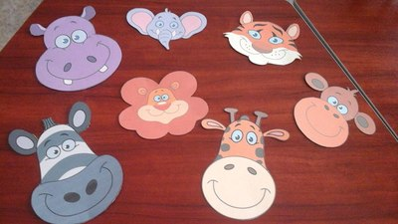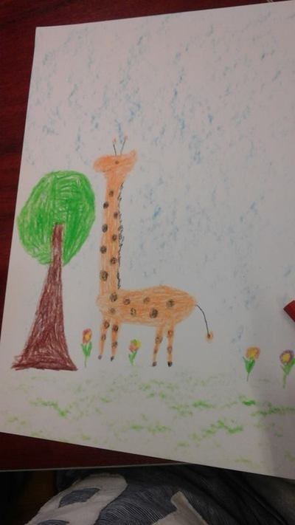

38. Activity title: „The veterinarian“
Activity type: lesson
Purpose:
To form in children ideas about the work of a doctor for animals (veterinarian).
Raise the love of animals for children, the desire to help them.
Teach children to display knowledge about the environment in the game.
Show children the value of veterinary medicine for pets.
Participants: group of children
Level: 4-6 year old
Materials:
picture and veterinary game
Time: 15-30 minutes
Activity description and instructions, rules, comments:
Teacher: Guys, the guest will come to us today, and who he is, you tell me, having guessed the riddle:

He treats mice and rats,
Crocodiles, hares, foxes,
Ties wounds
African monkey
And anyone will confirm to us:
Is this a doctor? (veterinarian)

Veterinarian enters in a white coat.
Veterinarian: Hello guys. I passed by and decided to come to visit you, find out if my help is needed here.

Teacher: We all read the fairy tale KI. Chukovsky “Aibolit”, and who remembers who the doctor treated?

Answers children.

Teacher: True, the beasts.

Veterinarian: Yes, guys, I really love animals and therefore I decided to become not a human doctor, but a doctor for animals.

Teacher: Does anyone know the name of the doctor who treats animals?

Veterinarian.

Veterinarian: That's right, my profession is called a veterinarian. Pets cannot, like wild animals, take care of their own health. Therefore, they are helped by a veterinarian. If you have a cat or a dog at home, you have probably called the veterinarian more than once.

Teacher: a clinic where animals are treated is called a veterinary clinic.

Veterinarian: The veterinarian not only treats sick pets, he makes them various prophylactic vaccinations, he cleans his ears, cuts his claws - in general, he watches if your pet is well fed, if it moves enough, what his appetite is.

Teacher: But if your cat or dog is sick, veterinarians, like regular doctors, examine your furry friend, give him medicine, and in severe cases perform surgery.

Veterinarian: Guys, do you like animals? Want to become a veterinarian?

Children: yes

Veterinarian: Now I will check how ready you are to work. Let's play the game "What does a vet need?" There are various items on the table, you need to choose only those that, in your opinion, can be useful in treating animals.

Well done! Nobody was wrong!

Teacher: Children, a veterinarian, or otherwise, a veterinarian can cure a small fish and a huge bear. He needs to know a lot and be able to. But most importantly - the veterinarian must be very kind and must love animals.

Veterinarian: Guys, now you know what my job is. If you remember, I came to you to offer my help in the treatment of sick animals. Carry your pets more likely, I will examine them and feed on the treatment.

The role-playing game "Hospital for Animals".

At the end of the game reading a poem:
If your cat
The leg hurts a little bit,
If your dog
Bock injured in a fight,
Time not wasting,
To cure them,
Urgently to the vet
Bring your pets.
He will illuminate the foot with an x-ray,
The wound of the dog is sewn up -
And the beast certainly
Everything will heal and pass.

Summing up: What profession did you meet? What should know and be able to vet? What qualities of character should have?

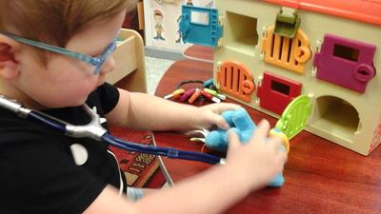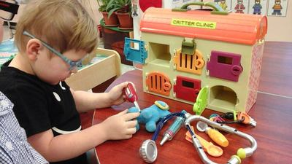

39. Activity title: „Planting onions“
Activity type: lesson
Purpose:
To acquaint children with the process of planting onions.
Formation of skills of various activities in nature.
Give an elementary concept of natural vitamins.
To cultivate the desire to achieve results, to participate in the common cause.
To consolidate knowledge about the structure of onions, about the conditions necessary for plant growth;
To consolidate knowledge of the color, shape of an object and be able to determine it by its characteristics;
Teach kids planting bulbs.
Instill a love of labor.
Participants: group of children
Level: 2-7 year old
Materials:
pots with loose soil, watering can with water, onions.
Time: 15-30 minutes
Activity description and instructions, rules, comments:
Children sit on the chairs around the table.
The teacher makes riddles:
"Sits grandfather, wearing a hundred coats, who undresses him, sheds tears" (bow)
"Oh, and angry, though small!
In the sun arrows released.
Do not hit the sun arrows
Placed on our plates. " (bow)
What do you think needs to be done to get green onions? (children's answers)
That's right, onions need to sprout.
What is necessary for plant growth? (children's answers)
For this you need: earth, water, light, heat.
Do you want green onions in our group? (children's answers)
Look carefully here how to do it. In a plastic container with the ground must be planted onions. How to plant a bulb?
Make a hollow in the ground with a stick, plant a bow, sprinkle it with earth so that the upper part protrudes, then pour.
Children look at the bulbs, compare them and make a conclusion.
All the bulbs are in brown, dry scales, hard to touch, on the bottom of the bulbs are old roots. This onion is called bulb.
And how to plant the bulb, what part should be planted in the ground? (children make a hole in the ground, plant an onion so that its upper part protrudes from the ground).
What else needs to be done? (it is necessary to water, the children take turns watered)
Several options have been proposed for planting onions: in a plastic container with earth, in a glass with cotton wool and a glass with water.
And now we will plant carrots and beets in the ground to collect seeds for the next harvest.
Listen to the verses about these vegetables.
"If you eat carrots more often, you don’t need training:
Every day, drink carrot juice - you will be strong and healthy. "
"Beets are known to all the guys. Beets are more likely to eat!
And there is no tastier salad than beetroot salad. "
Well, we are ready for the arrival of spring!
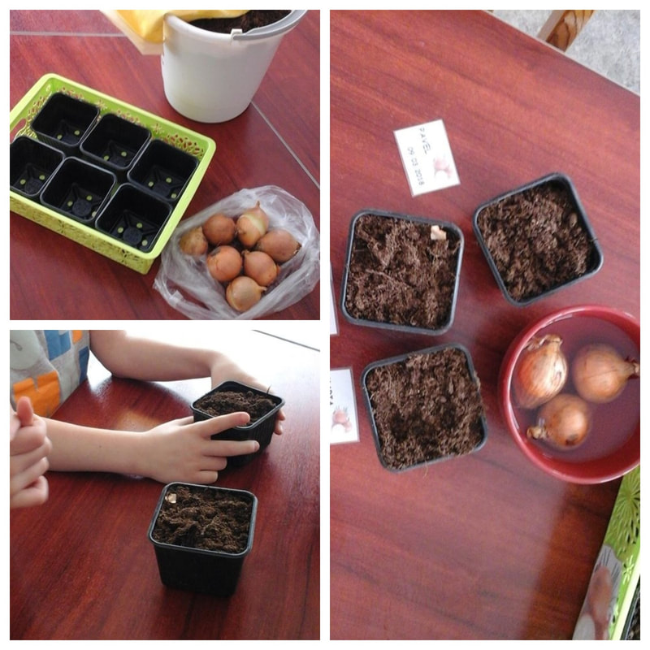

40. Activity title: „Observing the icicles“
Activity type: lesson
Purpose:
To acquaint children with the phenomenon of nature - an icicle. It grows upside down.
To draw children's attention to the fact that icicles are formed on the sunny side.
Why? snow melts and drips droplets, icicles do not have time to fall and freeze. Icicle grows in frosty weather, and melts in warm. Icicle begins to "cry." Show a variety of water conditions in the environment.
Experience: "Ice - solid water"
Put a piece of ice on your palm and watch it begin to melt.
Objective: To acquaint children with a natural phenomenon - ice. With its properties (ice - fragile and thin). Fix the view that the ice is clear, slippery.
Consider the pieces of ice.
Participants: group of children
Level: 3-5 year old
Materials:
Time: 15-30 minutes
Activity description and instructions, rules, comments:
Children go for a walk with the teacher.
Teacher: Children, look how beautiful it is on the street. The sun shines brightly, everything is sparkling all around. The snow is gradually melting, covered with a thin crust of ice.
"Spring has come, warmly brought"
Teacher: Now I will make you a riddle: What grows upside down?
Children: Icicle
Teacher: That's right, this is an icicle.
Teacher: On the street drops drip, melting icicles. When does it happen?
Kids: Springtime.
Teacher: Right
Teacher: Children, look, icicles hang from the roofs of our kindergarten, window sills. Let's look at them with you.
Children view icicles.
Teacher: What are they? (short or long), (thick or thin)
Children: (Children's Answers)
Teacher: The sun is warming, the icicles are melting. Listen to how they sing their song: "cap - cap - cap".
The teacher substitutes the bucket, the children listen and admire the icicles.
Reading poem
Icicle, icicle,
Tell me what
You cry so bitterly
Under our window?
Said the icicle
Through tears sighing:
- I'm crying about
What the sun melt!

The teacher tells the children that icicles grow in frosty weather. But, as soon as the sun warms, the snow begins to melt and drips down, the icicles do not have time to fall and freeze. Icicles form on the sunny side.
Teacher: Look at the children, as the sun shines brightly today, the icicles begin to melt ("cry").
Teacher: Icicles are frozen droplets of water that turn into ice.
The teacher knocks several icicles with a spatula, the children hold them in their palm
Teacher: What is she?
Children: Cold.
Teacher: What's going on with her?
Children: (Children's Answers)
Teacher: Why does she melt on your palm?
Children: (Children's Answers)
- Puzzle riddles:
They sat down on the eaves of the kids and grow all the time down.
Children: Icicles.
Teacher: Children, do you think why do icicles grow tip down?
Children: The droplets drip over an icicle, it draws out, and the tip of the icicle becomes thin.
Reading poem

Naughty icicles, sat on the eaves,
Naughty icicles looked down
Tired of them to hang, they began to drop droplets.
The whole day is pealing: “Cap - cap - cap! Don - don - don! ”

Experience: "Ice - solid water“
Objective: To acquaint children with a natural phenomenon - ice. With its properties (transparent, fragile, thin). Ice as well as snow melts from the heat.
The teacher recommends that the children place the icicle in a separate bowl to observe the state of the icicle in the group.
Teacher: What happens to the icicle?
Children: (Children's Answers)

Teacher: Look, in one jar we put a big icicle, and in another jar - a small one. Which icicle melted quickly? And why?

Conclusion: “Ice is solid water” (ice melts in heat, becomes water)


