31. Activity title: „Amanita“
Activity type: lessons
Purpose:
To consolidate the knowledge of children gained in classes on ecology and familiarization with others
Continue to acquaint children with the classification (names and species) of mushrooms.
Teach children to transfer the characteristics of fungi in the design of paper (conical cap, cylindrical leg, the connection of parts with glue).
Foster accuracy in working with glue and safety when working with scissors
Participants: group of children
Level: 4-6 year old
Materials: Photos with images of mushrooms, paper crafts for demonstration.
Time: 15-30 minutes
Activity description and instructions, rules, comments:
- Riddle
Under the pine at the track
There is a leg, but no boot,
Who is standing among the grass?
Is there a hat - no head?
Near the forest at the edge,
Decorating dark forest,
Grown motley like Parsley,
Poisonous ... (fly agaric).
2. Talk about mushrooms. Edible and inedible. Habitat. Features
Examining images of mushrooms.
3. Display and explanation of the execution of crafts. Repeat geometric shapes (cone, cylinder, circle, rectangle). The structure of the fungus (hat, leg).
4. Physical moment.
5. Analysis of children's work.
Now you know that the fly agaric is a beautiful, but poisonous mushroom. It is a lot of poisonous mushrooms in a wood, but they can be poisonous only for the person, and for animals - are useful. Sick, for example, calf. How is he cured? Where to get the medicine? He finds an amanita and eats it, an amanita for him is a medicine.
Finally, I would like to add that, despite the inedibility of this fungus, nature does not create anything unnecessary to it, therefore it is necessary not to tread and destroy even such seemingly useless mushrooms.
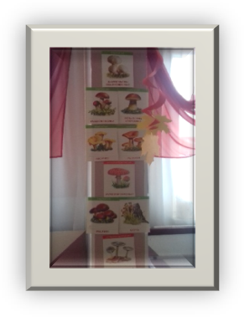

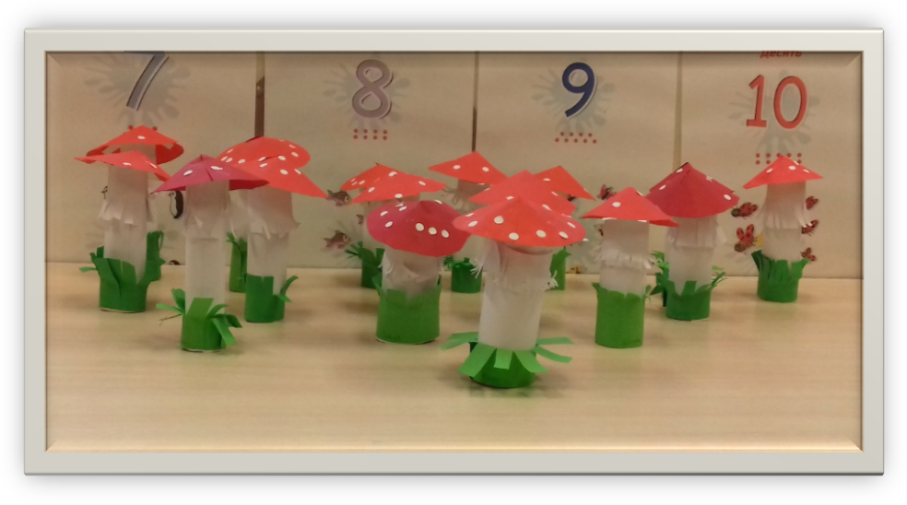
Ene Kruzman
Kindergarten Tareke, Estonia

32. Activity title: „Meet the rodent - Degu“
Activity type: lesson
Purpose:
development of coherent speech, cognitive activity.
formation of dialogic speech
exercise in matching nouns and adjectives in the case
activation in the speech of figurative adjectives: beautiful, fluffy, nimble, large, lobasty,
work on voice power, on intonational expressiveness
work on the formation of teamwork skills, hear each other
Participants: group of children
Level: 3-4 year old
Materials:
cage with Degu, carrots for treats
Time: 15-30 minutes
Activity description and instructions, rules, comments:
- Children, look who came to visit us today! This is Daegu.
- lives in South America, thick fur saves her from heat and cold
- the body is round, plump, like a ball
- elongated muzzle
- eyes are big, beautiful, they see well in the dark and in bright light
- ears rounded, long
- the tail is long, hard, serves as a steering wheel, helps when jumping
- mustache long, stick out in different directions
- hoisted velvet, like a cat with sharp claws; strong hoisted, help push off
- eat seeds, greens, tree bark, roots, berries, hay, vegetables, flowers
- wool reminds down; To care for a beautiful fur coat, Daegu bathe in sand and dust for a long time - the fur becomes equal, shiny, clean
- Daegu is active during the day, getting her own food.
- moves easily and quickly, always active, nimble
- Degu is gentle, playful, curious, runs very fast
- loves her stroking, scratching her back (but this can be done only with the animal that lives in your house; you cannot iron another's animal; it can get scared and bite - she has very sharp teeth)
- love to make a row, constantly gnawing something
- care: a large cage, a small house - a bath with a sand where it will tumble, cleaning the cage every day
- afraid of the cold and do not like the sun, so we often see a cage covered with a blanket.
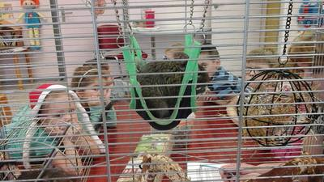
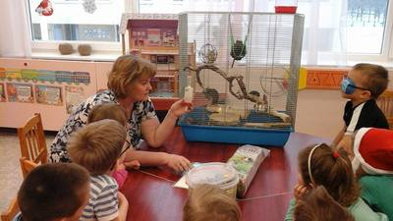

33. Activity title: „HORSE“
Activity type: games and exercises
Purpose:
To acquaint with the features of the appearance and lifestyle of the horse.
Enrich active and passive vocabulary on topic.
Teach children through simple experiments to find out the properties of sugar and water.
Continue to teach children to distinguish and name the numbers 1 and 2, correlate the number and the number, count down the specified number.
Learn to listen carefully and understand the poetic text.
To form stable ideas about color, position in space (on, behind, in front of, next to), geometric shapes (rectangle, square, triangle), size (high-low, large-small), speed (fast-slow).
Improve the skills of modeling, drawing with colored pencils, gluing, designing.
Learn to find a different subject.
To practice in onomatopoeia, the ability to harmonize words and movements.
Develop thinking, fine motor skills, coordination of movements, articulatory breathing, sense of rhythm, pace.
Participants: group of children
Level: 2-4 year old
Materials:
Toy horses, chest, cubes, bars of building material.
Pictures depicting a herd of horses.
Glasses with water. Teaspoons. Lump sugar.
Sheets of paper with a painted horse without a tail and mane, brown pencils cut from colored paper “saddles”, “horsemen” and “suns”, glue.
Clothespins, silhouettes of horses without legs and tail, cut from thick cardboard.
Plastic plates, with pasted figures 1 and 2. cut from cardboard horseshoe.
Dense silhouette of horses with threads inserted into the holes (mane and tail).
Salty dough, toy hammers.
Cut out thick paper horseshoes with holes, plastic bolts from the designer.
Salty dough, small counting sticks green.
Pictures with the image of horseshoes with one that is different from the others.
A rectangular, square and triangle structure painted on white cardboard; these same geometric shapes, cut from colored cardboard.
Silhouette colored pictures of three horses of different sizes, cut out of cardboard silhouette pictures of stables of the corresponding size with opening doors.
Audio recordings: “We are going, we are going on a horse”, “Tsok-Tsok”, “Look at the horse”.
Time: 15-30 minutes
Activity description and instructions, rules, comments:
Greeting
Surprise moment "Who is in the chest?"
Listen to the sound and guess who hid in the chest?
(An audio recording of the sound of horse hooves sounds).
Tsok, tsok, tsok, tsok!
I am a horse - gray side!
I'll knock the hoof.
If you want - ride!
Look how beautiful I am.
Good and tail, and mane.
Tsok, tsok, tsok, tsok!
I am a horse - gray side!

Examination and naming of parts of the toy "Horse"
Show where the horse has its head, side, tail, mane, hooves. Call me showing. (The teacher encourages the children to independently name the examined parts of the toy).
Here is the horse mom. And this is her baby - a foal. Who is big, horse or foal? Who is small?

Construction "Stable"
The house where the horses live is called the “stable.” Build a stable of colorful geometric shapes. Attach colored shapes to their image.
Show the blue shape. This is a triangle. How many triangles? One triangle.
Show the figures in yellow. These are squares. How many squares? Two squares.
Show the figures in red. These are rectangles. How many rectangles? Two rectangles. Make a pointer from a finger and show them a triangle, squares, a rectangle.

Didactic game "Find a stable for each horse"
How many stable houses do you have? Three stables. Are they the same or different? Various. Show the largest stable, the middle, the smallest.
And here are the horses. They are also three. Pick up each horse stable stable size.
Reading the English Pitfalls “The Blacksmith” translated by S. Ya. Marshak.
So that the horse does not break on the hard road of the hoof, invented a horseshoe. Horseshoes are such horse shoes that are nailed to the hooves of a horse. Shoe means nail the horseshoe.
- Hey blacksmith
Well done,
Limped my stallion.
You podkuy it again.
- Why not shoe up!
Here is a nail
Here is a horseshoe.
One, two -
And you're done!
Didactic exercise "How many horseshoes?"
How many horseshoes do you have? Three horseshoes. What is the number on this plate? The number 1. means in this plate you need to put one horseshoe. And on the other plate what figure? Figure 2. How many horseshoes do you need to put on a small plate with number 2? Two horseshoes. Here we have laid out all three horseshoes. One horseshoe and two horseshoes - three horseshoes.

Game "Insert Carnations in the Horseshoe"
Children insert nails (plastic screws from the designer) into the silhouette image of a horseshoe made of thick cardboard with holes.

Horseshoe Sculpture
From salt dough children mold a sausage by direct rolling. They bend it into the shape of a horseshoe, put nails on top (plastic screws from the designer), which are hammered with a toy hammer.

Didactic exercise "What is superfluous?"
In the picture, all the horseshoes are the same, except for one. Find this horseshoe. Not like everyone else. How is it different from other horseshoes? One horseshoe of a different color ..
Next, the children are offered another option, where one horseshoe is turned.
Didactic exercise "Where the horse goes"
Roll out the salty dough and press it down so that you get a big tortilla. It will be a land. Take the horses and walk them along the ground. Let your horses gallop so that their tracks will remain on the ground. View the tracks. Your horses galloped for a long time and wanted to eat. Take green sticks and stick it in the ground - grass for the horse will grow.
Dynamic pause "horses-toys"
A lot of toys, horses have guys, there are rocking horses. That's how this one is. Demonstration of a doll rocking horse. They sit on top and swing.
Let's swing on our socks back and forth, as if on a horse.
There are horses skipping ropes. Like these ones. A stick is placed between the legs and jump. Let's jump on the chopsticks-horses.
And you can play horses together. Take the rope and throw it like this. (On the chest, ends under the arms.) One playing horse. The other is the rider. Say "but" so that the horse goes. Say tpru to stop the horse.
(To the music "Food-going to the horse")

Didactic game "High or low horse jumping"
Put in front of the horse bar. Let your horse jump over it. Now put a bar next to it, and another one on top of it. Jump, horse! This is a low fence and the horse was jumping low, but this is a high fence and the horse was jumping high. Let your horse jump high and now low. How did the horse jump over this fence? Low. And how did the horse jump over this fence? High.

Exercise "Where's the horse?"
Put a cube in front of you. Now pick up the horse and put it
on top of the cube, behind the cube, in front of the cube, on the side next to the cube.

Tsok-tsok, tsok-tsok, here comes the horse.
Here the horses ran and hooves pounded.
Our horses are tired, loudly shouting loudly: i-th!

Here the horse galloped fast. And now slowly.
And now let's say, like horses: "Igo-oh-oh."

Massage "Look at the horse"
To the music and lyrics of the song, parents and then children “jump” with a plastic toy horse to each other on the backs, arms, legs.

Finger gymnastics and echo imitation "Jump horses"
Here are my helpers, Show palms, twist them
They, as you want to turn.
On the road, white, smooth
Jumping fingers like horses. moving your fingers
Tsok-Tsok-Tsok. Tsok-Tsok-Tsok. Onomatopoeia
Jumps frisky tab.
Horses shout loudly: “Yo-go!” Onomatopoeia
We rode away.

During imitation-clatter smile, open your mouth and click the tip of the tongue. The mouth is open. Language should be wide. Follow. So that the tip of the tongue does not tuck in and the lower jaw remains motionless.

Jumps frisky tab. What is the word "tab"? A tabun or herd is a company of horses that come together. Here is a picture of a herd of horses. How many horses are in the herd? Many horses.

Graphic activity "Beautiful horse"
Children, look, what did the artist forget to paint with our horses? Mane and tail. Do you know how to draw them? Do you want to learn this? (The tutor shows the way of drawing). Let's draw some more grass. So that our horse could eat. What pencil will we draw grass? Green pencil.
And now let's put a saddle on the picture. Here is a saddle have a horse on the back. It is called a saddle, because they sit on it when riding a horse. Who will go on our horse? Stick rider. And glue the sun so that our horse is warm and light.

Exercise with clothespins "Horse"
With the help of clothespins make the horse's tail and legs. Make the mane from ear to back, and legs - two in front and two behind.

Reading a poem by A. Barto "Horse"

I love my horse,
I brush her hair smoothly,
Scald smooth tail
And riding will visit.

(Reading is accompanied by game actions: the hair is combed “smoothly”, the tail is smoothed with a comb.)
- A comb is such a comb without a handle and a little curved.
- What does it mean to brush “smoothly”? “Smooth” is what? (Children's answers.)
- Listen, what a difficult word we met - "fur". Let's practice it pronounced correctly.

Exercise on the development of fine motor skills "Tail and mane"
Pull the thread by the knots and make the horse a beautiful tail and mane. Here our horse jumps fast. And now slowly.

Breathing exercise "Blow on the mane and tail"
When a horse gallops fast, her tail and her mane are fluttering. Let's blow on the tail and mane of the horse so that they flutter. Try to blow without puffing your cheeks.

Do not give you a horse
Lollipops and marmalades.
Better give her a little
Black bread in the palm.
She will eat slowly
And shake a fluffy mane.
Research activities
Here I have this. What love to eat horses. Do you know what it is? This is sugar.
Take a piece in your hands.
What sugar color? White color.
What sugar to touch? Hard or soft? Sugar is hard.
Try what it tastes like? Sweet, delicious.
And what about the cups? Water. Taste it. Water has no taste.
Now put a piece of sugar in a glass of water and stir with a spoon.
Look in the glass. Where did the sugar go? Sugar melted, dissolved in water.
Let's try the water again. What was the water like? The water has become sweet. Why did the water become sweet? What happened to the water? The water became sweet because we dissolved sweet sugar in it.

Mobile game "Horses roundabouts"

Barely spun roundabouts
(slowly walking in a circle, holding the hoop)
And then later
(slightly accelerated)
All run-run-run
(still accelerating)
And then, then, and then, all running, running, running
(run)
Hush, hush, do not rush
(slow down)
Stop the carousel. Stop!
(can be repeated in the other direction).

Physical "Horse"
The horse is waiting for me on the road, (hands behind my back are locked in the lock)
Beats a hoof at a gate, (rhythmic alternate lifts of the legs bent at the knees)
In the wind playing mane
Lush, fabulously beautiful. (shaking his head, then tilting to the side)
I will quickly leap into the saddle
I will not go - I will fly! (jumps in place)
Tsok-Tsok-Tsok,
Tsok-Tsok-Tsok, (arms bent at the elbows in front of him)
There, beyond the far river,
I wave your hand. (jumps in place)
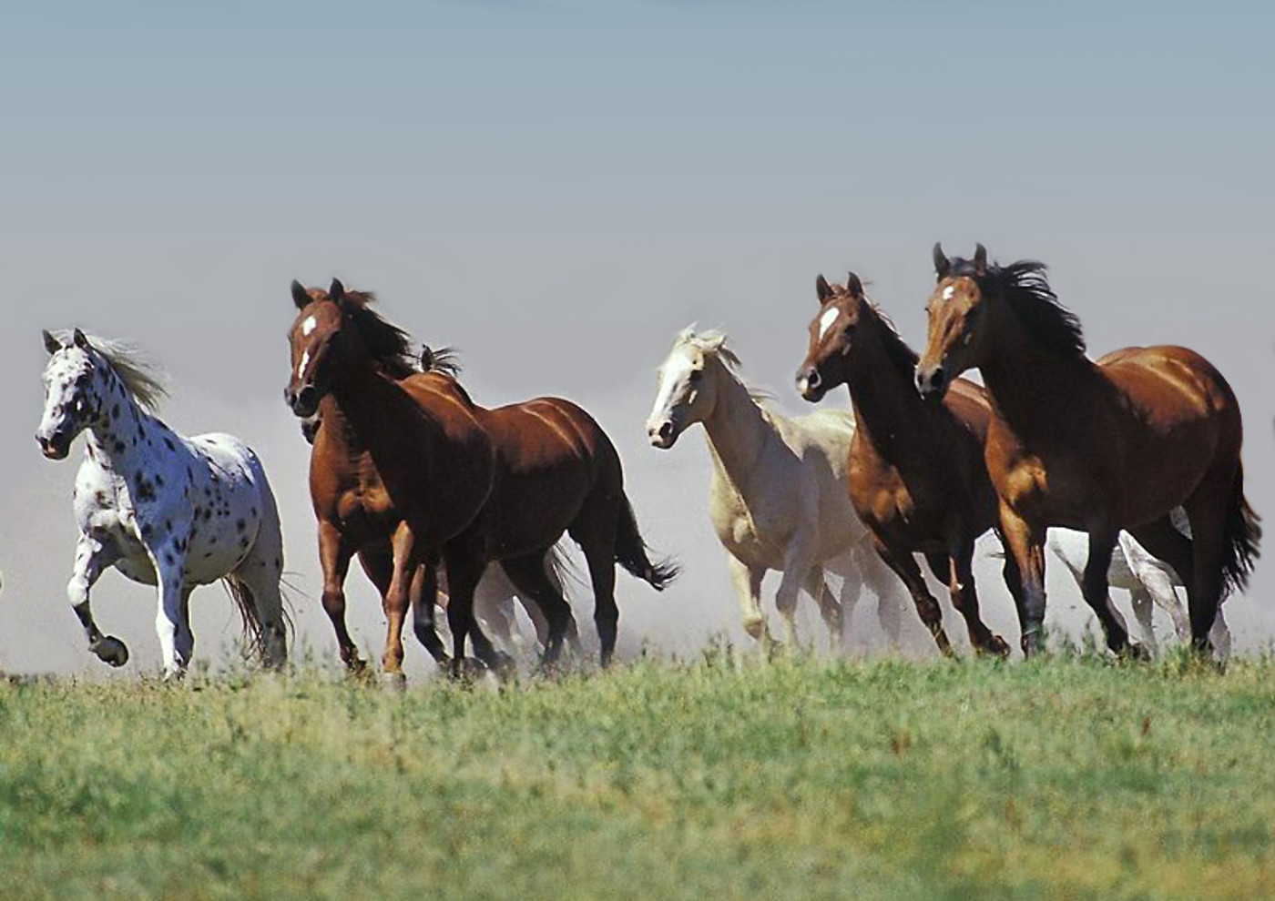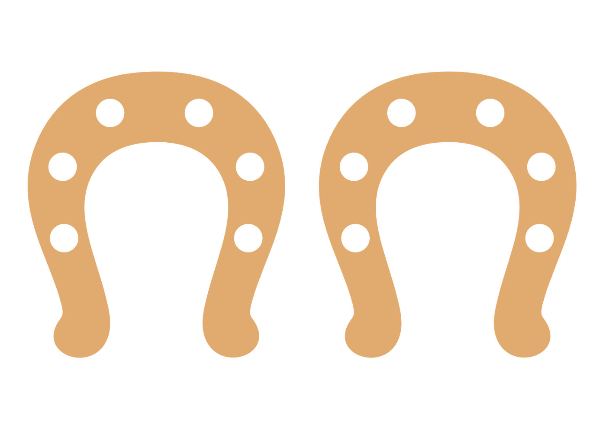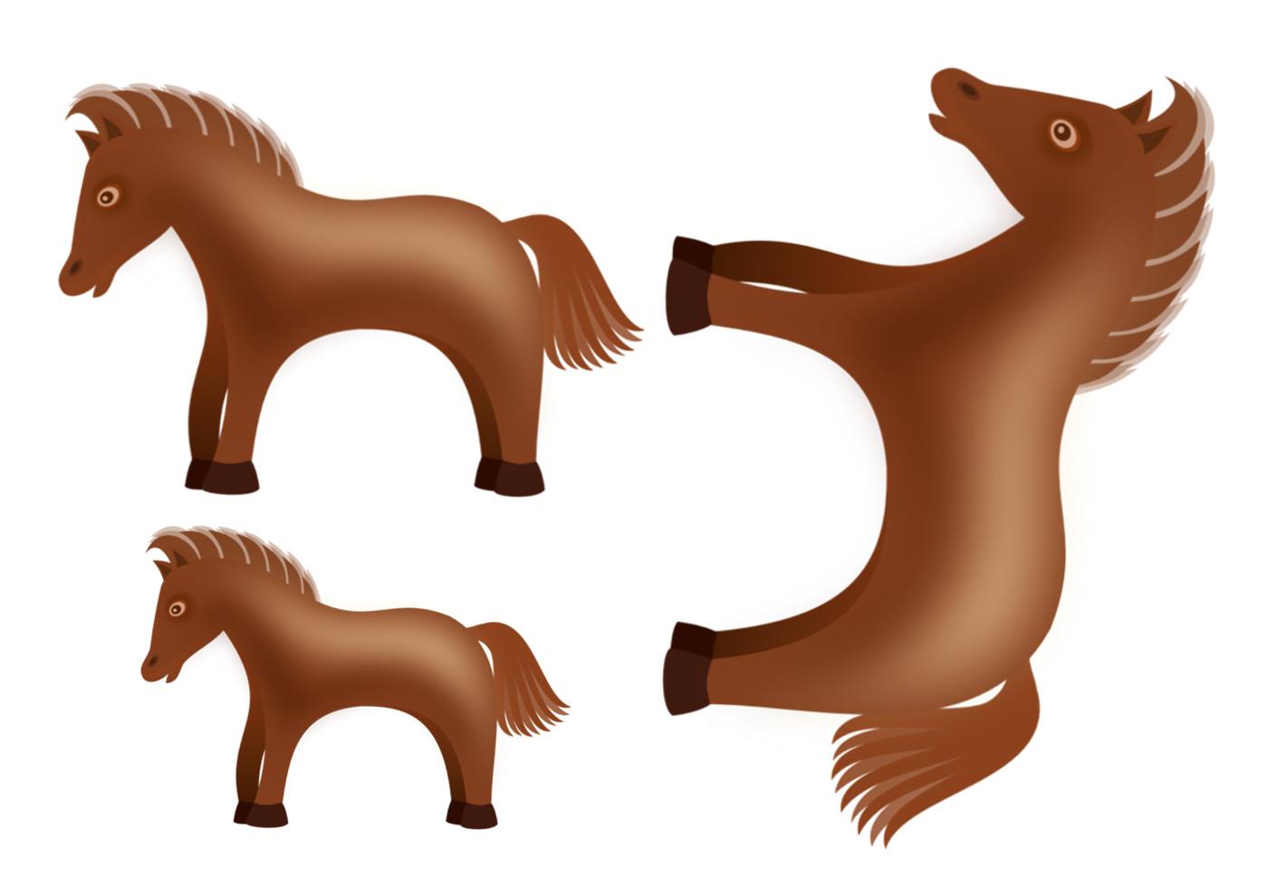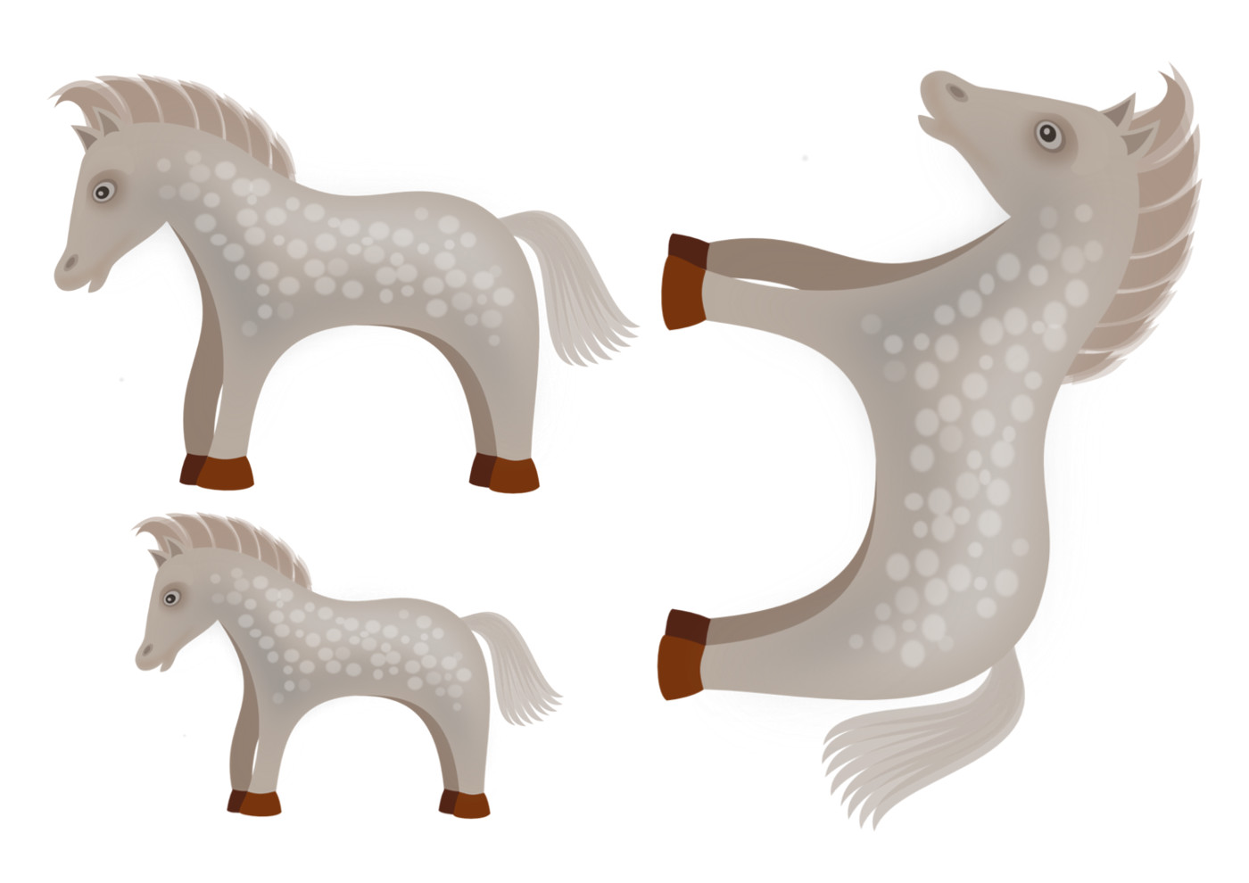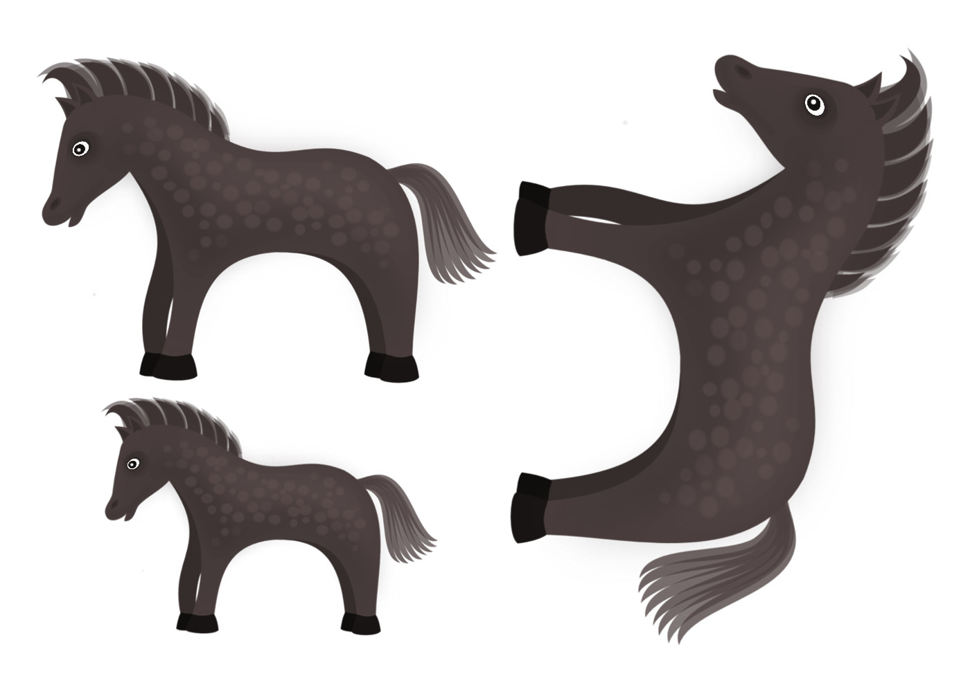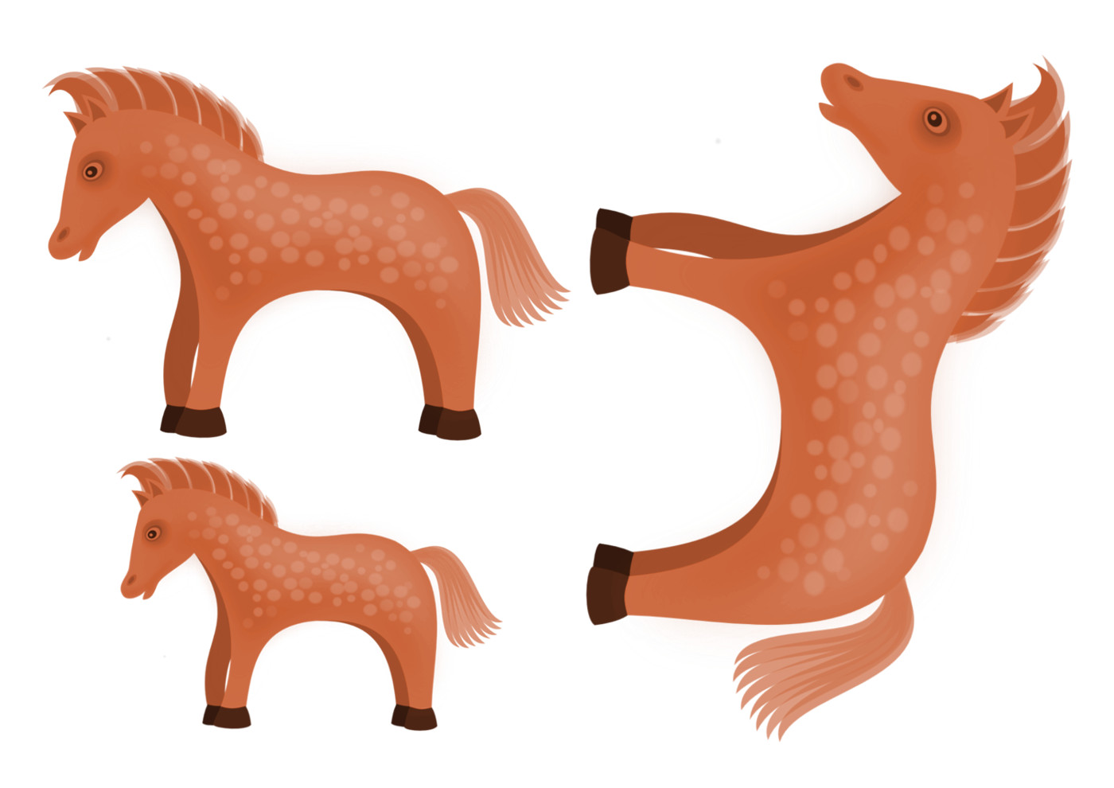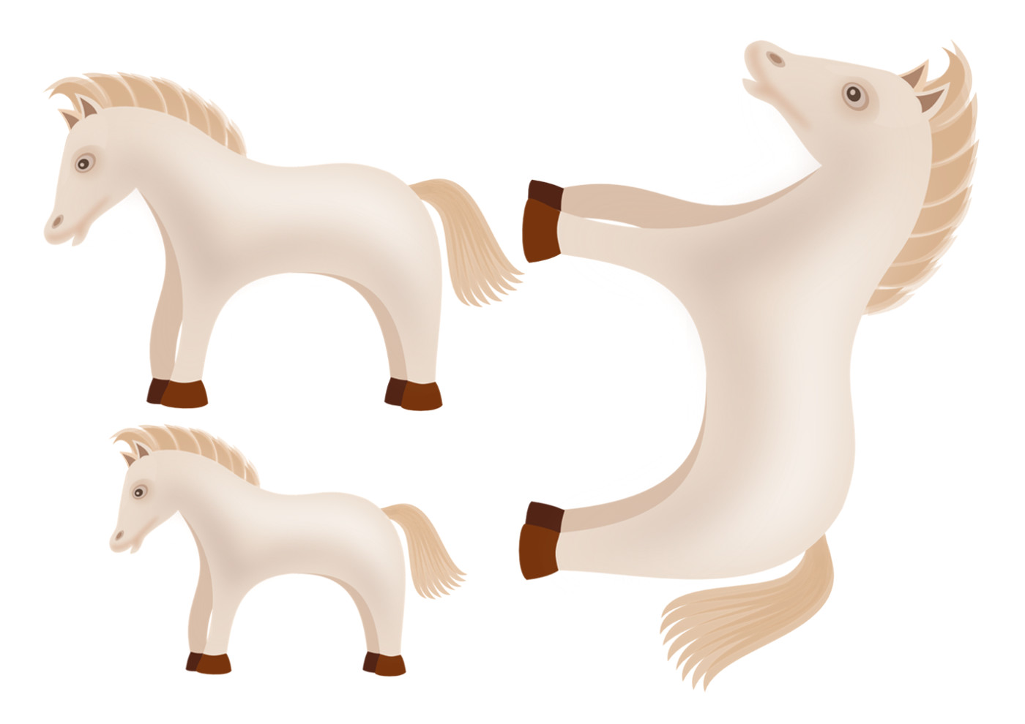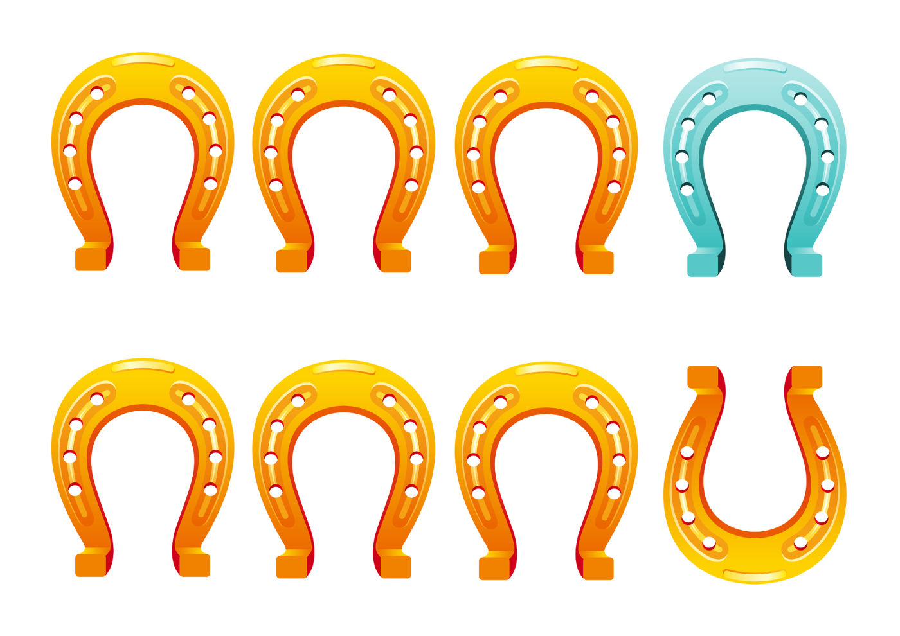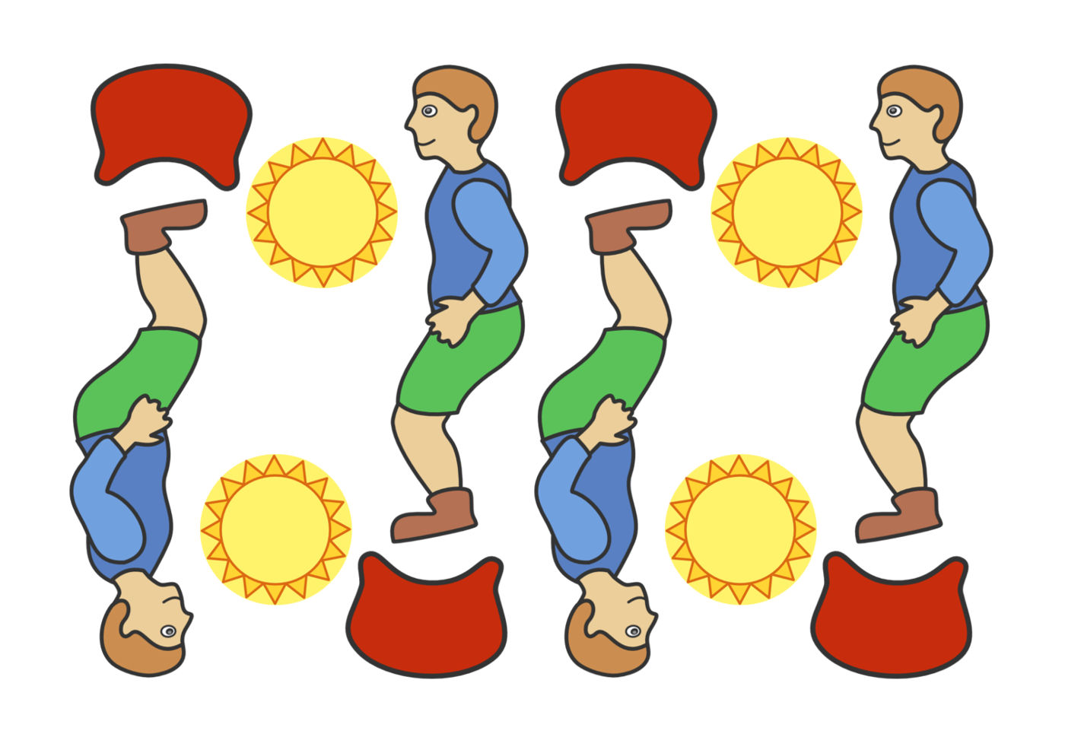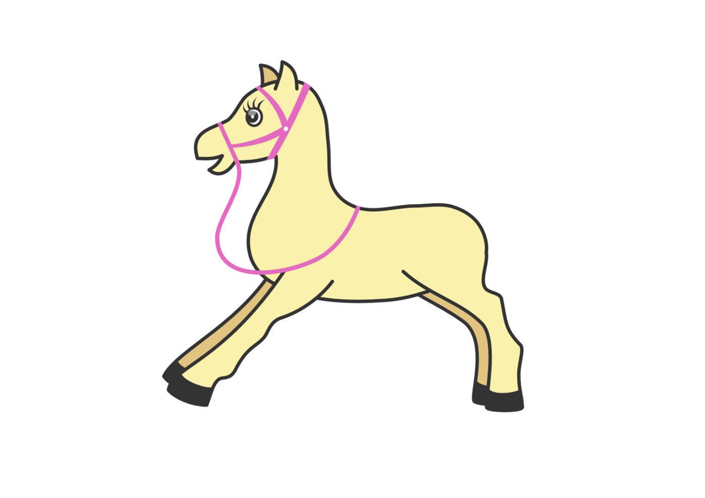

34. Activity title: „BIRDS“
Activity type: games and exercises
Purpose:
Expand children's knowledge of birds.
Enrich the vocabulary of children on this topic.
To consolidate knowledge of size (large-small), color (yellow, red, blue, green), position in space (top-bottom, right-left), geometric shapes (circle, square, triangle, rectangle).
Continue learning to count the specified number of subjects and designate the number as a number (1 and 2).
Improve the skills of drawing with fingers and pencils, sticking, sculpting.
Develop thinking, fine motor skills, coordination of movements.
Develop auditory and visual perception.
Raise the desire to help the birds.
Participants: group of children
Level: 2-4 year old
Materials:
Pictures demo (crow, cuckoo, sparrow, nightingale, starling)
Pictures with the image of a peacock, different in color and size of buttons.
Clothespins, silhouette images of birds.
Pictures of the big and small nests, cards with numbers 1 and 2, cut out of cardboard eggs.
The silhouette image of the egg, cut into two parts.
Plastic eggs, small toys-birds.
Picture-background for drawing berries, red finger paints.
The image of a seagull on a stick.
Paired pictures with the image of birds.
Picture background with a feeder, glue, cereals, birds, cut out of paper.
Cardboard blank "bird", cut out of paper wings, glue. Black plasticine.
Silhouette images of fish.
Pictures-backgrounds with the image of a birdhouse on one edge of a leaf and birds on another edge, pencils.
The picture with the image of a woodpecker, a tree trunk with beetles and a caterpillar, which are plastered with clay, stacks.
The picture depicting the scheme of the birdhouse, geometric shapes of colored cardboard, corresponding to the scheme.
Picture-blank with the image of tits, black plasticine, yellow finger paints.
Bells.
Audio recordings of the voices of birds, a song from the m / f "Who are the birds?", "We will pour crumbs to the birds", "Nightingale" by Alyabyev.
Time: 15-30 minutes
Activity description and instructions, rules, comments:
Hearing the voices of birds
Look at the picture - this is a crow bird. Listen to her voice. Try it yourself to say like a crow "kar-r."
Look at the picture - this is a bird sparrow. Listen to his voice. Try it yourself to say like a chick-tweet sparrow.
Look at the picture - this is a cuckoo bird. Listen to her voice. Try it yourself to say like a cuckoo cuckoo.

Didactic exercise "Whose voice?"
In different places of the room are images of birds. Kids go to that picture. The voice of whose bird sounds.

Didactic exercise "Eggs in the nests"
There are nests in front of you. Count them. How many nests in the picture? Two nests. And the nests are the same or different. Various. One nest is big, the other is small. Show the big nest. Show the little nest.
Put one egg in a small nest, and put two eggs in a large nest.
Put the number 1 under the nest, in which one egg. And what figure we put under the nest with two eggs? Number 2.

Didactic game "Put a whole egg out of parts"
This egg is broken. There was a chick in it. Grown and broke an egg. To go outside. Let's try to lay an egg. From parts to make a whole.

Game "What is inside the egg"
Take an egg from the basket, open it and see what's inside.
Children open plastic eggs and find inside toys depicting birds. Children call their bird if they cannot do it themselves, calls an adult and asks the child to repeat.

Finger drawing "Berries for a bird"
In winter, birds eat berries left on the branches of trees. Let's draw more berries for the birds.

The game with clothespins "Bird"
Attach the clothespin to the bird in such a way that it has a beak, legs and a beautiful tail.

Application "Birds on the feeder"
On a winter day among the branches
The table is set for guests.
The board is new,
For birds, dining,
Calling for dinner
Crumbs to try.
Spread the surface of the feeder with glue, put the grits on top. Now birds will fly, grains peck. Stick the birds on the picture.

Musical exercise "We poured crumbs to birds"
Children ring bells to the music.

Designing "Birdhouse"
People help the birds when they feed them. And people help the birds when they build houses for them and hang them in the trees. Here's a birdhouse for a starling bird.
Let's lay out the birdhouse of geometric shapes.
What kind of geometric shapes did you use? What color is a square? Triangle, circle, rectangle?
Now take a wand and attach a perch to the birdhouse. On which the bird will sit. And here the starling flew to you in the birdhouse.

Graphic activity "Help the birds fly to the birdhouse"

- Pick up a birdhouse, a birdhouse, and attach it to a tree. Well done. Let's glue it on. And now let's take pencils and draw a path from each bird to the birdhouse.

Dynamic pause "On the road I rush"
Children move to the music, depicting the flight of a bird (walking, running, jumping).

Listening to music: “Nightingale” Alyabyev.

Didactic game "Who is not a bird?"
Look at the picture carefully and think, who in the picture is not a bird? How did you guess? And who is it?
Didactic game "Find a bird unlike the others"

- And now you need to find in the picture a bird that is different from other birds. Where is she?

Didactic game "Find a pair"
Choose a picture of a bird. Find your bird another exactly the same second bird.
Finger gymnastics "Sparrow"
You're a baby, sparrow,
In the cold, do not be shy.
On the feeder beak hit,
Eat quickly.

(The children clasp their thumbs and wave their palms, imitating a bird's flight. Then they put the rounded right hand with the fingertips on the table and tap it with the pad of the index finger. Then do the same with the left hand).

The game with buttons "peacock tail"
But the bird, whose name is Peacock. The peacock has a beautiful tail. And we will make it even more beautiful when we spread the buttons on the feathers of the peacock tail.

Construction of paper "Bird"
Glue your bird's eyes out of black clay, one on each side of the head. And then glue the wings, also one on each side of the bird body. (After the end of the work is proposed to beat the craft).
The outdoor game "Warm, cold"
And now let's play the game "Warm, cold."
You guys will be sparrows. At the command of "warmth" - fly and chirp, and at the command of "cold" - mumble and squat down next to each other.

Graphic activity "Tit"
Children make an eye out of a piece of black plasticine to the bird. A yellow paint finger paint over the abdomen of the bird.

Exercise "Help the woodpecker find food"
Woodpecker is looking for bugs and worms under the bark of a tree. Take the stacks and remove the top of the bark to find a woodpecker's food under it.

Gymnastics for the eyes "Seagull"
But the seabird seagull. Let's follow the eyes of her flight.
Here the gull flew up. Flew left. Down sank. I flew to the right. Spun over the waves.

Dynamic pause "Seagulls catch fish"
And now children turn into birds - seagulls. Gulls are sea birds, most of all they love to eat fish that they themselves catch in the sea. Go for the fish. Catch and bring two fish. (The teacher asks the child how many fish he caught and what color they are).
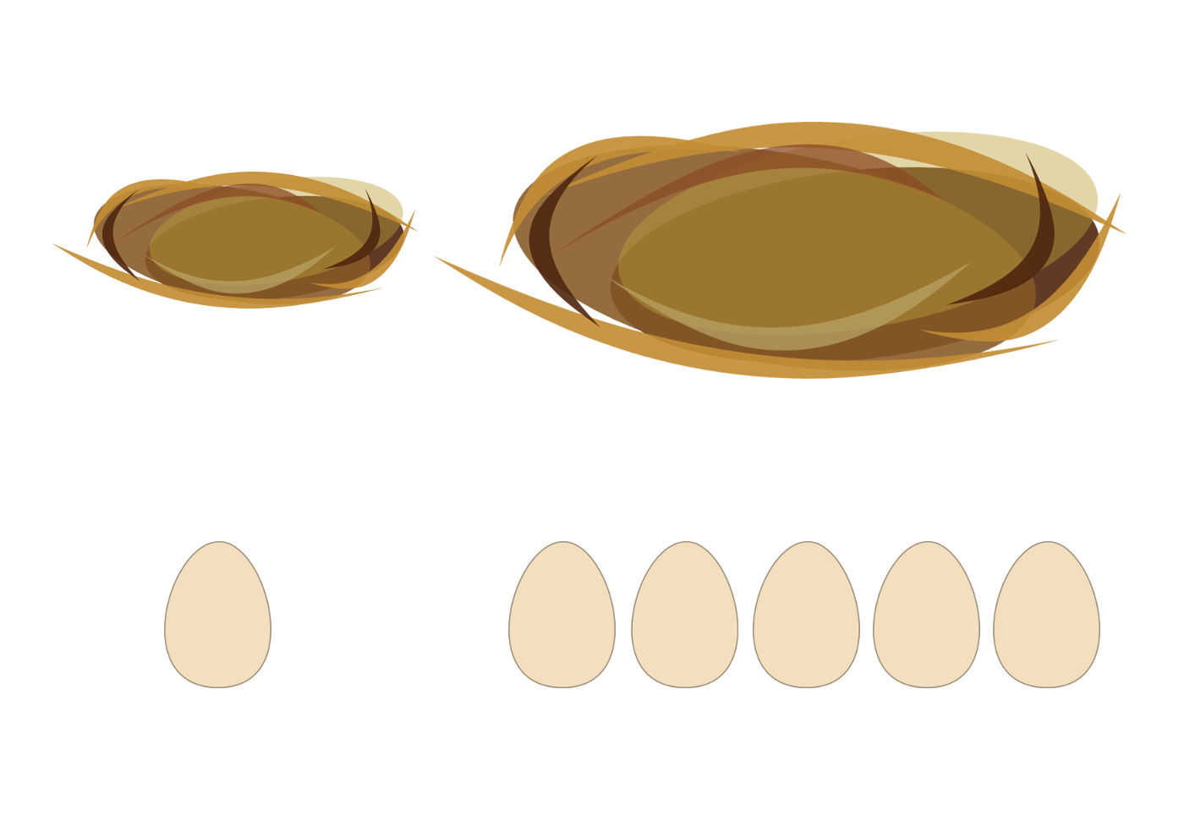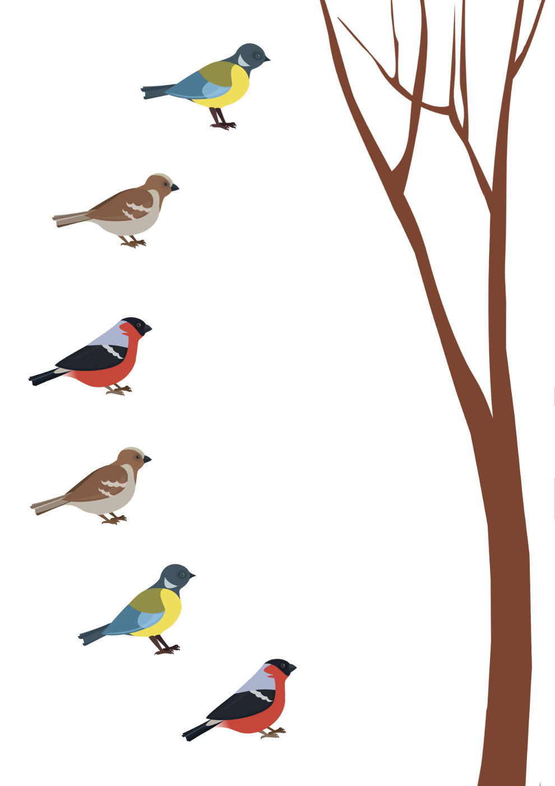

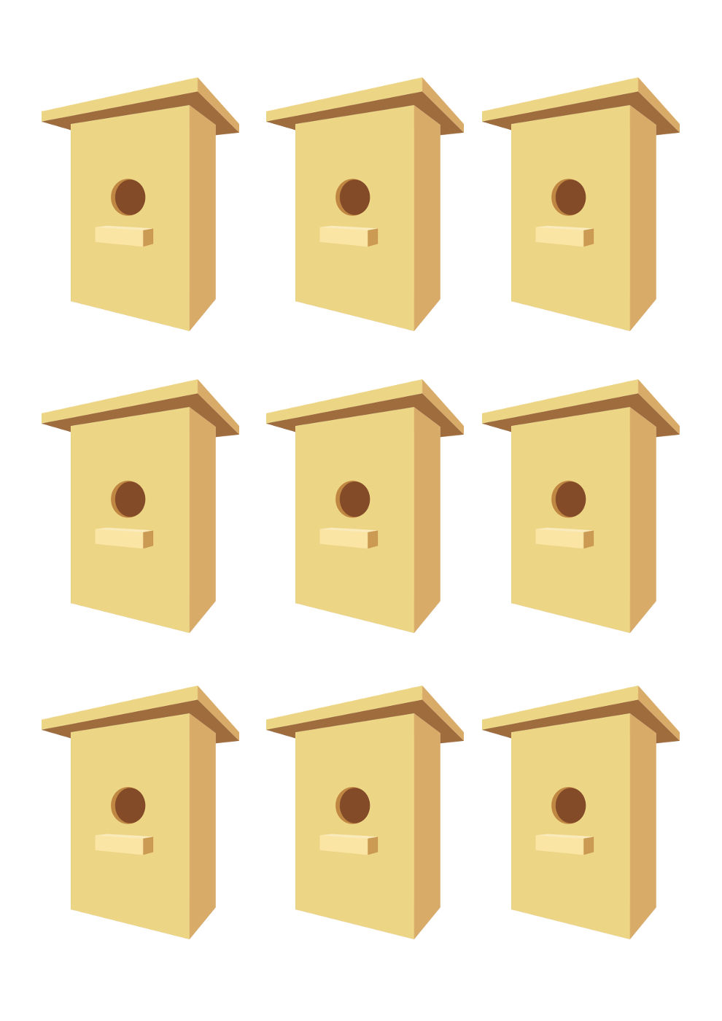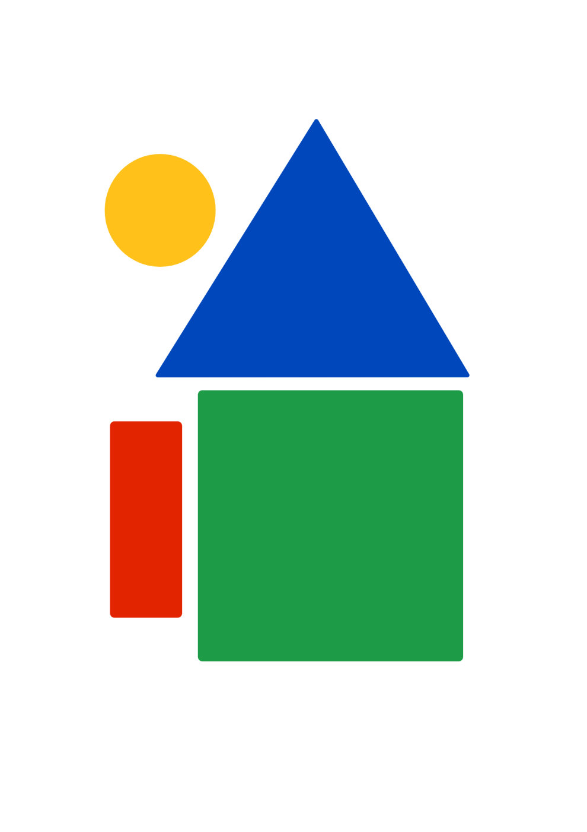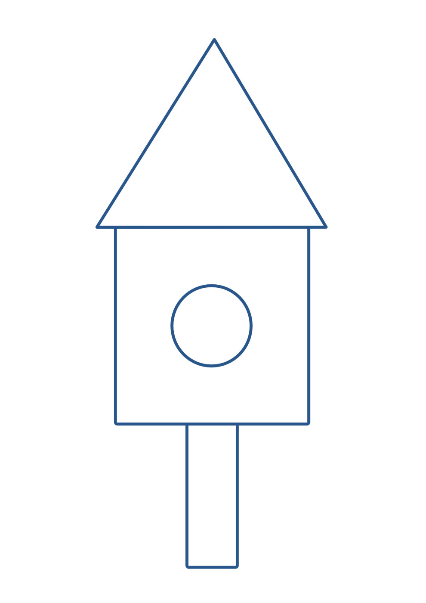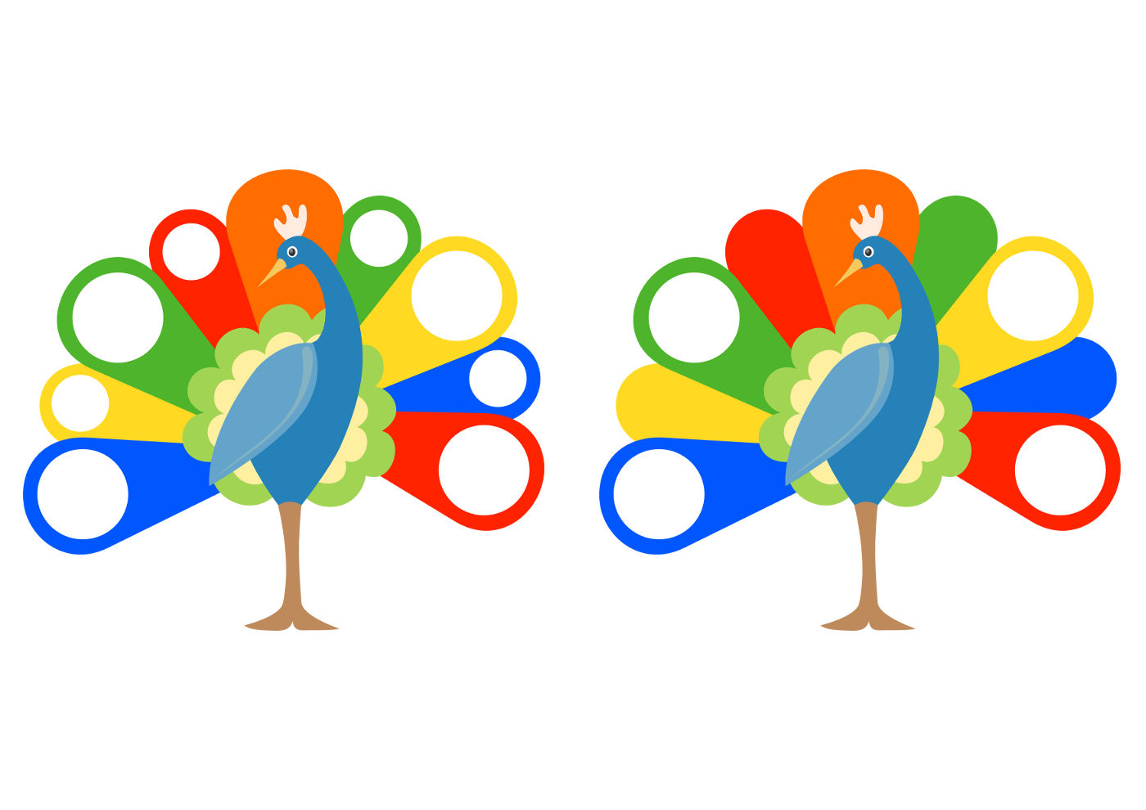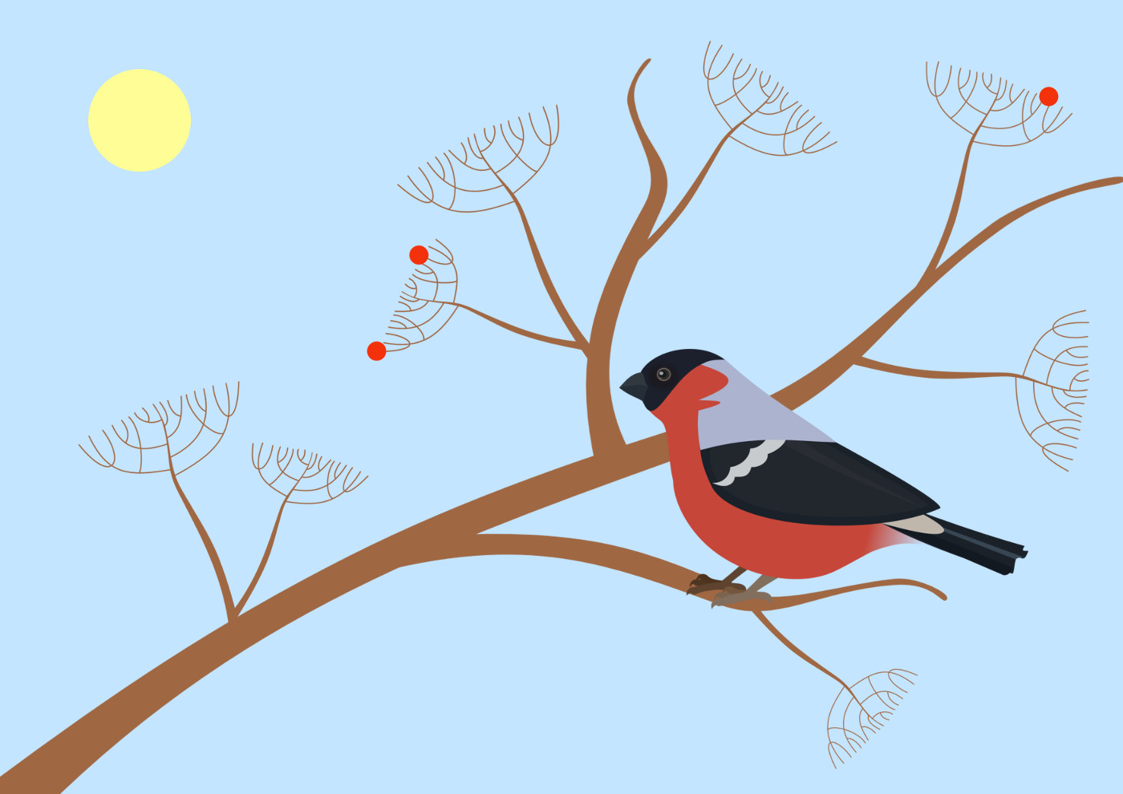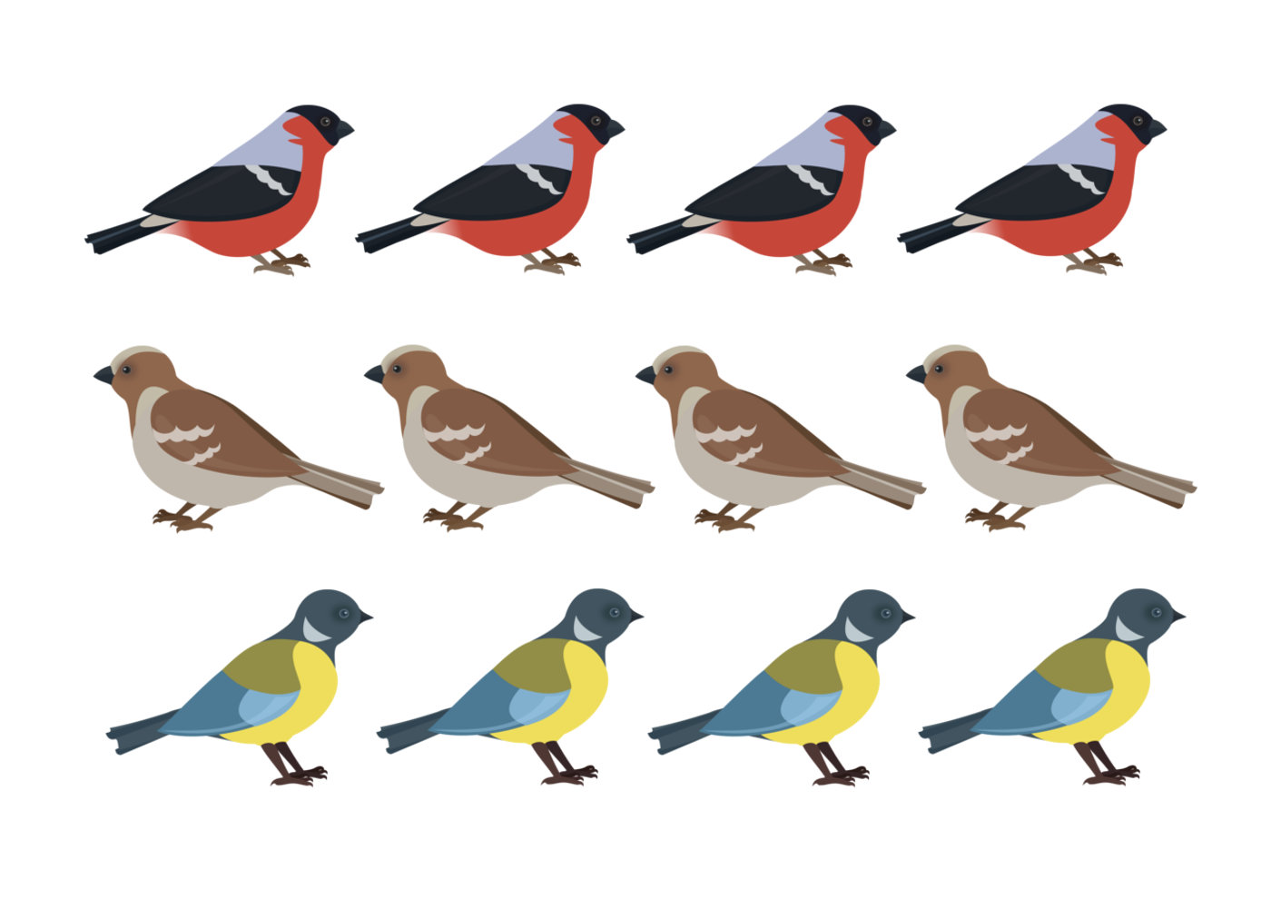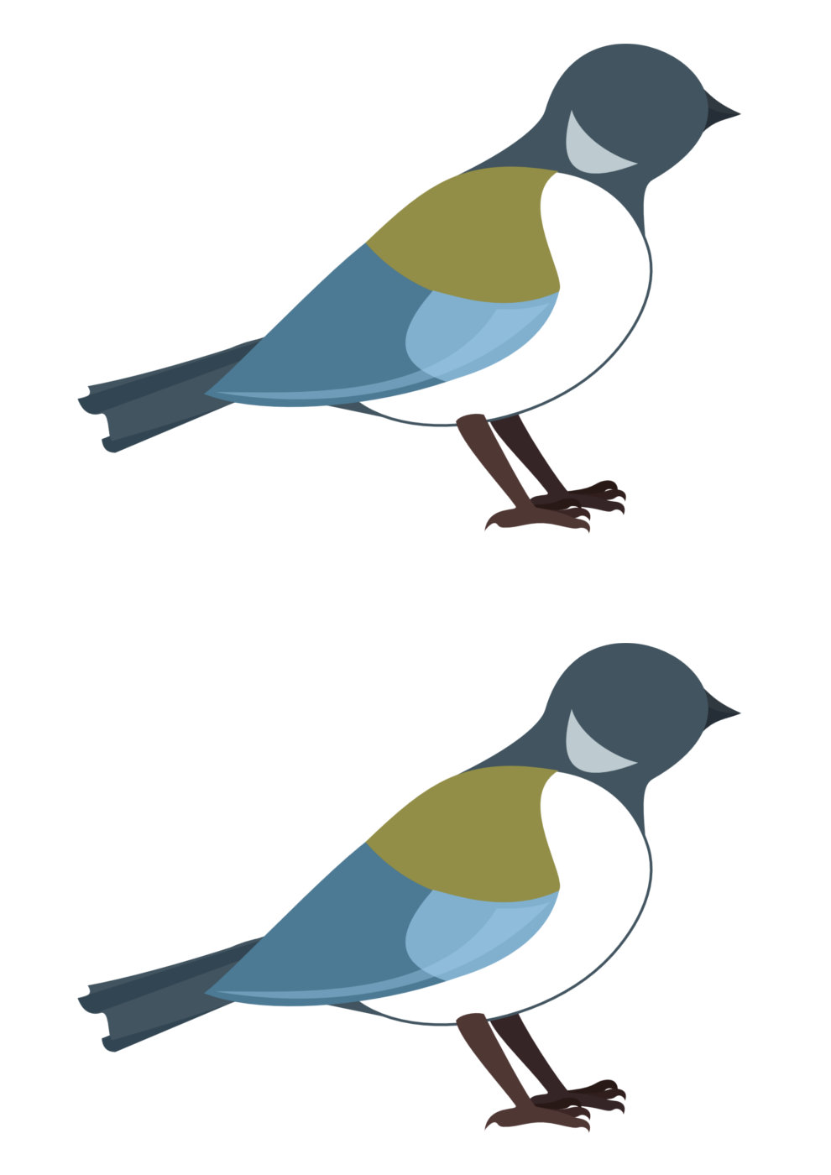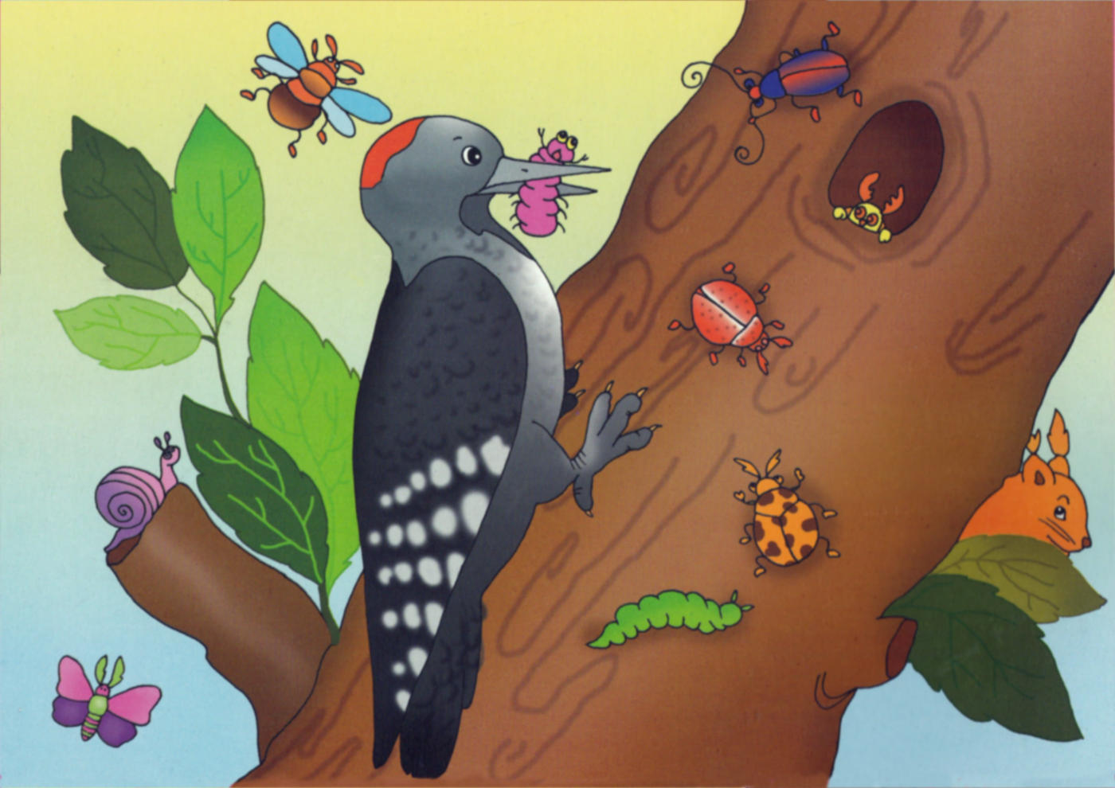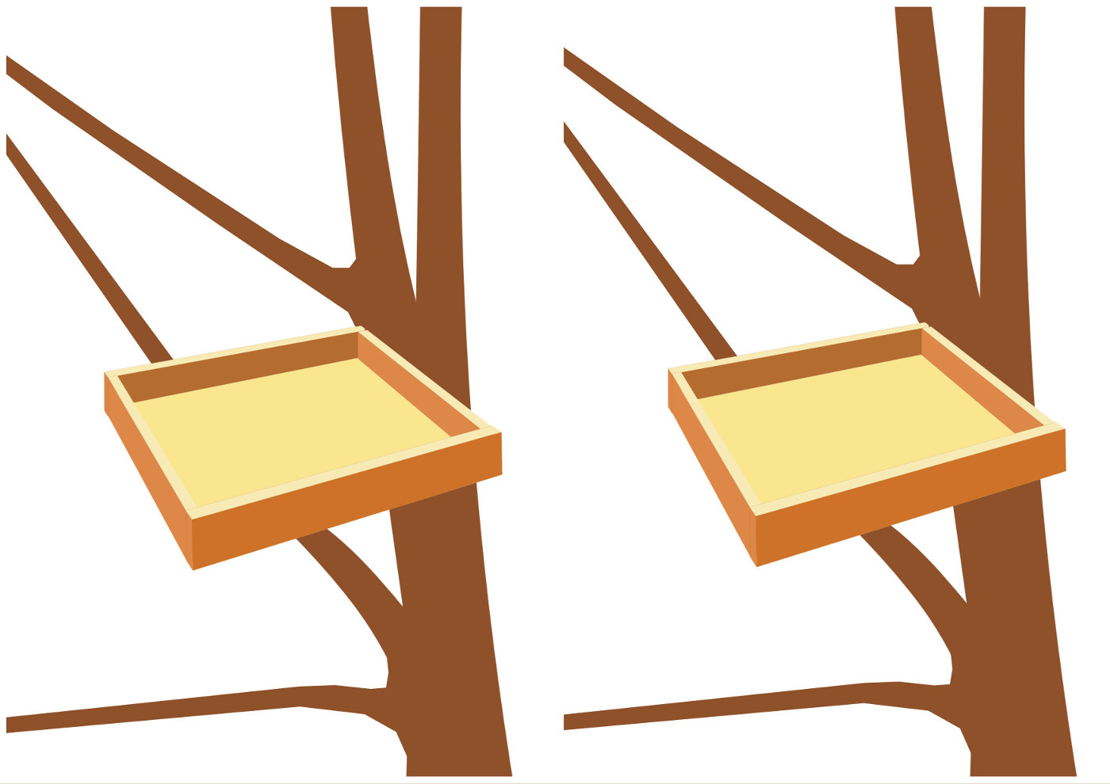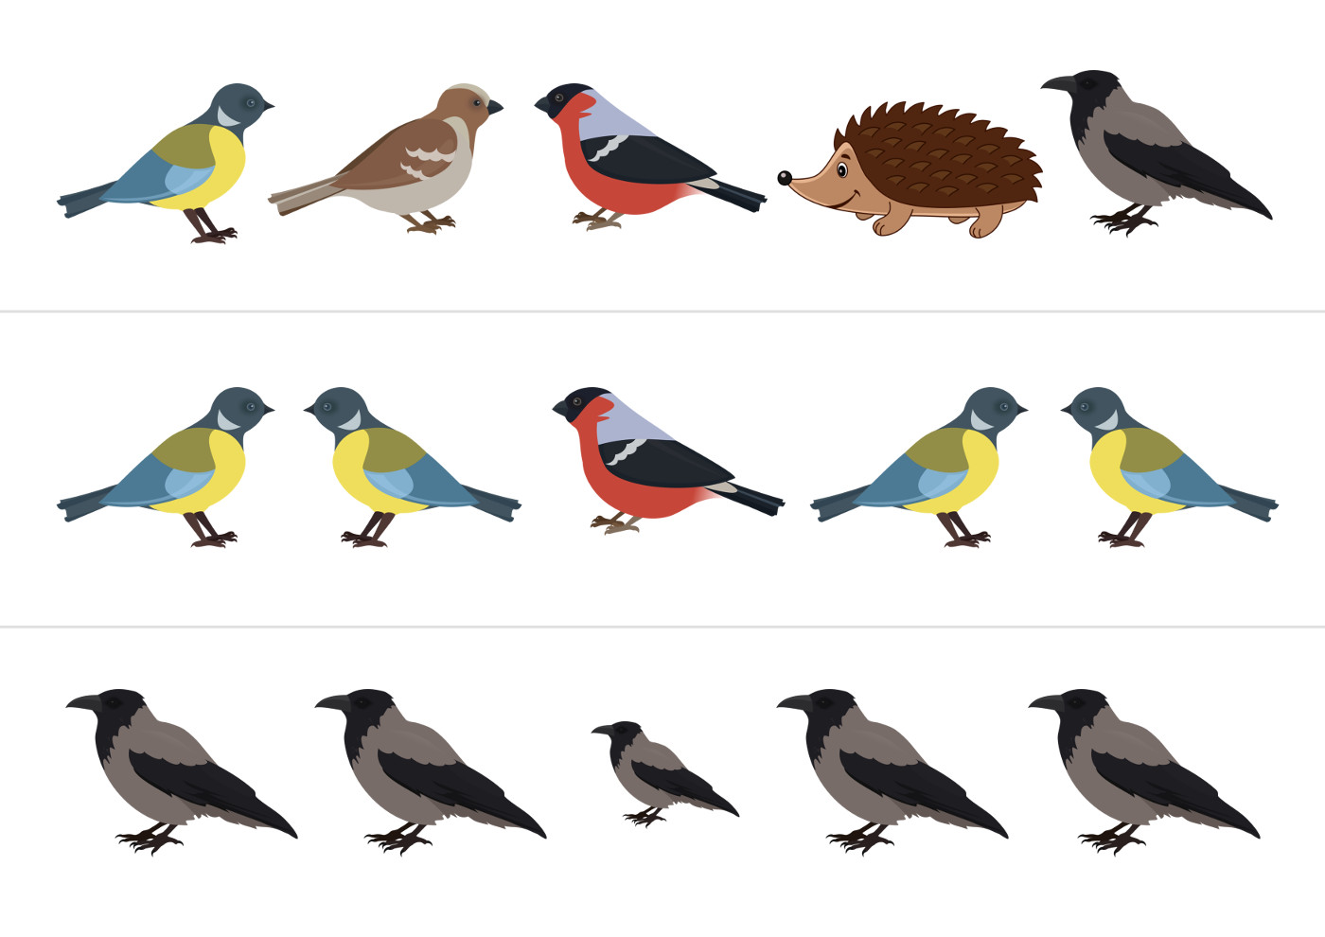

35. Activity title: „Autumn“
Activity type: games and exercises
Purpose:
Continue to acquaint children with flowers (red, yellow, green), the concepts of "big-small", "one-many", "top-bottom".
Teach children to repeat words and actions along the lines of an adult.
To form skills in working with clay.
Develop fine and general motor skills.
To develop visual and auditory perception, sense of rhythm.
Participants: group of children
Level: 2-4 year old
Materials:
Autumn leaves are large and small.
Cut out of cardboard leaves of yellow, red and green flowers and the same colors of the vase (trays, bags, etc.), droplets of blue.
Carved from oilcloth puddles.
Nuts, toy "squirrel", a plastic bottle with a carved "hollow."
Plasticine yellow, red and green colors, sheets of paper with a painted tree.
Wooden spatulas with clothespins of red, yellow, green colors attached to them.
Cut out of the cage for eggs flowers and flower beds.
Sheets of paper with the background "autumn, tree trunks without a crown.
Metallophone
Audio recordings: “The waltz of flowers” ​​by P. I. Tchaikovsky, the song “Autumn, autumn has come, the leaves are crumbled”.
Time: 15-30 minutes
Activity description and instructions, rules, comments:
Hello Greetings
Hello palms - clap, clap, clap
Hello legs - top, top, top.
Hello cheeks - spank, splat, splat
Hello sponge - Smack, Smack, Smack
Hello teeth - AM, AM, AM.
Hello spout - beep, beep, beep.
Hello guys - hello!

Guys! Today we go to the autumn forest. Admire the beauty of autumn.

Finger gymnastics "Autumn leaves"
One, two, three, four, five,
We will collect the leaves.
Squeeze and unclasp cams.
Birch leaves
Bend fingers, starting with a big one.
Rowan leaves,
Poplar leaves,
Aspen leaves,
We will gather the oak leaves,
We will collect a beautiful autumn bouquet.
Twirl the hands with spread fingers.

Didactic exercise "Big and small leaves"
Here you have the leaves. They are different. Here is a big sheet. But a small piece. Show me a big sheet. Show a small sheet. Put a large piece of paper on the table .. Put a small piece of paper on top of a large one. Now put a small piece of paper on the table and cover it with a large sheet on top. Hid a small piece of paper. A large sheet covered small so that the small sheet is not visible. Where is the little sheet? Here it is, under a large leaflet.

Physical "Trees"
Pens raised and gently wave,
The wind shakes the foliage.
Down lowered, hands shook,
Dropping foliage to the ground.

Game with clothespins "The wind tears leaves from a tree"
Here the autumn wind blew. Blow like the wind. The wind blew all the leaves off the trees. Remove the clothespins from the wand.

The game "Collect the leaves and arrange them in color"
That's how many leaves we have in different colors. Let's collect them and put them in a bouquet.
In this vase, carry the leaflets like this. (Show). What color are they? Yellow. In the yellow vase collect the yellow leaves. What color vase is this? Red. In the red vase will collect red leaves. What color vase is this? Green. In the green vase collect the leaves of green.

Dynamic pause "blowing, blowing wind"
Blowing, blowing wind, blowing blowing.
Long exhale.
Yellow leaves of a tree tears off.
Gently lower the raised arms.
And leaves fly over the forest path.
Wave your hands.
Leaflets fall right under our feet.
Sit down.

Sculpture bas-relief "Autumn Leaves"
See how sad the trees are without leaves. Let's make our painted trees leaves of plasticine. Tear off small pieces, apply to the branch and press down with your finger.

The game "Droplet and palm"
Rain-rain, little by little,
Drip-drip on the palm.
Fingers tapping on the palm like raindrops.

Take a drop in your hand, lift it up, slowly lower it down, right on the palm of your other hand.

"We put on rubber boots on legs"
We make movements, as if we are putting on real boots. Put on “boots” - we are recovering to walk in “puddles” (we try to walk in such a way as to attack only on “pools”, not to step on the floor).

Plant flowers in the flower bed
Autumn pleases us with beautiful flowers. Let us and we will plant flowers on a bed. Take flowers (cut from the egg cage) and plant them - put them in the holes (sections from the egg cage). And in the middle of the flower, lower a piece of yellow plasticine and press it down with your finger. Here are some beautiful flowers grown in your flower bed.

Listening to the music “Waltz of the Flowers” ​​P. I. Tchaikovsky.
Children listen to music, at will, you can pick up artificial flowers in your hands and move around with them.

Collect nuts for the squirrel

See who it jumps? Who came to visit us? This is a squirrel.

Squirrel rides through the branches.
Collect nuts for kids.
All squirting sweet
They love to gnaw nuts.

Let's help the squirrel to collect nuts. Here I have one nut. And how many nuts do you have? Lots of nuts. I will take my one nut and put it in the hollow of the squirrel tree. Like this. And now you fold the nuts in the hollow. You have a lot of nuts. That will be a protein happy!

Musical and rhythmic exercise "Autumn, autumn has come"

